**The Ballad of Thunder Road (Don Raye / Robert Mitchum)**

**C**

Let me tell the story, I can tell it all;

**Dm G7 C**

About the mountain boy who ran illegal alcohol.

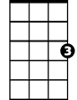

C

**C**

His daddy made the whiskey,

the son he drove the load;

**Dm G7**

And when his engine roared

**C Dm C**

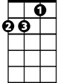

Dm

They called the highway "Thunder Road".

**C**

Sometimes into Ashville,

Sometimes Memphis town.

**Dm G7**

The Revenuers chased him

**C**

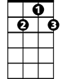

G7

But they couldn't run him down.

**C**

Each time they thought they had him

His engine would explode.

**Dm G7**

He'd go by like they were standing

F

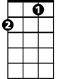

**C Dm C**

Still on "Thunder Road".

**Chorus:**

**F**

And there was thunder, thunder

**C** **F G7**

Over "Thunder Road", Thunder was his engine

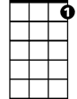

C7

**C C7**

And white lightening was his load.

**F**

And there was moonshine, moonshine

**C**

To quench the devil's thirst.

**Dm G7**

The law they swore they'd get him

**C**

But the devil got him first.

**C**

It was on the first of April, Nineteen-Fifty-Four

**Dm G7**

The Federal man sent word

**C**

He'd better make his run no more.

**C**

He said "200 agents were covering the state;

**Dm G7**

Which ever road he tried to take

**C Dm C**

They'd get him sure as fate."

**C**

'Son' his daddy told him, 'make this run your last.

**Dm G7**

The tank is filled with 100 proof;

**C**

You're all tuned-up and gassed.

**C**

Now don't take any chances, if you can't get through.

**BARITONE**

**Dm G7**

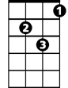

Dm

C



I'd rather have you back again

**C Dm C**

Than all that Mountain Dew.'

**(Chorus)**

**C**



G7

Roaring out of Harlan; revving up his mill.

**Dm G7**

He shot the Gap at Cumberland

**C**

And streamed by Maynardville.

**C**

With G men on his tail light; road block up ahead,

**Dm G7**

The mountain boy took roads

**C Dm C**

That even angels fear to tread.

**C**

Blazing right through Knoxville, out on Kingston Pike,

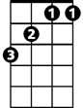

F

**Dm G7**

Then right outside of Bearden,

**C**

They made the fatal strike.

**C**

He left the road at 90; that's all there is to say,

**Dm G7**

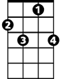

C7

The devil got the moonshine

**C Dm C**

And the mountain boy that day.

**(Chorus) 2X**

**Dm G7**

The law they swore they'd get him

**F Dm C**

But the devil got him first.