The Battle of New Orleans (Jimmy Driftwood, ca. 1959) (C)

Strum in on C  C F  In 1814 we took a little trip  G7  A-long with Col. Jackson  C  down the mighty Mississip'  F  We took a little bacon and we took a little beans  G7  And we caught the bloody British  C  in a town in New Orleans.  Chorus  C  We fired our guns and the British kept a comin'  There wasn't nigh as many as there  G7 C  was a while a-go  F  We fired once more and they began to runnin'  G7 C  On down the Mississippi to the Gulf of Mex-i-co.  C  We looked down the river  F  and we see'd the British come  G7  And there musta been a hund'erd of 'em  C  beatin' on the drum  They stepped so high and they  F  made their bugles ring  G7  We stood beside our cotton bales  C  and didn't say a thing. Chorus |  |  |  |  | C F  Old Hick'ry said we could take 'em by su'prise  G7  If we didn't fire our musket  C  till we looked 'em in the eyes  F  We held our fire till we see'd their faces well  G7  Then we opened up with squirrel guns  C  and really gave 'em Well - Chorus  Bridge  C  Yeah! they ran through the briars  and they ran through the brambles  And they ran through the bushes  G7 C  Where a rabbit couldn't go  They ran so fast that the  hounds couldn't catch 'em  G7 C  On down the Mississippi to the Gulf of Mex-i-co.  C F  We fired our cannon till the barrel melted down  G7  So we grabbed an alligator  C  and we fought another round  We filled his head with cannonballs  F  and powdered his behind  G7  And when we touched the powder off,  C  the 'gator lost his mind. Chorus Bridge
GCEA | 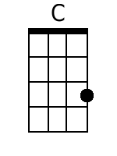 | 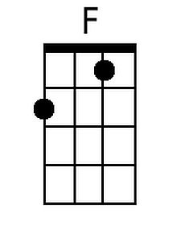 | 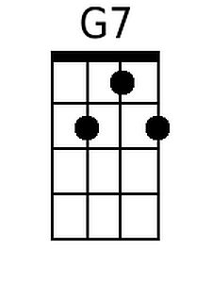 |  |  | DGBE | 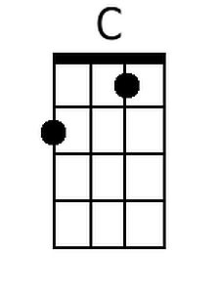 | 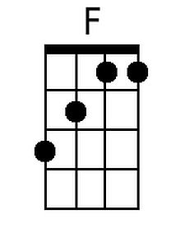 | 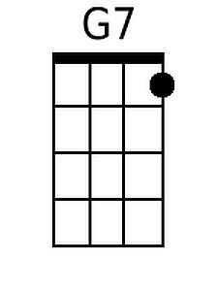

The Battle of New Orleans (Jimmy Driftwood, ca. 1959) (G)

Strum in on G  G C  In 1814 we took a little trip  D7 G  A-long with Col. Jackson down the mighty Mississip'  C  We took a little bacon and we took a little beans  D7  And we caught the bloody British  G  in a town in New Orleans.  Chorus  G  We fired our guns and the British kept a comin'  There wasn't nigh as many  D7 G  as there was a while a-go  C  We fired once more and they began to runnin'  D7 G  On down the Mississippi to the Gulf of Mex-i-co.  G  We looked down the river  C  and we see'd the British come  D7  And there musta been a hund'erd of 'em  G  beatin' on the drum  They stepped so high  C  and they made their bugles ring  D7  We stood beside our cotton bales  G  and didn't say a thing. Chorus |  |  |  |  | G C  Old Hick'ry said we could take 'em by su'prise  D7  If we didn't fire our musket  G  till we looked 'em in the eyes  C  We held our fire till we see'd their faces well  D7  Then we opened up with squirrel guns  G  and really gave 'em Well - Chorus  Bridge  G  Yeah! they ran through the briars  and they ran through the brambles  And they ran through the bushes  D7 G  Where a rabbit couldn't go  They ran so fast that the hounds couldn't catch 'em  D7 G  On down the Mississippi to the Gulf of Mex-i-co.  G C  We fired our cannon till the barrel melted down  D7  So we grabbed an alligator  G  and we fought another round  We filled his head with cannonballs  C  and powdered his behind  D7  And when we touched the powder off,  G  the 'gator lost his mind. Chorus Bridge
GCEA | 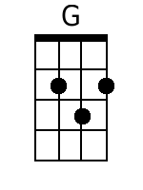 |  | 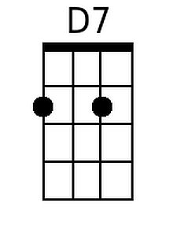 |  |  | DGBE | 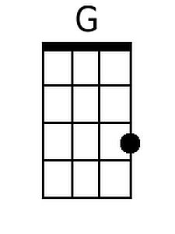 |  | 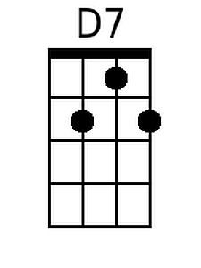

The Battle of New Orleans (Jimmy Driftwood, ca. 1959) (NN)

1 | 4 | 5(7)
A | D | E7
C | F | G7
D | G | A7
F | Bb | C7
G | C | D7

Strum in on 1  1 4  In 1814 we took a little trip  5(7)  A-long with Col. Jackson  1  down the mighty Mississip'  4  We took a little bacon and we took a little beans  5(7)  And we caught the bloody British  1  in a town in New Orleans.  Chorus  1  We fired our guns and the British kept a comin'  There wasn't nigh as many  5(7) 1  as there was a while a-go  4  We fired once more and they began to runnin'  5(7) 1  On down the Mississippi to the Gulf of Mex-i-co.  1  We looked down the river  4  and we see'd the British come  5(7)  And there musta been a hund'erd of 'em  1  beatin' on the drum  They stepped so high  4  and they made their bugles ring  5(7)  We stood beside our cotton bales  1  and didn't say a thing. Chorus | 1 4  Old Hick'ry said we could take 'em by su'prise  5(7)  If we didn't fire our musket  1  till we looked 'em in the eyes  4  We held our fire till we see'd their faces well  5(7)  Then we opened up with squirrel guns  1  and really gave 'em Well - Chorus  Bridge  1  Yeah! they ran through the briars  and they ran through the brambles  And they ran through the bushes  5(7) 1  Where a rabbit couldn't go  They ran so fast that the  hounds couldn't catch 'em  5(7) 1  On down the Mississippi to the Gulf of Mex-i-co.  1 4  We fired our cannon till the barrel melted down  5(7)  So we grabbed an alligator  1  and we fought another round  We filled his head with cannonballs  4  and powdered his behind  5(7)  And when we touched the powder off,  1  the 'gator lost his mind. Chorus Bridge

