The Battle of New Orleans (Jimmy Driftwood) (G)

Strum in on G

G C
In 1814 we took a little trip
D7 G
A-long with Col. Jackson down the mighty Mississip'
C
We took a little bacon and we took a little beans
D7 G
And we caught the bloody British in a town in New
Orleans.

Chorus
G
We fired our guns and the British kept a comin'
D7 G
There wasn't nigh as many as there was a while a-go

We fired once more and they began to runnin'
D7 G
On down the Mississippi to the Gulf of Mex-i-co.

G C
We looked down the river and we see'd the British come
D7 G
And there musta been a hund'erd of 'em beatin' on the
drum
C
They stepped so high and they made their bugles ring
D7 G
We stood beside our cotton bales and didn't say a thing. Chorus

G C
Old Hick'ry said we could take 'em by su'prise
D7 G
If we didn't fire our musket till we looked 'em in the eyes
C
We held our fire till we see'd their faces well
D7 G
Then we opened up with squirrel guns and really gave
'em Well - Chorus

Bridge
G
Yeah! they ran through the briars and they ran through
the brambles
And they ran through the bushes
D7 G
Where a rabbit couldn't go

They ran so fast that the hounds couldn't catch 'em
D7 G
On down the Mississippi to the Gulf of Mex-i-co.

G C
We fired our cannon till the barrel melted down
D7 G
So we grabbed an alligator and we fought another round
C
We filled his head with cannonballs and powdered his
behind
D7 G
And when we touched the powder off, the 'gator lost his
mind. Chorus Bridge

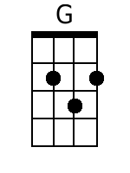 | 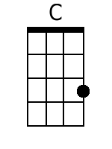 | 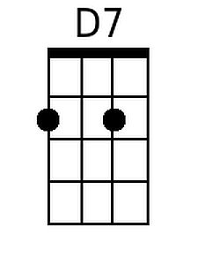 | Baritone | 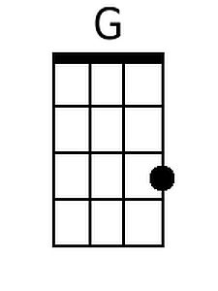 | 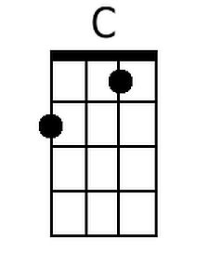 | 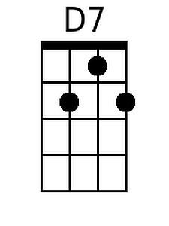

The Battle of New Orleans (Jimmy Driftwood) (NN)

1 | 4 | 5(7)
A | D | E7
C | F | G7
D | G | A7
F | Bb | C7
G | C | D7

Strum in on 1

1 4
In 1814 we took a little trip
5(7) 1
A-long with Col. Jackson down the mighty Mississip'
4
We took a little bacon and we took a little beans
5(7) 1
And we caught the bloody British in a town in New Orleans.

Chorus
1
We fired our guns and the British kept a comin'
5(7) 1
There wasn't as many as there was a while a-go

We fired once more and they began to runnin'
5(7) 1
On down the Mississippi to the Gulf of Mex-ico.

1 4
We looked down the river and we see'd the British come
5(7) 1
And there musta been a hund'erd of 'em beatin' on the drum
4
They stepped so high and they made their bugles ring
5(7) 1
We stood beside our cotton bales and didn't say a thing. Chorus

1 4
Old Hick'ry said we could take 'em by su'prise
5(7) 1
If we didn't fire our musket till we looked 'em in the eyes
4
We held our fire till we see'd their faces well
5(7) 1
Then we opened up with squirrel guns and really gave 'em Well - Chorus

Bridge
1
Yeah! they ran through the briars and they ran through the brambles

And they ran through the bushes
5(7) 1
where a rabbit couldn't go

They ran so fast that the hounds couldn't catch 'em
5(7) 1
On down the Mississippi to the Gulf of Mex-i-co.

1 4
We fired our cannon till the barrel melted down
5(7) 1
So we grabbed an alligator and we fought another round
4
We filled his head with cannonballs and powdered his behind
5(7)
And when we touched the powder off,
1
the 'gator lost his mind. Chorus Bridge

