**The Boxer (Paul Simon)**

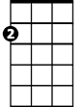

Am

**C G Am**

I am just a poor boy though my story's seldom told,

**G**

I have squandered my resistance

**G7 Em7 C G Am**

For a pocketful of mumbles, such are promises, all lies and jest

**G F C G7 F C**



C

Still, a man hears what he wants to hear and disregards the rest

**C G Am**

When I left my home and my family I was no more than a boy

**G**

In the company of strangers



G

**G7 Em7 C G Am**

In the quiet of the railway station, running scared, laying low,

**G F C**

Seeking out the poorer quarters where the ragged people go,

**G7 F C**

Looking for the places only they would know.

Em7

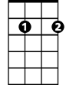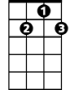

G7

F



**Chorus:**

**Am G Am**

Lie-la-lie..lie la lie la lala lie – lie la lie

**G C**

Em

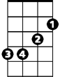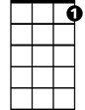

C7

Lie la lie lalalala lie lalala lie

**C7 C**

Asking only workman's wages,

**G Am**  **G**

I come looking for a job, but I get no offers,

**G7 Em7 C G Am**

Just a come-on from the whores on Seventh Avenue, I do declare,

**G F C**

There were times when I was so lonesomeI took some comfort there.

**G7 F C**

La la la la la

**(Chorus)**

**C7 C G Am**

Now the years are rolling by me, they are rocking evil - ly

**G**

I am older than I once was,

**G7 Em7 C G Am**

But younger than I’ll be, but that’s not unusual, no it isn’t strange

**G F C**

After changes upon changes, we are more or less the same

**G7 F C**

After changes we are more or less the same

**(Chorus)**

**C7 C G Am**

Then I'm laying out my winter clothes and wishing I was gone,

**G**

Going home –

**G7 Em7 C Em Am**

Where the New York City winters aren't bleeding me, leading me-e

**G G7 F C**

To going home.

**C G Am**

In the clearing stands a boxer, and a fighter by his trade

**G**

And he carries the reminders

**G7 Em7 C**

Of ev'ry glove that laid him down and cut him till he cried out

**G Am**

In his anger and his shame,

**G F C G7 Em7 C**

"I am leaving, I am leaving." But the fighter still remains

**(Chorus end in Am ) (repeat from G to fade)**

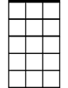

Em7

**BARITONE**



G7



Em

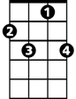

C7

C



F



G

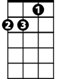

Am