The Boy from New York City (George Davis & John T. Taylor, 1964)
The Ad Libs (1964); The Manhattan Transfer (1981) – Key of A

Intro: | A | D | A7 | D | (2x)  Chorus  A D A7 D  Oo-wah oo-wah, cool cool kitty,  A D  Tell us about the boy  A7 D  From New York City.  (2x first and last times)  A D A7 D  He's kinda tall.  A D A7 D  He's really fine. (yeah, yeah)  A D A7 D  Some-day I hope to make him mine,  A D A7 D  All mine. (yeah, yeah)  D G  And he's neat  D7 G D G D7 G  __ and oh, so sweet.  A D A7  And just the way he looked at me  D A D A7 D  Swept me off my feet. (yeah, yeah)  E7 D7  Ooh ee, you ought to come and see  A D A7  How he walks, (yeah, yeah)  D A D A7 D  __ And he talks. Chorus  A D A7 D  He's really down.  A D A7 D  And he's no clown. (yeah, yeah)  A D  He has the finest penthouse  A7 D A D A7 D  I've ever seen in town. (yeah, yeah) |  |  |  |  | D G D G D7  And he's cute in his mohair suit.  G A D  __ And he keeps his pockets  A7 D A D A7 D  Full of spending loot. (yeah, yeah)  E7 D7  Ooh ee you ought to come and see  A D A7  his pretty bar,  D A D A7  And his brand new car.  D G D7 G  Every time he says he loves me,  A D A7 D  chills run down my spine.  D G D7 G  Every time he wants to kiss me, ooh ,  B7 E7  he makes me feel so fine. Yeah! Chorus  D7 A D A7  He can dance,  D A D A7  __ and make ro-mance.  D A D A7  And that’s when I fell in love  D A D A7  with just one glance.  D G D A7  He was shy,  G D G D7 G  and so was I.  A D  And now I know we'll never  A7 D A D A7 D  ever say good bye.  E7 D7  Oo ee you ought to come and see  A D A7  he's the most  D A D A7 D  __ from coast to coast. Chorus (2x) |  |  |  | 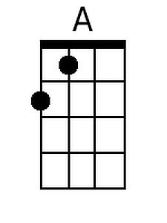
 |  |  |  |  |  |  |  |  | 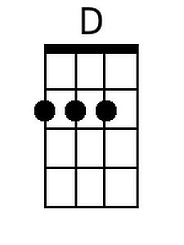
 |  |  |  |  |  |  |  |  | 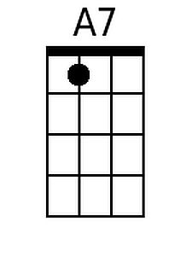
 |  |  |  |  |  |  |  |  | 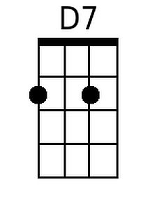
 |  |  |  |  |  |  |  |  | 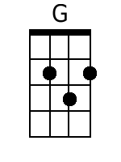
 |  |  |  |  |  |  |  |  | 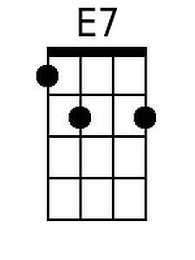
Baritone | 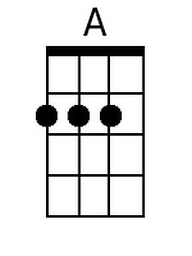 | 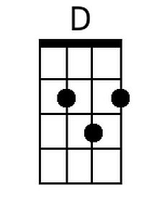 | 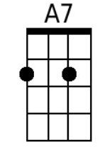 | 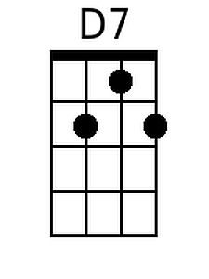 |  | 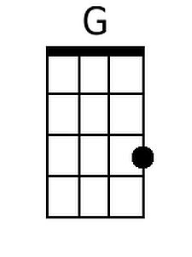 | 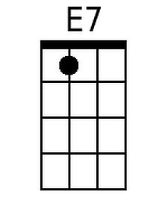

The Boy from New York City (George Davis & John T. Taylor, 1964)
The Ad Libs (1964); The Manhattan Transfer (1981) – Key of D

Intro: | D | G | D7 | G | (2x)  Chorus  D G D7 G  Oo-wah oo-wah, cool cool kitty,  D G  Tell us about the boy  D7 G  From New York City.  (2x first and last times)  D G D7 G  He's kinda tall.  D G D7 G  He's really fine. (yeah, yeah)  D G D7 G  Some-day I hope to make him mine,  D G D7 G  All mine. (yeah, yeah)  G C  And he's neat  G7 C G C G7 C  __ and oh, so sweet.  D G D7  And just the way he looked at me  G D G D7 G  Swept me off my feet. (yeah, yeah)  A7 G7  Ooh ee, you ought to come and see  D G D7  How he walks, (yeah, yeah)  G D G D7 G  __ And he talks. Chorus  D G D7 G  He's really down.  D G D7 G  And he's no clown. (yeah, yeah)  D G  He has the finest penthouse  D7 G D G D7 G  I've ever seen in town. (yeah, yeah) |  |  |  |  | G C G7 C G C G7  And he's cute in his mohair suit.  C D G  __ And he keeps his pockets  D7 G D G D7 G  Full of spending loot. (yeah, yeah)  A7 G7  Ooh ee you ought to come and see  D G D7  his pretty bar,  G D G D7  And his brand new car.  G C G7 C  Every time he says he loves me,  D G D7 G  chills run down my spine.  G C G7 C  Every time he wants to kiss me, ooh,  E7 A7  he makes me feel so fine. Yeah! Chorus  G7 D G D7  He can dance,  G D G D7  __ and make ro-mance.  G D G D7  And that’s when I fell in love  G D G D7  with just one glance.  G C G D7  He was shy,  C G C G7 C  and so was I.  D G  And now I know we'll never  D7 G D G D7 G  ever say good bye.  A7 G7  Oo ee you ought to come and see  D G D7  he's the most  G D G D7 G  __ from coast to coast. Chorus (2x)
 |  |  |  |  |  |  |  |  | 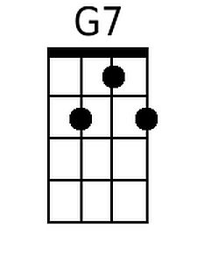
 |  |  |  |  |  |  |  |  | 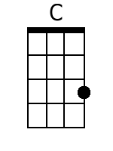
Baritone |  |  |  | 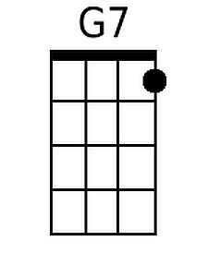 |  | 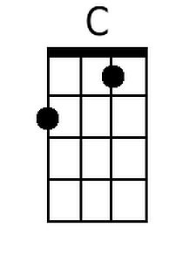

The Boy from New York City (George Davis & John T. Taylor, 1964)
The Ad Libs (1964); The Manhattan Transfer (1981) – Key of G

Intro: | G C | G7 | C | (2x)  Chorus  G C G7 C  Oo-wah oo-wah, cool cool kitty,  G C  Tell us about the boy  G7 C  From New York City.  (2x first and last times)  G C G7 C  He's kinda tall.  G C G7 C  He's really fine. (yeah, yeah)  G C G7 C  Some-day I hope to make him mine,  G C G7 C  All mine. (yeah, yeah)  C F  And he's neat  C7 F C F C7 F  __ and oh, so sweet.  G C G7  And just the way he looked at me  C G C G7 C  Swept me off my feet. (yeah, yeah)  D7 C7  Ooh ee, you ought to come and see  G C G7  How he walks, (yeah, yeah)  C G C G7 C  __ And he talks. Chorus  G C G7 C  He's really down.  G C G7 C  And he's no clown. (yeah, yeah)  G C  He has the finest penthouse  G7 C G C G7 C  I've ever seen in town. (yeah, yeah) |  |  |  |  | C F C F C7  And he's cute in his mohair suit.  F G C  __ And he keeps his pockets  G7 C G C G7 C  Full of spending loot. (yeah, yeah)  D7 C7  Ooh ee you ought to come and see  G C G7  his pretty bar,  C G C G7  And his brand new car.  C F C7 F  Every time he says he loves me,  G C G7 C  chills run down my spine.  C F C7 F  Every time he wants to kiss me, ooh ,  A7 D7  he makes me feel so fine. Yeah! Chorus  C7 G C G7  He can dance,  C G C G7  __ and make ro-mance.  C G C G7  And that’s when I fell in love  C G C G7  with just one glance.  C F C G7  He was shy,  F C F C7 F  and so was I.  G C  And now I know we'll never  G7 C G C G7 C  ever say good bye.  D7 C7  Oo ee you ought to come and see  G C G7  he's the most  C G C G7 C  __ from coast to coast. Chorus (2x)
 |  |  |  |  |  |  |  |  | 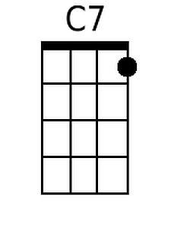
 |  |  |  |  |  |  |  |  | 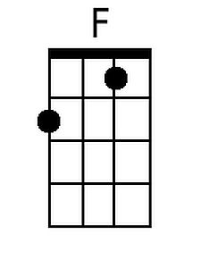
Baritone |  |  |  | 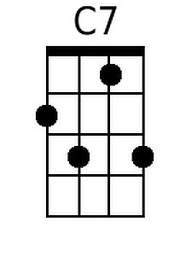 |  | 