The Brand New Tennessee Waltz (Jesse Winchester)

Intro: F /// /// C /// /// G7 /// /// C ////  C F C  Oh my, but you have a pretty face, you favor I girl that I knew.  F C G C  I imagine that she's back in Tennessee, and by God, I should be there too;  G7 C  I've a sadness too sad to be true  C F C  But I left Tennessee in a hurry dear, the same way that I'm leaving you  F C G C  ‘Cause love is mainly just memories, and everyone's got him a few;  G7 C - C7  So when I'm gone I'll be glad to love you  Chorus  F C G  At the Brand New Tennessee Waltz, you're lit’rally waltzing on air  F C G7 C  At the Brand New Tennessee Waltz, there's no telling who will be there.  C F C  When I leave it will be like I found you love, de-scending Victorian stairs  F C  And I'm feeling like one of your photographs,  G C  where I’m trapped while I’m putting on airs;  G7 C C7  So I’ll get even by saying who cares? Chorus  C F C  So have all of your passionate violins, play a tune for a Tennessee kid  F C G C  Who's feeling like leaving another town, but with no place to go if he did;  G7 C C7  ‘Cause they'll catch you wherever you're hid. Chorus  Outro: C/// G7/// C/// C7/// F /// G7 /// C / - G7/ C/ |  |  |  |  |  |  |  | 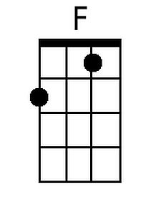
 |  |  |  |  |  |  |  | 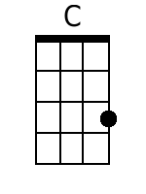
 |  |  |  |  |  |  |  | 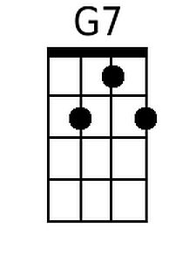
 |  |  |  |  |  |  |  | 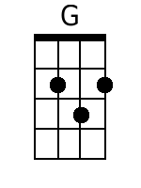
 |  |  |  |  |  |  |  | 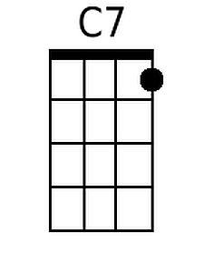
Baritone
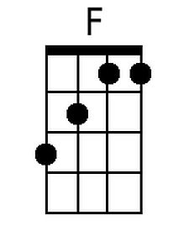 | 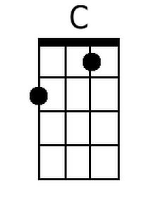 | 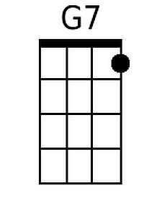 | 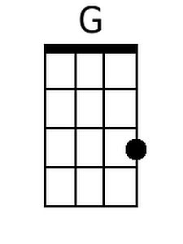 | 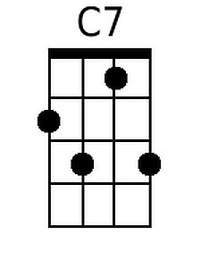

The Brand New Tennessee Waltz (Jesse Winchester)

Intro: C /// /// G /// /// D7 /// /// G ////

G C G
Oh my, but you have a pretty face, you favor I girl that I knew.
C G D G
I imagine that she's back in Tennessee, and by God, I should be there too;
D7 G
I've a sadness too sad to be true

G C G
But I left Tennessee in a hurry dear, the same way that I'm leaving you
C G D G
'Cause love is mainly just memories, and everyone's got him a few;
D7 G - G7
So when I'm gone I'll be glad to love you

Chorus
C G D
At the Brand New Tennessee Waltz, you're lit'rally waltzing on air
C G D7 G
At the Brand New Tennessee Waltz, there's no telling who will be there.

G C G
When I leave it will be like I found you love, de-scending Victorian stairs
C G
And I'm feeling like one of your photographs,
D G
where I'm trapped while I'm putting on airs;
D7 G G7
So I'll get even by saying who cares? Chorus

G C G
So have all of your passionate violins, play a tune for a Tennessee kid
C G D G
Who's feeling like leaving another town, but with no place to go if he did;
D7 G G7
'Cause they'll catch you wherever you're hid. Chorus

Outro: C/// G7/// C/// C7/// F /// G7 /// C / - G7/ C/

 |  |  |  |  |  |  |  | 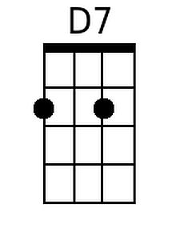
 |  |  |  |  |  |  |  | 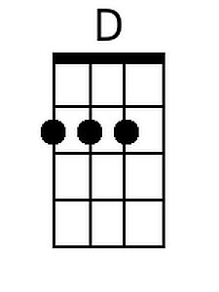
Baritone
 |  | 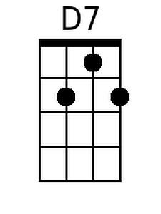 | 