
The Christmas Song
C79 C
(Mel Torme and Robert Wells, 1945) – The Christmas Song by Nat King Cole (1946, 1961)

Intro Last two lines of first verse  C Dm Em Am  Chestnuts roasting on an open fire  C C7 F E7  Jack Frost nipping at your nose  Am Fm C B7  Yuletide carols being sung by a choir  Em A7 Dm G  And folks dressed up like Eskimos  C Dm Em Am  Everybody knows a turkey and some mistletoe  C C7 F E7  Help to make the season bright  Am Fm C B7  Tiny tots with their eyes all aglow  Em Am F G7 C  Will find it hard to sleep to- night  Bridge  Gm C Gm C  They know that San-ta's on his way  Gm C F  He’s loaded lots of toys and goodies in his sleigh  Fm Eb  And every mother’s child is gonna spy  Am D7 F G7  To see if Reindeer really know how to fly  C Dm Em Am  And so I’m offering this simple phrase  C C7 F E7  To kids from one to ninety-two  Am Fm C B7  Although it’s been said many times many ways -  F C G7 C  Merry Christmas to __ you.  Repeat from Bridge  Am Fm C B7  Although it’s been said many times many ways  F C F C  Merry Christmas, Merry Christmas,  F C G7 C  Merry Christmas - to - you | 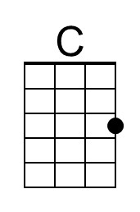 | 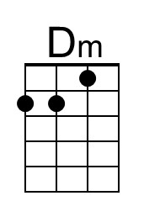 | 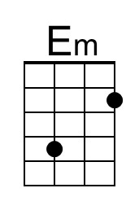 | 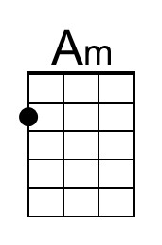
 | 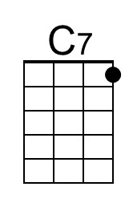 | 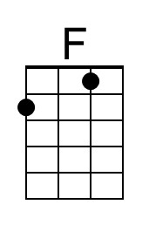 | 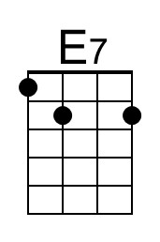 | 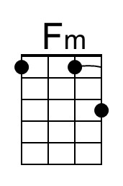
 | 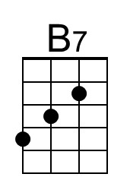 | 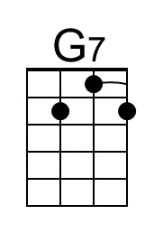 | 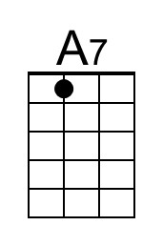 | 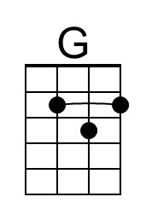
 | 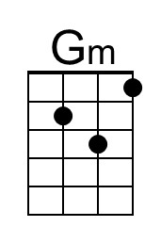 | 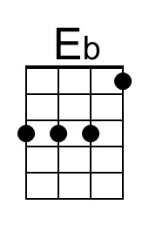 | 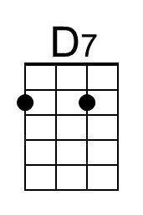
 | 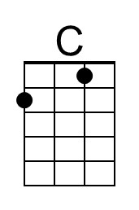 | 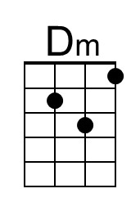 | 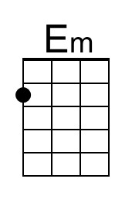 | 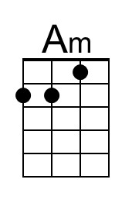
 | 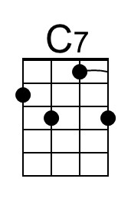 | 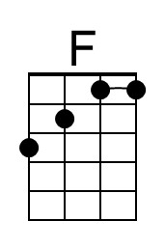 | 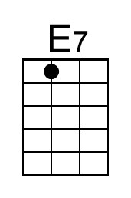 | 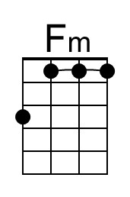
 | 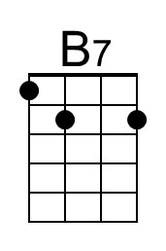 | 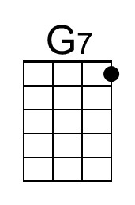 | 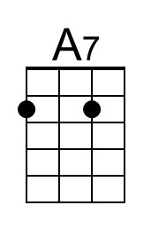 | 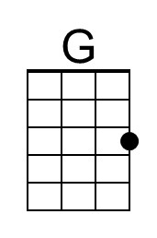
 | 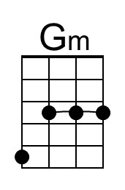 | 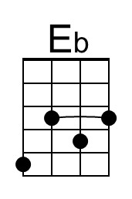 | 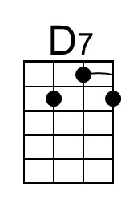

The Christmas Song
C79 G
(Mel Torme and Robert Wells, 1945) – The Christmas Song by Nat King Cole (1946, 1961)

Intro Last two lines of first verse  G Am Bm Em  Chestnuts roasting on an open fire  G G7 C B7  Jack Frost nipping at your nose  Em Cm G F#7  Yuletide carols being sung by a choir  Bm E7 Am D  And folks dressed up like Eskimos  G Am Bm Em  Everybody knows a turkey and some mistletoe  G G7 C B7  Help to make the season bright  Em Cm G F#7  Tiny tots with their eyes all aglow  Bm Em C D7 G  Will find it hard to sleep to- night  Bridge  Dm G Dm G  They know that San-ta's on his way  Dm G C  He’s loaded lots of toys and goodies in his sleigh  Cm Bb  And every mother’s child is gonna spy  Em A7 C D7  To see if Reindeer really know how to fly  G Am Bm Em  And so I’m offering this simple phrase  G G7 C B7  To kids from one to ninety-two  Em Cm G F#7  Although it’s been said many times many ways -  C G D7 G  Merry Christmas to __ you.  Repeat from Bridge  Em Cm G F#7  Although it’s been said many times many ways  C G C G  Merry Christmas, Merry Christmas,  C G D7 G  Merry Christmas - to - you |  |  | 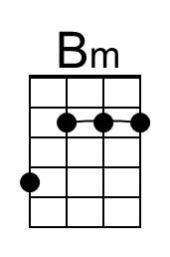
 |  |  |  | 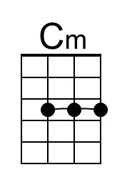
 | 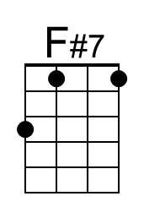 |  |  | 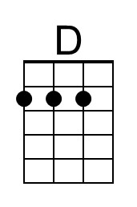
 |  | 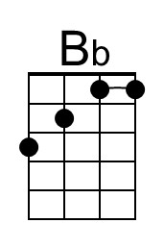
 |  |  | 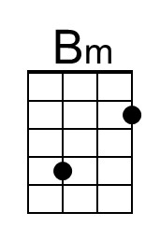
 |  |  |  | 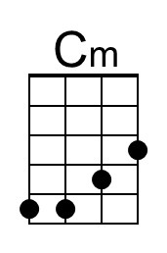
 | 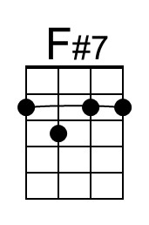 |  |  | 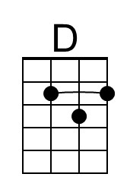
 |  | 