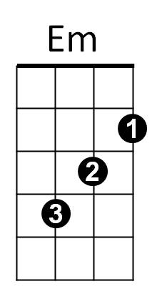**The Christmas Song (Mel Torme and Robert Wells) Key C**



G

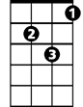

Gm

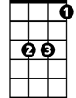

Eb

F



E7

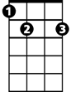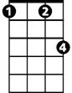

Fm

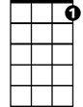

C7

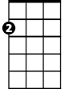

Am

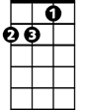

Dm



C

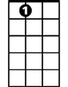

A7

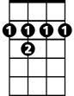

B7

**C Dm Em Am**

Chestnuts roasting on an open fire

**C C7 F E7**

Jack Frost nipping at your nose

**Am Fm C B7**

Yuletide carols being sung by a choir

**Em A7 Dm G**

And folks dressed up like Eskimos

**C Dm Em Am**

Everybody knows a turkey and some mistletoe

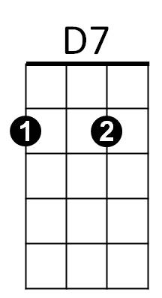**C C7 F E7**

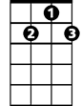

G7

Help to make the season bright

**Am Fm C B7**

Tiny tots with their eyes all aglow

**Em Am F G7 C**

Will find it hard to sleep to- night

**Bridge:**



F



E7

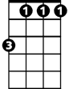

Fm



Am



Em



Dm

C



**BARITONE**

**Gm C Gm C**

They know that San-ta's on his way

**Gm C F**

He’s loaded lots of toys and goodies in his sleigh

**Fm Eb**

And every mother’s child is gonna spy

**Am D7 F G7**

To see if Reindeer really know how to fly

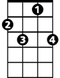

C7

**C Dm Em Am**

And so I’m offering this simple phrase

**C C7 F E7**

To kids from one to ninety-two

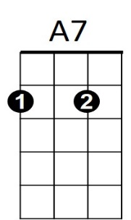 **Am Fm C B7**

B7



G



G7

Although it’s been said many times many ways -

**F C G7 C**

Merry Christmas to you

**Repeat from Bridge**



D7

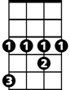

Eb

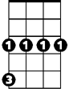

Gm

**Am Fm C B7**

Although it’s been said many times many ways

**F C F C**

Merry Christmas, Merry Christmas,

**F C G7 C**

Merry Christmas - to - you