The Coventry Carol (Am)
Words Attributed to Robert Croo, 1534; English Melody, 1591

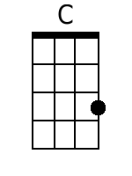  Am Em Am Dm E Am Dm E7 Am  1. Lullay, Thou little tiny Child, By, by, lul - ly, lul - lay.  C G Am E Am Dm E Am Dm E A  Lul- lay, Thou lit- tle tiny Child. By, by, lul - ly, lul-lay.  Am Em Am Dm E Am Dm E7 Am  2. O sisters, too, how may we do, For to pre-serve this day;  C G Am E Am Dm E Am Dm E A  This poor Young-ling for whom we sing, By, by, lul-ly, lul-lay.  Am Em Am Dm E Am Dm E7 Am  3. Herod the King, in his rag-ing, Charged he hath this day;  C G Am E Am Dm E Am Dm E A  His men of might, in his own sight, All children young, to slay.  Am Em Am Dm E Am Dm E7 Am  4. Then woe is me, poor Child, for Thee, And ever mourn and say;  C G Am E Am Dm E Am Dm E A  For Thy part-ing, nor say nor sing, By, by, lul - ly, lul-lay. |  |  |  |  |  |  | 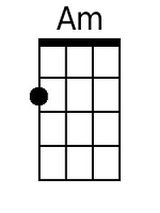 |  | 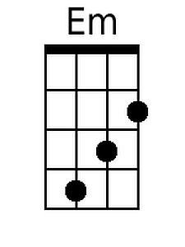
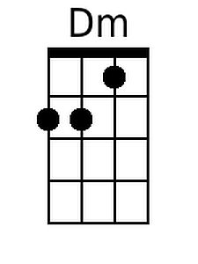
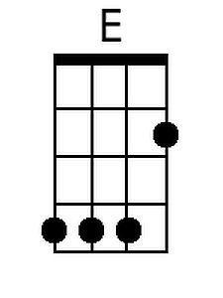
 |  |  |  |  |  |  | 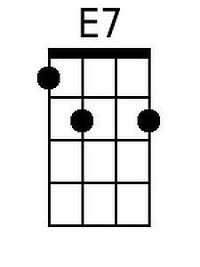
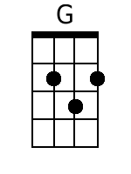
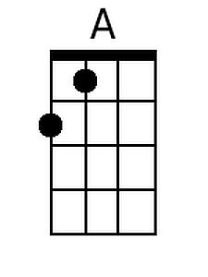
Baritone
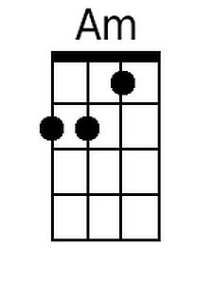 | 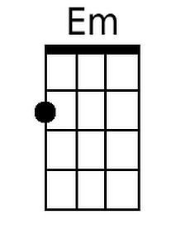 | 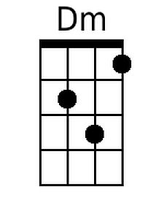 | 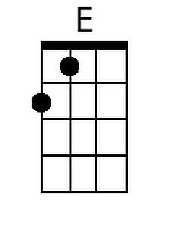 | 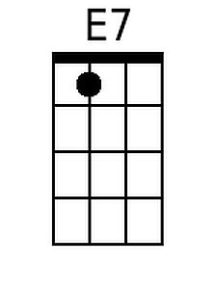 | 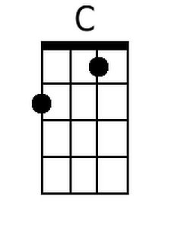 | 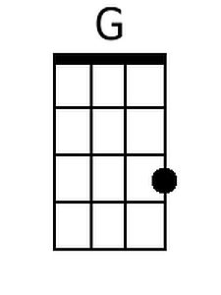 |  | 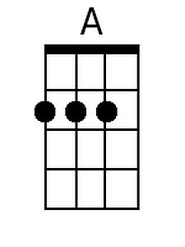

The Coventry Carol (Em)
Words Attributed to Robert Croo, 1534; English Melody, 1591

Em Bm Em Am B Em Am B7 Em  1. Lullay, Thou little tiny Child, By, by, lul - ly, lul - lay.  G D Em B Em Am B Em Am B E  Lul- lay, Thou lit- tle tiny Child. By, by, lul - ly, lul-lay.  Em Bm Em Am B Em Am B7 Em  2. O sisters, too, how may we do, For to pre-serve this day;  G D Em B Em Am B Em Am B E  This poor Young-ling for whom we sing, By, by, lul-ly, lul-lay.  Em Bm Em Am B Em Am B7 Em  3. Herod the King, in his rag-ing, Charged he hath this day;  G D Em B Em Am B Em Am B E  His men of might, in his own sight, All children young, to slay.  Em Bm Em Am B Em Am B7 Em  4. Then woe is me, poor Child, for Thee, And ever mourn and say;  G D Em B Em Am B Em Am B E  For Thy part-ing, nor say nor sing, By, by, lul - ly, lul-lay. |  |  |  |  |  |  |  | 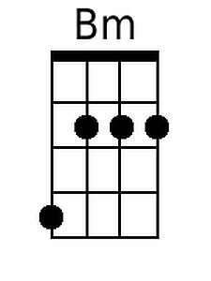
 |  |  |  |  |  |  | 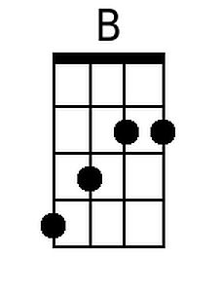
 |  |  |  |  |  |  | 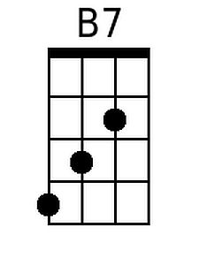
 |  |  |  |  |  |  | 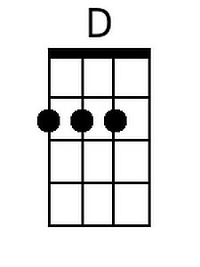
Baritone
 | 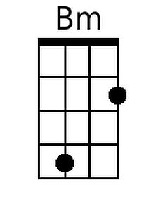 |  | 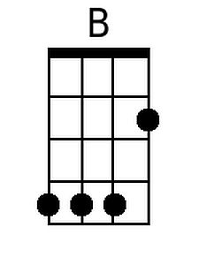 | 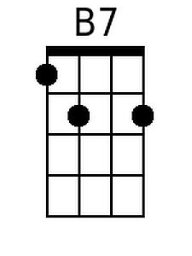 |  | 