The Coventry Carol (Am)
Words Attributed to Robert Croo, 1534; English Melody, 1591 (¾ Time)

Intro: Strum in on Am  Am Dm E7 Am Dm E7 Am  1. Lullay, Thou little tiny Child, By, by, lul - ly, lul - lay.  G Dm E7 Am Dm A  Lul- lay, Thou lit- tle tiny Child. By, by, lul - ly, lul-lay.  Am Dm E7 Am Dm E7 Am  2. O sisters, too, how may we do, For to pre-serve this day;  G Dm E7 Am Dm A  This poor Young-ling for whom we sing, By, by, lul-ly, lul-lay.  Am Dm E7 Am Dm E7 Am  3. Herod the King, in his rag-ing, Charged he hath this day;  G Dm E7 Am Dm A  His men of might, in his own sight, All children young, to slay.  Am Dm E7 Am Dm E7 Am  4. Then woe is me, poor Child, for Thee, And ever mourn and say;  G Dm E7 Am Dm A  For Thy part-ing, nor say, nor sing, By, by, lul - ly, lul-lay. |  |  |  |  |  |  | 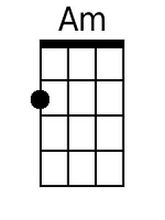 |  | 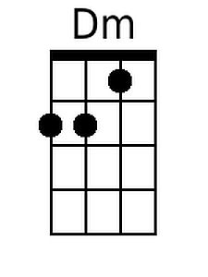
 |  |  |  |  |  |  | 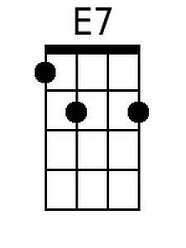 |  |  | 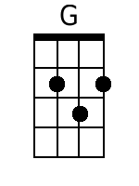
 |  |  |  |  |  |  | 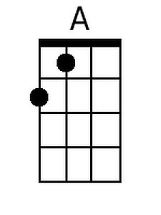
Baritone
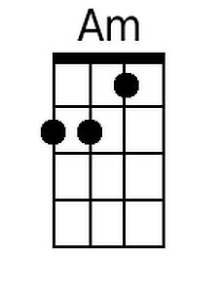 | 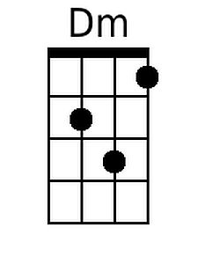 | 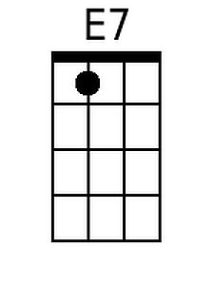 | 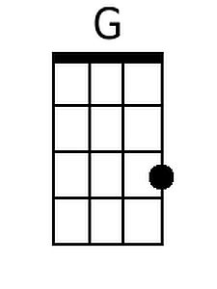 | 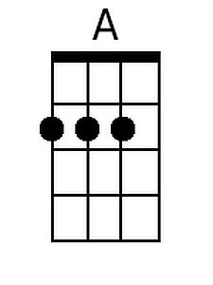

The Coventry Carol (Dm)
Words Attributed to Robert Croo, 1534; English Melody, 1591 (¾ Time)

Intro: Strum in on Dm  Dm Gm A7 Dm Gm A7 Dm  1. Lullay, Thou little tiny Child, By, by, lul - ly, lul - lay.  C Gm A7 Dm Gm D  Lul- lay, Thou lit- tle tiny Child. By, by, lul - ly, lul-lay.  Dm Gm A7 Dm Gm A7 Dm  2. O sisters, too, how may we do, For to pre-serve this day;  C Gm A7 Dm Gm D  This poor Young-ling for whom we sing, By, by, lul-ly, lul-lay.  Dm Gm A7 Dm Gm A7 Dm  3. Herod the King, in his rag-ing, Charged he hath this day;  C Gm A7 Dm Gm D  His men of might, in his own sight, All children young, to slay.  Dm Gm A7 Dm Gm A7 Dm  4. Then woe is me, poor Child, for Thee, And ever mourn and say;  C Gm A7 Dm Gm D  For Thy part-ing, nor say, nor sing, By, by, lul - ly, lul-lay. |  |  |  |  |  |  |  | 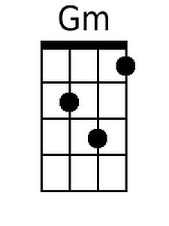
 |  |  |  |  |  |  | 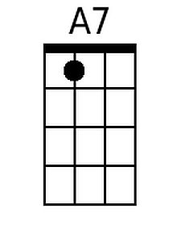 | 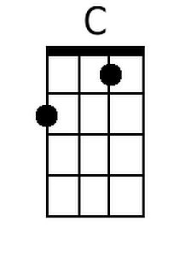
 |  |  |  |  |  |  | 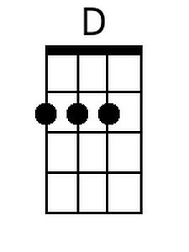
Baritone
 | 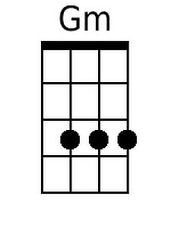 | 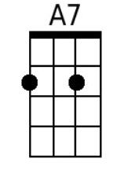 |  | 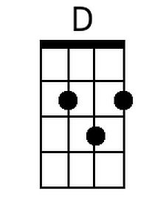

The Coventry Carol (Em)
Words Attributed to Robert Croo, 1534; English Melody, 1591 (¾ Time)

Intro: Strum in on Em  Em Am B7 Em Am B7 Em  1. Lullay, Thou little tiny Child, By, by, lul - ly, lul - lay.  D Am B7 Em Am E  Lul- lay, Thou lit- tle tiny Child. By, by, lul - ly, lul-lay.  Em Am B7 Em Am B7 Em  2. O sisters, too, how may we do, For to pre-serve this day;  D Am B7 Em Am E  This poor Young-ling for whom we sing, By, by, lul-ly, lul-lay.  Em Am B7 Em Am B7 Em  3. Herod the King, in his rag-ing, Charged he hath this day;  D Am B7 Em Am E  His men of might, in his own sight, All children young, to slay.  Em Am B7 Em Am B7 Em  4. Then woe is me, poor Child, for Thee, And ever mourn and say;  D Am B7 Em Am E  For Thy part-ing, nor say, nor sing, By, by, lul - ly, lul-lay. |  |  |  |  |  |  | 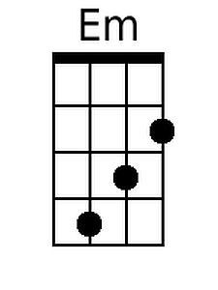
 |  |  |  |  |  |  | 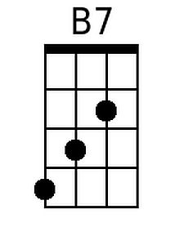
 |  |  |  |  |  |  | 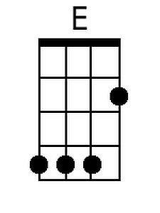
Baritone
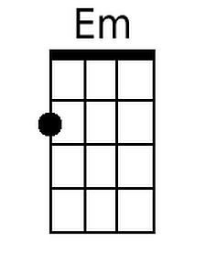 |  | 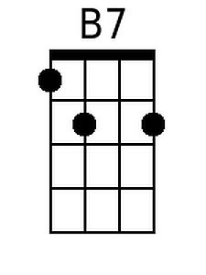 |  | 