The Coventry Carol (Am)
Words Attributed to Robert Croo, 1534; English Melody, 1591 (¾ Time)

  Am Dm E7 Am Dm E7 Am  1. Lullay, Thou little tiny Child, By, by, lul - ly, lul - lay.  G Dm E7 Am Dm A  Lul- lay, Thou lit- tle tiny Child. By, by, lul - ly, lul-lay.  Am Dm E7 Am Dm E7 Am  2. O sisters, too, how may we do, For to pre-serve this day;  G Dm E7 Am Dm A  This poor Young-ling for whom we sing, By, by, lul-ly, lul-lay.  Am Dm E7 Am Dm E7 Am  3. Herod the King, in his rag-ing, Charged he hath this day;  G Dm E7 Am Dm A  His men of might, in his own sight, All children young, to slay.  Am Dm E7 Am Dm E7 Am  4. Then woe is me, poor Child, for Thee, And ever mourn and say;  G Dm E7 Am Dm A  For Thy part-ing, nor say, nor sing, By, by, lul - ly, lul-lay. |  |  |  |  |  |  |  |  | 


 |  |  |  |  |  |  | 


Baritone
 |  |  | 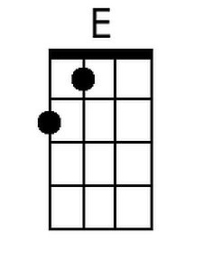 |  |  |  |  | 

The Coventry Carol (Em)
Words Attributed to Robert Croo, 1534; English Melody, 1591

Em Bm Em Am B Em Am B7 Em  1. Lullay, Thou little tiny Child, By, by, lul - ly, lul - lay.  G D Em B Em Am B Em Am B E  Lul- lay, Thou lit- tle tiny Child. By, by, lul - ly, lul-lay.  Em Bm Em Am B Em Am B7 Em  2. O sisters, too, how may we do, For to pre-serve this day;  G D Em B Em Am B Em Am B E  This poor Young-ling for whom we sing, By, by, lul-ly, lul-lay.  Em Bm Em Am B Em Am B7 Em  3. Herod the King, in his rag-ing, Charged he hath this day;  G D Em B Em Am B Em Am B E  His men of might, in his own sight, All children young, to slay.  Em Bm Em Am B Em Am B7 Em  4. Then woe is me, poor Child, for Thee, And ever mourn and say;  G D Em B Em Am B Em Am B E  For Thy part-ing, nor say nor sing, By, by, lul - ly, lul-lay. |  |  |  |  |  |  |  | 
 |  |  |  |  |  |  | 
 |  |  |  |  |  |  | 
 |  |  |  |  |  |  | 
Baritone
 |  |  | 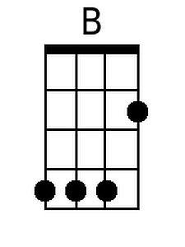 |  |  | 

