The Dock of the Bay (Otis Redding & Steve Cropper, 1967) (C)
(Sittin' On) The Dock of the Bay by Otis Redding (1967)

Intro (4 measures) C  C E7  Sittin' in the morning sun  F E Eb D  I'll be sittin' in the eve-n- ing come  C E7  Watching the ships roll in,  F E Eb D  Then I watch them roll a-wa-ay a - gain, yeah  Chorus 1  C A7  I'm sittin' on the dock of the bay  C A7  Watching the tide roll away  C D  Ooh I'm just sittin' on the dock of the bay  C A7  Wasti ng ti---ime.  C E7  I left my home in Georgia  F E Eb D  Headed for the Fris-co bay  C E7  'Cause I've had nothing to live for  F E Eb D  And look like nothing's gonna co-me my way.  Chorus 1  Bridge  C G F  Look like nothing's gonna change  C G F  Everything still remains the same  C G F  I can't do what ten people tell me to do  Bb G  So I guess I'll re-main the same |  |  |  |  | C E7  Sittin' here resting my bones  F E Eb D  And this loneliness won't leave me a - lone  C E7  These two thousand miles I roamed  F E Eb D  Just to make this do-ck my home.  Chorus 2  C A7  Now I'm just gonna sit at the dock of the bay  C A7  Watching the tide roll away, oooh  C D  Sittin' on the dock of the bay  C A7  Wasting ti---ime  Outro  whistle and fade out (kazoos?)
 |  |  |  |  | 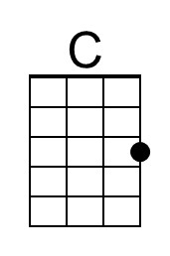 |  | 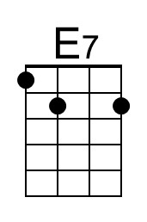 |  | 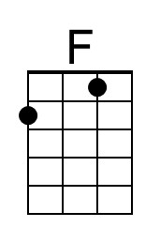 |  | 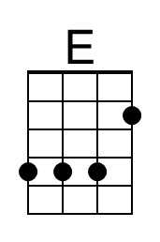
 |  |  |  |  | 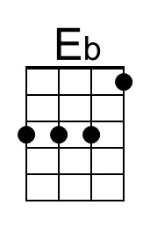 |  | 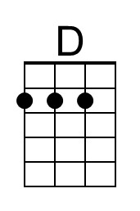 |  | 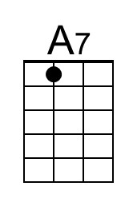 |  | 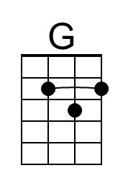
 |  |  |  |  | 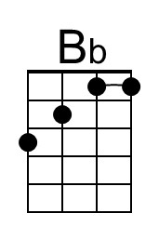
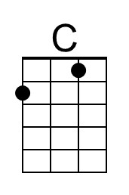 | 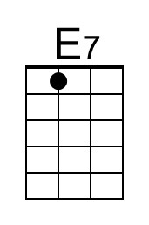 | 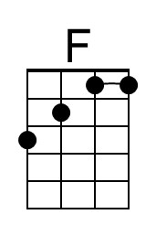 | 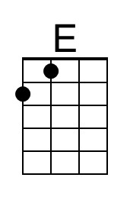 | 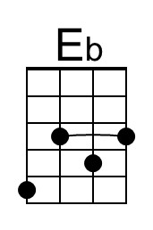 |  | 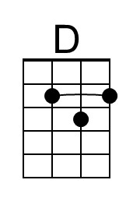 |  | 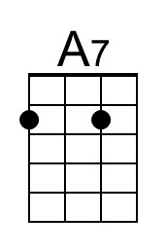 |  | 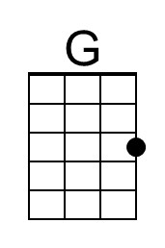 |  | 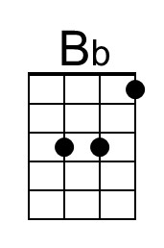

The Dock of the Bay (Otis Redding & Steve Cropper, 1967) (D)
(Sittin' On) The Dock of the Bay by Otis Redding (1967)

Intro (4 measures) D  D F#7  Sittin' in the morning sun  G F# F E  I'll be sittin' in the eve-n- ing come  D F#7  Watching the ships roll in,  G F# F E  Then I watch them roll a-wa-ay a - gain, yeah  Chorus 1  D B7  I'm sittin' on the dock of the bay  D B7  Watching the tide roll away  D E  Ooh I'm just sittin' on the dock of the bay  D B7  Wasti ng ti---ime  D F#7  I left my home in Georgia  G F# F E  Headed for the Fris-co bay  D F#7  'Cause I've had nothing to live for  G F# F E  And look like nothing's gonna co-me my way.  Chorus 1  Bridge  D A G  Look like nothing's gonna change  D A G  Every-thing still remains the same  D A G  I can't do what ten people tell me to do  C A  So I guess I'll remain the same |  |  |  |  | D F#7  Sittin' here resting my bones  G F# F E  And this loneliness won't leave me a - lone  D F#7  These two thousand miles I roamed  G F# F E  Just to make this do-ck my home.  Chorus 2  D B7  Now I'm just gonna sit at the dock of the bay  D B7  Watching the tide roll away, oooh  D E  Sittin' on the dock of the bay  D B7  Wasting ti---ime  Outro  whistle and fade out (kazoos?)
 |  |  |  |  |  |  | 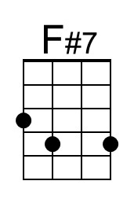 |  |  |  | 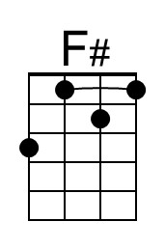
 |  |  |  |  |  |  |  |  | 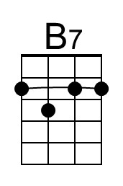 |  | 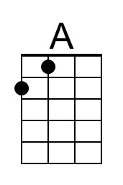
 | 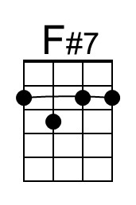 |  | 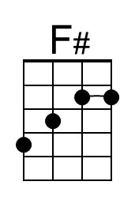 |  |  |  |  | 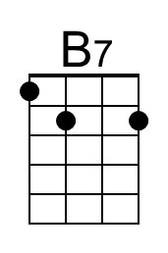 |  | 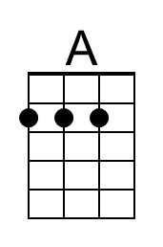

The Dock of the Bay (Otis Redding & Steve Cropper, 1967) (G)
(Sittin' On) The Dock of the Bay by Otis Redding (1967)

Intro (4 measures) G  G B7  Sittin' in the morning sun  C B Bb A  I'll be sittin' in the eve-n- ing come  G B7  Watching the ships roll in,  C B Bb A  Then I watch them roll a-wa-ay a - gain, yeah  Chorus 1  G E7  I'm sittin' on the dock of the bay  G E7  Watching the tide roll away  G A  Ooh I'm just sittin' on the dock of the bay  G E7  Wasti ng ti---ime.  G B7  I left my home in Georgia  C B Bb A  Headed for the Fris-co bay  G B7  'Cause I've had nothing to live for  C B Bb A  And look like nothing's gonna co-me my way.  Chorus 1  Bridge  G D C  Look like nothing's gonna change  G D C  Everything still remains the same  G D C  I can't do what ten people tell me to do  F D  So I guess I'll remain the same |  |  |  |  | G B7  Sittin' here resting my bones  C B Bb A  And this loneliness won't leave me a - lone  G B7  These two thousand miles I roamed  C B Bb A  Just to make this do-ck my home.  Chorus 2  G E7  Now I'm just gonna sit at the dock of the bay  G E7  Watching the tide roll away, oooh  G A  Sittin' on the dock of the bay  G E7  Wasting ti---ime  Outro  whistle and fade out (kazoos?)
 |  |  |  |  |  |  |  |  |  |  | 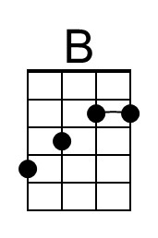
 |  |  | 