The Drinkin' Gourd
(The Muddy Road To Freedom)
By Nick Woods and Randy Sparks
Key of Am (Original Key of Dm). 4/4 Time. Ukulele.
Available at YouTube: https://www.youtube.com/watch?v=EEYB26pshOA

Note:

This version, by Randy Sparks, was based on a song sung by a black street singer in his seventies named John Woodum in Bossier City, Louisiana (near Shreveport) in 1955. This version differs considerably from the version recorded by Lee Hays of the Weavers; that set of lyrics is very close to the lyrics published by H. B. Parks in the Texas Folk-lore Society (1928), collected from three sources in the 1910s. The Parks version was re-published by John and Alan Lomax in American Ballads and Folk Songs (1934).

There is an extensive history on the versions of “The Drinkin' Gourd” on-line at:
Follow The Drinking Gourd-A Cultural History, http://www.followthedrinkinggourd.org/index.htm

See Also C. A. Sanders' recounting of the history of this song at:
The True History of Follow the Drinking Gourd,
https://casanders.net/music-history/the-true-story-of-follow-the-drinking-gourd

Recorded by the New Christy Minstrels on their 1963 album Ramblin'.

The Drinkin' Gourd
(The Muddy Road To Freedom)
By Nick Woods and Randy Sparks (“Based in a traditional work.”)
Key of Am (Original Key of Dm). 4/4 Time. Ukulele.
Performed by The New Christy Minstrels on their album Ramblin' (1963)

GCEA  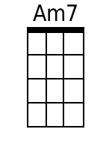 |  | Two Measure Introduction: Am7  D Am  Follow the drinkin' gourd,  D Am  Follow the drinkin' gourd,  C G Am E7  oo, ah,  F Am F Am6 F  Follow the drinkin' gourd.  Am F Am6 - F  Think I heard the angels say,  Am F Am6 F  Follow the drinkin' gourd.  C G Am Em  Stars in the heaven gonna show you the way,  Am Em Am F Am6 F  Follow the drinkin' gourd.  Am F Am6 F  Step by step, keep a-travelin' on.  Am -F Am6 F  Follow the drinkin' gourd.  C G Am Em  Sleep in the holler till the daylight is gone.  Am Em Am  Follow the drinkin' gourd.  Am Em Am  Follow the drinkin' gourd,  D Am  Follow the drinkin' gourd,  C G Am E  Keep on a-travelin' that muddy road to freedom.  || 2/4 ||  || 4/4 ||  F Am F Am6 F  Follow the drinkin' gourd.  Am F Am6 F  There's a great day comin' and it won't be long.  Am - F Am6 F  Follow the drinkin' gourd.  C G Am Em  All God's children gotta sing this song.  Am Em Am F Am6 F  Follow the drinkin' gourd.  Am F Am6 F  Follow that river till the clouds roll by;  Am - F Am6 F  Follow the drinkin' gourd.  C G Am Em  Keep on movin', better look to the sky.  Am Em Am  Follow the drinkin' gourd.  D Am  Follow the drinkin' gourd,  D Am  Follow the drinkin' gourd,  [Spoken]  C G  There's a little bit of heaven  Am E  in that muddy road to freedom.  F Am  Follow the drinkin' gourd.  C G Am E  Keep on a-travelin' that muddy road to freedom,  A D B7 E7 [Hold] [Retard]  Step by step, keep a-travelin' on.  F G A [Hold]  Follow the drinkin' gourd.
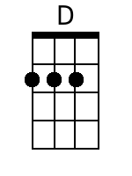  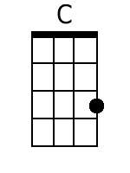  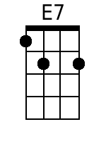  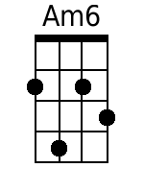  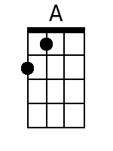  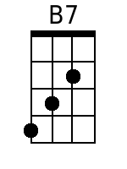 | 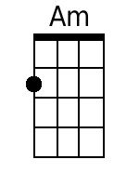  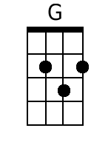  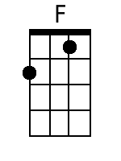  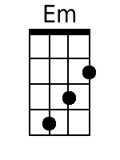  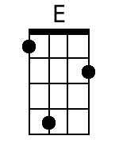
Bari

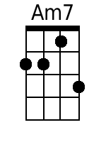
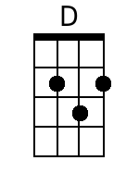  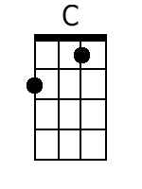  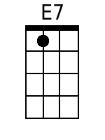  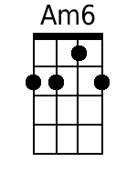  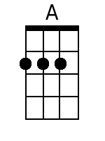  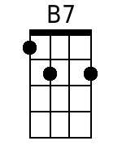 | 