The E-ri-e (Anonymous, 1800s)

Lyrics & Melody line at the Mudcat Cafe / The Digital Tradition
E-ri-e Canal

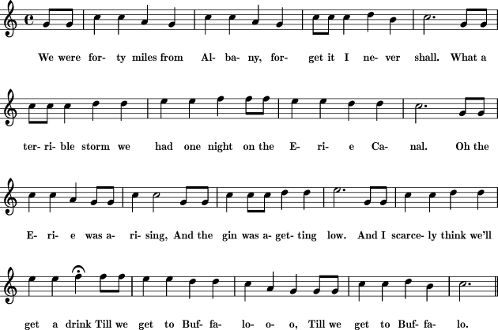

Thread at the Mudcat Cafe: Origins: The Erie Canal (E-Ri-E)

‘The E-ri-e’ from Traditional Ballad Index

The entry on this song from the Traditional Ballad Index:
http://www.fresnostate.edu/folklore/ballads/LxU045.html

E-ri-e, The
DESCRIPTION: About a "terrible storm" on the Erie Canal. "Oh, the E-ri-e was a-rising And the gin was a-getting low, And I scarcely think we'll get a little drink Till we get to Buffalo." Humorous anecdotes of a highly hazardous voyage
AUTHOR: unknown
EARLIEST DATE: 1927 (Sandburg-The American Songbag)
KEYWORDS: canal humorous cook animal wreck
HISTORICAL REFERENCES:
1825 - Erie Canal opens (construction began in 1817)
FOUND IN: US(MW) Canada(Mar)
REFERENCES (12 citations):
Creighton-MaritimeFolkSongs, p. 144, "It's Let Go Your Bowline" (1 text, 1 tune)
Thompson-BodyBootsAndBritches-NewYorkStateFolktales, pp. 245-246, "(no title)" (assorted excerpts; see also "Black Rock Pork" on pp. 243-244, which includes much of this song although without a chorus); pp. 250-251, "The E-ri-e" (1 text)
Sandburg-The American Songbag, p. 180, "The E-ri-e" (1 text, 1 tune)
Lomax/Lomax-FolkSong USA 45, "The E-ri-e" (1 text, 1 tune)
Lomax/Lomax-American Ballads And Folk Songs, pp. 470-471, "The E-ri-e" (1 text, 1 tune); see also pp. 455-457, "Ballad of the Erie Canal" (1 text, composite and probably containing stanzas which belong here); pp. 459-463, "The Erie Canal Ballad" (8 texts, some fragmentary, the fourth of which appears to belong here)
Cohen-AmericanFolkSongsARegionalEncyclopedia1, pp. 103-104, "The E-ri-e" (1 text)
Warner-FolkSongsAndBalladsOfTheEasternSeaboard, pp. 36-36, "The E-ri-e" (1 text)
Darling-NewAmericanSongster, pp. 333-335, "The Erie Canal" (1 text)
Arnett-IHearAmericaSinging, p. 56, "The Erie Canal" (1 text, 1 tune)
Seeger-AmericanFavoriteBallads, p. 87, "Erie Canal" (1 text, 1 tune)
Silber/Silber-FolksingersWordbook, p. 43, "E-ri-e" (1 text)
DT, ERICANL1 ERIECNL3*
Roud #6599
RECORDINGS:
Pete Seeger, "Erie Canal" (on PeteSeeger07, PeteSeeger07a)
CROSS-REFERENCES:
- cf. "The Raging Canal (I)" (plot)
- cf. "A Trip on the Erie (Haul in Your Bowline)" (plot)
- cf. "A Nautical Yarn" (theme)
- cf. "The Erie Canal"
- cf. "Black Rock Pork" (plot, lyrics)
- cf. "Canalman's Farewel (Lay Me on the Horse-Bridge)" (lyrics)
- cf. "The Calabar" (theme)
- cf. "Stormy Weather Boys" (subject)
- cf. "The Farmington Canal Song" (theme)
- cf. ""The Wreck of the Mary Jane"" (theme)
- cf. "The Wreck of the Varty" (theme)
- cf. "On Board the Bugaboo" (theme)
- cf. "Changing Berth" (theme)
- cf. "The Wreck of the Gwendoline" (theme)
- cf. "The Fish and Chip Ship" (theme)
- cf. "The Shipwreck on the Lagan Canal" (theme)
NOTES [222 words]: The Erie Canal, as originally constructed, was a completely flat, shallow waterway. The barges were drawn along by mules. Thus, apart from getting wet, storms posed little danger, and the only way one could run aground was to run into trash that had fallen into the canal.
As for needing a distress signal ("We h'isted (the cook) upon the pole
As a signal of distress"), one could always step off onto dry land....
The Lomaxes, in American Ballad and Folk Songs, thoroughly mingled many texts of the Erie Canal songs (in fairness, some of this may have been the work of their informants -- but in any case the Lomaxes did not help the problem). One should check all the Erie Canal songs for related stanzas.
Dan Milner, in the essay "Collecting Occupational Songs" in Scott B. Spencer, editor, The Ballad Collectors of North America, Scarecrow Press, 2012, pp. 198-199, observes that it is not known whether this song derives from the Harrigan and Hart piece "Buffalo" (printed 1878) or vice versa.
The song he refers to is "Oh! Dat Low Bridge!" (Finson-Edward-Harrigan-David-Braham, vol. II, #122, pp. 139-141) that begins "It's many miles to Buffalo, Oh, dat low bridge, Balky mule he travel slow, Oh, dat low bridge...." It also talks about the cook. How much inspiration flowed between that song and this I do not know. - RBW
Last updated in version 5.2#
File: LxU045

Notes:
The Harrigan-Hart-Braham song “Oh! Dat Low Bridge!” does not contain much in common with this version of the song. The link to the complete song (lyrics and music) is from the Library of Congress.

The E-ri-e
Carl Sandburg, The American Songbag (1927)

The page from Sandburg’s The American Songbag (1927), p. 180, is attached; it has three verses and the refrain. The song is contained in a section titled “Great Lakes and Erie Canal” that contains four other related songs including “The Erie Canal”, also attached. The American Songbag is in the public domain and is widely available; this link is to the Internet Archive.
His complete preface to the song:
When hard work and the monotony of life overshadowed the souls on the Erie Canal, the crew did what so many sailors and longshoremen ever have done. They took to drink and to song and to hopes for an end of the voyage, to voicing in a tune their feelings about how life used them up and left them unsung and unwept. The preacher, Koheleth, who sings so rhythmically in the Book of Ecclesiastes, ''Vanity of vanities, all is vanity/' or Omar in his short-spoken pessimism, arrive at a philosophy somewhat like that sung here. Some might call it "realistic in the method of approach." It tries for laughter at monotony and fate. We have this text and tune from Robert Wolfe and Oliver R. Barrett of Chicago. The canal's name is enunciated in three syllables, viz., "E-ri-e."
Sandburg noted, "We have this text and tune from Robert Wolfe and Oliver R. Barnett of Chicago." I was unable to determine the identities of Wolfe or Barnett. Here are the lyrics given by Sandburg:

1. We were forty miles from Albany,
Forget it I never shall,
What a terrible storm we had one night
On the E-ri-e Canal.

Refrain:
Oh the E-ri-e was a-rising
The gin was getting low
And I scarcely think
We'll get a drink
Till we get to Buffalo,
Till we get to Buffalo.
2. We were loaded down with barley,
We were chuck up full of rye;
And the captain he looked down at me
With his goddam wicked eye. Refrain:

3. Oh the girls are in the Police Gazette,
The crew are all in jail;
I'm the only living sea cook's son
That's left to tell the tale. Refrain:

