The Glow-Worm ("Das Glühwürmchen") (G)
Heinz Bolten-Backers, 1902; English lyrics by Lilla Cayley Robinson, ca. 1905
Expanded and revised by Johnny Mercer for The Glow-Worm by the Mills Brothers (1952)
Adaptation by Theresa Miller

Instrumental Intro Strum Pattern: D D u d d
G C Am G D7 G ↓ - D7 ↓
Light the path be-low, a-bove, and lead us on to love.

G D7 D G
Shine, little glow worm, glimmer, glimmer. Shine, little glow worm, glimmer, glimmer.
G D7 D G Gsus2 G
Lead us lest too far we wander. Love's sweet voice is calling yon - der.
G D7 D G
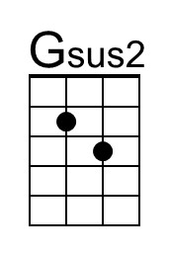
Shine, little glow worm, shimmer, shimmer. Hey there, don't get dimmer, dimmer.
G C Am G D7 G ↓ D7 ↓
Light the path be-low, a-bove. And lead us on to love.

G D7 G
Glow, little glow worm, fly of fire. Glow like an incan-descent wire.
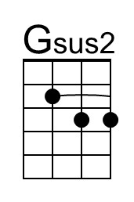
G D7 D G
Glow for the female of the species. Turn on the AC and the DC.
G D7 D G Gsus2 G
This night could use a little brightnin'. Light up, you little ol' bug of light - nin'.
G C Am G D7 G - D7
When you gotta glow, you gotta glow. Glow, little glow worm, glow.

G D7 G
Glow, little glow worm, glow and glimmer. Swim through the sea of night, little swimmer.
G D7 D G Gsus2 G
Thou aeronautical boll weevil. Illuminate yon woods pri - meval.
G D7 D G
See how the shadows deepen, darken. You and your chick should get to sparkin'.
G C Am G D7 G - D7
I got a gal that I love so. Glow, little glow worm, glow.

G D7 D G
Glow little glow worm, turn the key on. You are equipped with tail-light neon.
G D7 D G
You got a cute vest-pocket flasher. Which you can make both slow and faster.
G D7 D G Gsus2 G
I don't know who you took a shine to, or who you're out to make a sign to.
G C Am G D7 G
I got a gay that I love so. Glow, little glow worm, glow.
G D7 D G
Glow, little glow worm, glow.
G D7 D G
Ritard. Glow, little glow worm, glow.

Originally: “Mazda,” the name of a brand of light bulbs.

