**The Impossible Dream (Joe Darion / Mitchell Leigh) Key C**

**C Cmaj7**

To dream - the impossible dream

**F Dm**

To fight the unbeatable foe

**Em F**

To bear with unbearable sorrow

**Dm G**

To run where the brave dare not go

**C Cmaj7**

To right the un-rightable wrong

**F Dm**

To love pure and chaste from afar

**Em F**

To try when your arms are too weary

**Dm G**

To reach the unreachable star

**Chorus:**

**C Am**

This is my quest, to follow that star

**Em F**

No matter how hopeless, no matter how far

**Am**

To fight for the right –

**F**

Without question or pause

**C Am**

To be willing to march into Hell

**F Bb**

For a heavenly cause

**Dm Bb**

And I know if I'll only be true –

**Em**

To this glorious quest

**F Dm**

That my heart will lay peaceful and calm

**E7 G G7**

When I'm laid to my rest

**BARITONE**

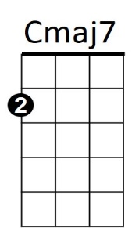

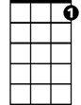

G7

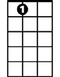

E7

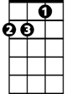

Am



F

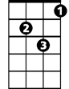

Dm

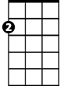

Em



G

C



**C Cmaj7**

And the world will be better for this

**F**

That one man,

**Dm**

Scorned and covered with scars

**Em F**

Still strove with his last ounce of courage

**Dm G**

To reach the unreachable star

**(Chorus)**

**C Cmaj7**

And the world will be better for this

**F**

That one man,

**Dm**

Scorned and covered with scars

**Em F**

Still strove with his last ounce of courage

**C Em C**

To reach the unreachable star

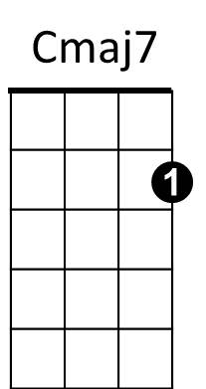



Am



Bb

E7

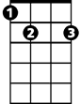

Em

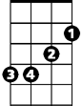

F



G



C



Dm

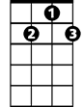

G7

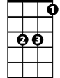

Bb

**The Impossible Dream (Joe Darion / Mitchell Leigh) Key G**

**G Gmaj7**

To dream - the impossible dream

**C Am**

To fight the unbeatable foe

**Bm C**

To bear with unbearable sorrow

**Am D**

To run where the brave dare not go

**G Gmaj7**

To right the un-rightable wrong

**C Am**

To love pure and chaste from afar

**Bm C**

To try when your arms are too weary

**Am D**

To reach the unreachable star

**Chorus:**

**G Em**

This is my quest, to follow that star

**Bm C**

No matter how hopeless, no matter how far

**Em**



G

To fight for the right –

**C**

Without question or pause

**G Em**

To be willing to march into Hell

Em



**C F**

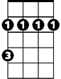

Bm

For a heavenly cause

**Am F**

And I know if I'll only be true –

**Bm**

To this glorious quest

**C Am**

That my heart will lay peaceful and calm

**B7 D D7**

When I'm laid to my rest

**BARITONE**



F

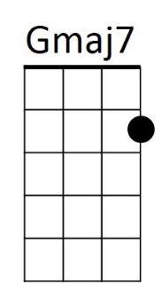



D

B7



Em

Bm



G



Am

C



**G Gmaj7**

And the world will be better for this

**C**

That one man,

**Am**

Scorned and covered with scars

**Bm C**

Still strove with his last ounce of courage

**Am D**

To reach the unreachable star

**(Chorus)**

**G Gmaj7**

And the world will be better for this

**C**

That one man,

**Am**

Scorned and covered with scars

**Bm C**

Still strove with his last ounce of courage

**G Bm G**

To reach the unreachable star

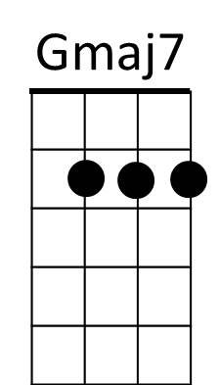

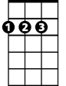

D



Am



C

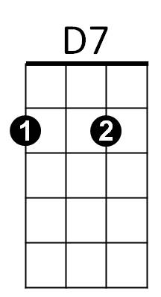

F



D7