
The Little Drummer Boy
C13 C
(Katherine K. Davis, 1941) – The Little Drummer Boy by the Jack Halloran Singers (1957)

Intro (Chords for first line of verse) C | F | C |  C F C | C |  Come, they told me, pa-rapa-pom-pom,  C F C | C |  _ A newborn king to see, pa-rapa-pom pom,  G C G | G |  _ Our finest gifts we bring, pa-rapa-pom-pom,  G7 C C7 F  _ To set be-fore the king, pa-rapa-pom-pom,  C G  Rapa-pom-pom, rapa-pom-pom.  C F C | C | G C  So to honour him, pa-rapa-pom-pom, when we come.  C F C | C |  Little Baby, pa-rapa-pom-pom,  C F C | C |  _ I am a poor boy, too, pa-rapa-pom-pom,  G C G | G |  _ I have no gift to bring, pa-rapa-pom-pom,  G7 C C7 F  _ That`s fit to give a king, pa-rapa-pom-pom,  C G  Rapa-pom-pom, rapa-pom-pom.  C F C | C | G C  Shall I play for you, pa-rapa-pom-pom, on my drum.  C F C | C |  Then He nodded, pa-rapa-pom-pom,  C F C | C |  _ The ox and lamb kept time, pa-rapa-pom-pom,  G C G | G |  _ I played my drum for him, pa-rapa-pom-pom,  G7 C C7 F  _ I played my best for him, pa-rapa-pom-pom,  C G  Rapa-pom-pom, rapa-pom-pom.  C F C | C | G C  Then he smiled at me, pa-rapa-pom-pom, me and my drum,  G C G C G C  Me and my drum, me and my drum, me and my drum. | 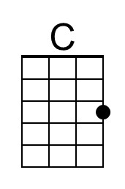 | 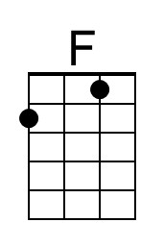
 | 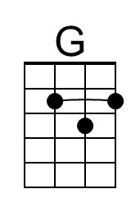 | 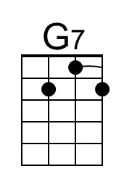
 | 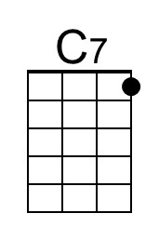
 | Baritone
 | 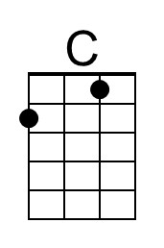 | 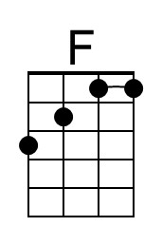
 | 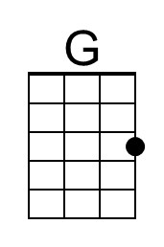 | 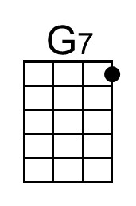
 | 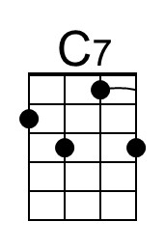

The Little Drummer Boy
C13 G
(Katherine K. Davis, 1941) – The Little Drummer Boy by the Jack Halloran Singers (1957)

Intro (Chords for first line of verse) G | C | G |

G C G | G |
Come, they told me, pa-rapa-pom-pom,
G C G | G |
_ A newborn king to see, pa-rapa-pom pom,
D G D | D |
_ Our finest gifts we bring, pa-rapa-pom-pom,
D7 G G7 C
_ To set be-fore the king, pa-rapa-pom-pom,
G D
Rapa-pom-pom, rapa-pom-pom.
G C G | G | D G
So to honour him, pa-rapa-pom-pom, when we come.

G C G | G |
Little Baby, pa-rapa-pom-pom,
G C G | G |
_ I am a poor boy, too, pa-rapa-pom-pom,
D G D | D |
_ I have no gift to bring, pa-rapa-pom-pom,
D7 G G7 C
_ That`s fit to give a king, pa-rapa-pom-pom,
G D
Rapa-pom-pom, rapa-pom-pom.
G C G | G | D G
Shall I play for you, pa-rapa-pom-pom, on my drum.

G C G | G |
Then He nodded, pa-rapa-pom-pom,
G C G | G |
_ The ox and lamb kept time, pa-rapa-pom-pom,
D G D | D |
_ I played my drum for him, pa-rapa-pom-pom,
D7 G G7 C
_ I played my best for him, pa-rapa-pom-pom,
G D
Rapa-pom-pom, rapa-pom-pom.
G C G | G | D G
Then he smiled at me, pa-rapa-pom-pom, me and my drum,
D G D G D G
Me and my drum, me and my drum, me and my drum.
 | 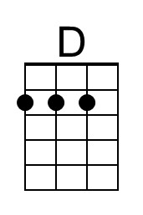 | 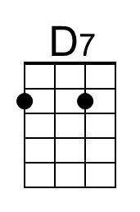
 | Baritone
 | 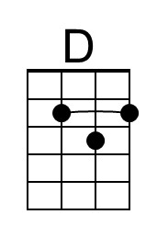 | 