**The Little Old Lady From Pasedena (Gary L Usher / Roger Christian) Key C**

**Intro: Eb G**

It's the little old lady from Pasadena

**C**

The little old lady from Pasadena

**F C**

(Go granny, go granny, go granny, go!)

**C**

Has a pretty little flower bed of white gardenias

**G D7 G**

(Go granny, go granny, go granny, go!)

**C Am F**

But parked in a rickety old garage

**Dm Bb G**

Is a brand new, shiny red, super-stock Dodge!

**Chorus:**

**C**

An d everybody's saying that there's nobody meaner

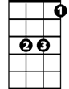

Eb

Than the little old lady from Pasadena

**F**

She drives real fast and she drives real hard

**C**

She's the terror of Colorado Boulevard

**Eb G**

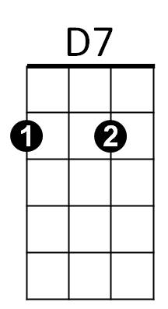It's the little old lady from Pasadena

**C**

If you see her on the street, don't try to choose her

**F C**

(Go granny, go granny, go granny, go!)

**C**

You might drive a goer but you'll never lose her

**G D7 G**

(Go granny, go granny, go granny, go!)

**C Am F**

She's gonna get a ticket now, sooner or later

**Dm Bb G**

'Cause she can't keep her foot off the accelerator!

**BARITONE**

**(Chorus)**

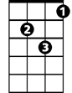

Dm

C



G

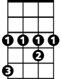

Eb

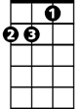

Am

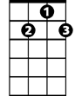

D7



F

**C**

*The little old lady from Pasadena*

**F C**

(Go granny, go granny, go granny, go!)

**C**

*Has a pretty little flower bed of white gardenias*

**G D7 G**

(Go granny, go granny, go granny, go!)

**C Am F**

The guys come to race her from miles around

**Dm Bb G**

But she'll give 'em a length, then she'll shut 'em down

**(Chorus)**

**2x C F C**

Go granny, go granny, go granny, go!

**G D7 G**

Go granny, go granny, go granny, go!

F



C



G



Bb



Dm

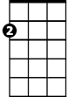

Am



Bb

. **The Little Old Lady From Pasedena (Gary L Usher / Roger Christian)**

**Bb D**

It's the little old lady from Pasadena

**G**

The little old lady from Pasadena

**C G**

(Go granny, go granny, go granny, go!)

**G**

Has a pretty little flower bed of white gardenias

**D A7 D**

(Go granny, go granny, go granny, go!)

**G Em C**

But parked in a rickety old garage

**Am F D**

Is a brand new, shiny red, super-stock Dodge!

**Chorus:**

**G**

And everybody's saying that there's nobody meaner

Than the little old lady from Pasadena

**C**

She drives real fast and she drives real hard

**G**

She's the terror of Colorado Boulevard

**Bb D**

It's the little old lady from Pasadena

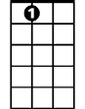

A7

**G**

If you see her on the street, don't try to choose her

**C G**

(Go granny, go granny, go granny, go!)

**G**

You might drive a goer but you'll never lose her

**D A7 D**

(Go granny, go granny, go granny, go!)

**G Em C**

She's gonna get a ticket now, sooner or later

**Am F D**

'Cause she can't keep her foot off the accelerator!



F

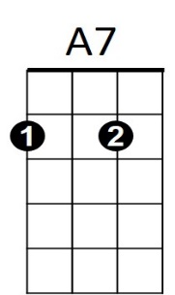



Am



Em

**BARITONE**



D



G



Bb

**(Chorus)**

C



**G**

*The little old lady from Pasadena*

**C G**

(Go granny, go granny, go granny, go!)

**G**

*Has a pretty little flower bed of white gardenias*

**D A7 D**

(Go granny, go granny, go granny, go!)

**G Em C**

The guys come to race her from miles around

**Am F D**

But she'll give 'em a length, then she'll shut 'em down

**(Chorus)**

**2x G C G**

Go granny, go granny, go granny, go!

**D A7 D**

Go granny, go granny, go granny, go!

. . .

.



G



Bb



C

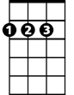

D

Em

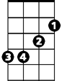

F



Am