The Long And Winding Road (McCartney & Lennon, 1968)
The Long And Winding Road by The Beatles – Key of Am

Am Em Dm7 C C7 F  The long and winding road, that leads to your door,  Em Am Dm7 G7 C - C7  Will never disap-pear __ I've seen that road be-fore.  F Em Am - Am7 Dm7 G7 C  _ It always leads me here Leads me to your door.  Am Em Dm7 C C7 F  The wild and windy night, that the rain washed a-way,  Em Am Dm7 G7 C - C7  Has left a pool of tears, __ Crying for the day.  F Em Am - Am7 Dm7 G7 C  _ Why leave me standing here? __ Let me know the way.  Bridge  C F C Dm7 G7  Many times I've been alone and many times I've cried  C F C Dm7 G7  Anyway you'll never know the many ways I've tried.  Am Em Dm7 C C7 F  And still they lead me back, to the long winding road,  Em Am Dm7 G7 C - C7  You left me standing here __ a long, long time a-go.  F Em Am - Am7 Dm7 G7 C  _Don't leave me waiting here, __ lead me to your door.  Instrumental Bridge  Am Em Dm7 C C7 F  And still they lead me back, to the long winding road,  Em Am Dm7 G7 C - C7  You left me standing here __ a long, long time a-go  F Em Am - Am7 Dm7 G7 C  _Don't keep me waiting here, __ lead me to your door.  Dm7 G C  Da, da, da, da-- |  |  |  |  |  |  | 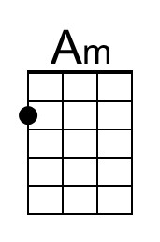 | 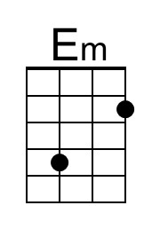
 |  |  |  |  |  |  | 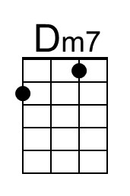 | 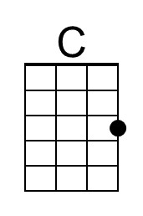
 |  |  |  |  |  |  | 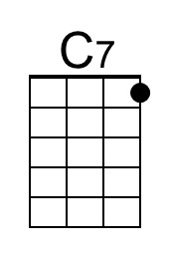 | 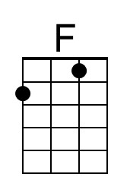
 |  |  |  |  |  |  | 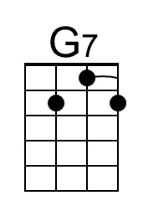 | 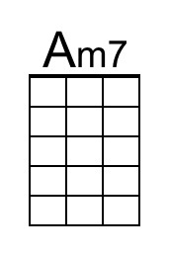
Bari | 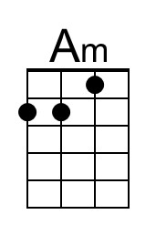 | 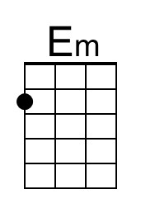 | 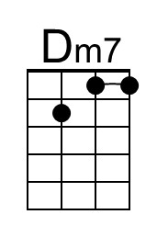 | 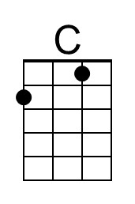 | 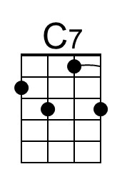 | 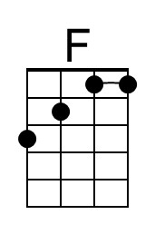 | 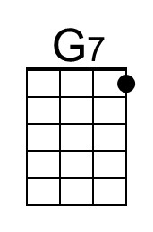 | 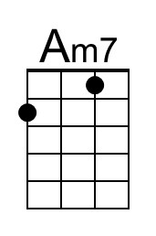

The Long And Winding Road (McCartney & Lennon, 1968)
The Long And Winding Road by The Beatles – Key of Em

Em Bm Am7 G G7 C  The long and winding road That leads to your door  Bm Em Am7 D7 G - G7  Will never disap-pear __ I've seen that road be-fore  C Bm Em - Em7 Am7 D7 G  _ It always leads me here Leads me to your door.  Em Bm Am7 G G7 C  The wild and windy night, That the rain washed a-way  Bm Em Am7 D7 G - G7  _Has left a pool of tears, __ Crying for the day  C Bm Em - Em7 Am7 D7 G  _Why leave me standing here? __ Let me know the way.  Bridge  G C G Am7 D7  Many times I've been alone and many times I've cried  G C G Am7 D7  Anyway you'll never know the many ways I've tried.  Em Bm Am7 G G7 C  And still they lead me back to the long winding road  Bm Em Am7 D7 G - G7  You left me standing here __ a long, long time a-go  C Bm Em - Em7 Am7 D7 G  _Don't leave me waiting here, __ lead me to your door  Instrumental Bridge  Em Bm Am7 G G7 C  And still they lead me back to the long winding road  Bm Em Am7 D7 G - G7  You left me standing here __ a long, long time a-go  C Bm Em - Em7 Am7 D7 G  _Don't keep me waiting here, __ lead me to your door  Am7 D G  Da, da, da, da-- |  |  |  |  |  |  |  | 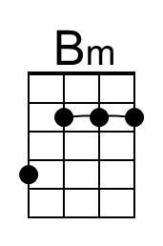
 |  |  |  |  |  |  |  | 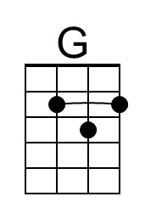
 |  |  |  |  |  |  | 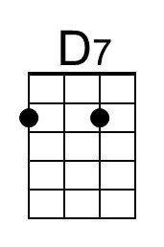 | 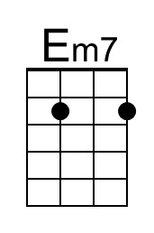
Bari |  | 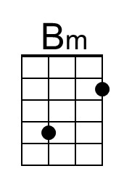 |  | 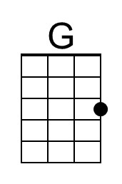 |  |  | 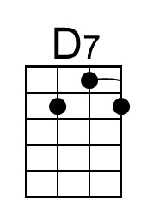 | 