The Long And Winding Road (McCartney & Lennon, 1968) (Am)
The Long And Winding Road by The Beatles (Cm)

Am Em F C C7 F  The long and winding road, that leads to your door,  Em Am7 Dm7 G7 C - C7  Will never disap-pear __ I've seen that road be-fore.  F Em Am Am7 Dm7 G7 C  _ It always leads me here ___ Leads me to your door.  Am Em F C C7 F  The wild and windy night, that the rain washed a-way,  Em Am7 Dm7 G7 C - C7  Has left a pool of tears, ___ Crying for the day.  F Em Am Am7 Dm7 G7 C  _ Why leave me standing here? ___ Let me know the way.  Bridge  C F C Dm7 G7  Many times I've been alone and many times I've cried  C F C Dm7 G7  Anyway you'll never know the many ways I've tried.  Am Em F C C7 F  And still they lead me back, to the long winding road,  Em Am7 Dm7 G7 C - C7  You left me standing here ___ a long, long time a-go.  F Em Am Am7 Dm7 G7 C  _Don't leave me waiting here, ___ lead me to your door.  Instrumental Bridge  Am Em F C C7 F  But still they lead me back, to the long winding road,  Em Am7 Dm7 G7 C - C7  You left me standing here ___ a long, long time a-go  F Em Am Am7 Dm7 G7 C  _Don't keep me waiting here, ___ lead me to your door.  F C  _Yeah, yeah, yeah, yeah. |  |  |  |  |  |  |  |  | 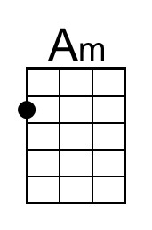 |  | 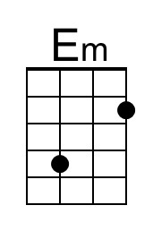
 |  |  |  |  |  |  |  |  | 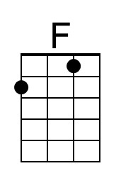 |  | 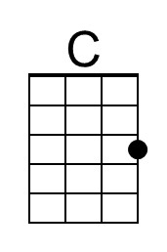
 |  |  |  |  |  |  |  |  | 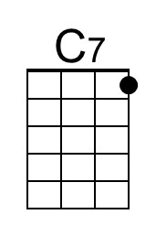 |  | 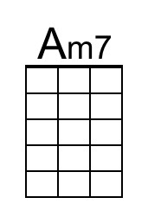
 |  |  |  |  |  |  |  |  | 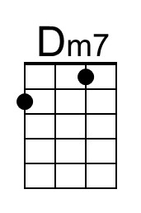 |  | 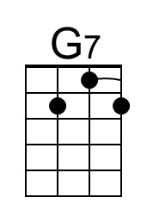
Bari | 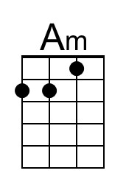 | 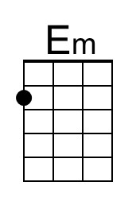 | 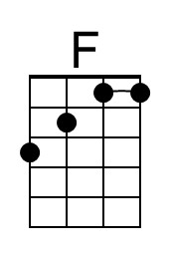 | 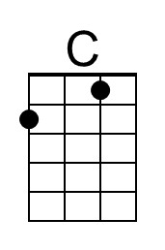 | 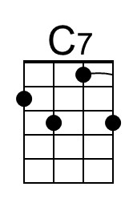 | 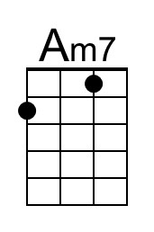 | 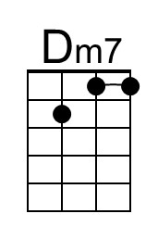 | 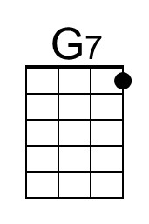

The Long And Winding Road (McCartney & Lennon, 1968) (Bm)
The Long And Winding Road by The Beatles (Cm)

Bm F#m G D D7 G  The long and winding road, that leads to your door,  F#m Bm7 Em7 A7 D - D7  Will never disap-pear __ I've seen that road be-fore.  G F#m Bm Bm7 Em7 A7 D  _ It always leads me here ___ Leads me to your door.  Bm F#m G D D7 G  The wild and windy night, that the rain washed a-way,  F#m Bm7 Em7 A7 D - D7  Has left a pool of tears, ___ Crying for the day.  G F#m Bm Bm7 Em7 A7 D  _ Why leave me standing here? ___ Let me know the way.  Bridge  D G D Em7 A7  Many times I've been alone and many times I've cried  D G D Em7 A7  Anyway you'll never know the many ways I've tried.  Bm F#m G D D7 G  And still they lead me back, to the long winding road,  F#m Bm7 Em7 A7 D - D7  You left me standing here ___ a long, long time a-go.  G F#m Bm Bm7 Em7 A7 D  _Don't leave me waiting here, ___ lead me to your door.  Instrumental Bridge  Bm F#m G D D7 G  But still they lead me back, to the long winding road,  F#m Bm7 Em7 A7 D - D7  You left me standing here ___ a long, long time a-go  G F#m Bm Bm7 Em7 A7 D  _Don't keep me waiting here, ___ lead me to your door.  G D  _Yeah, yeah, yeah, yeah. |  |  |  |  |  |  |  | 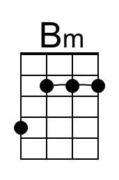 | 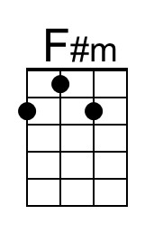
 |  |  |  |  |  |  |  | 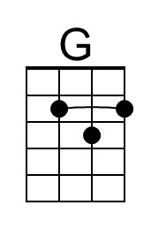 | 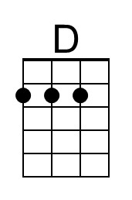
 |  |  |  |  |  |  |  | 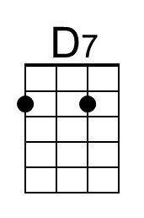 | 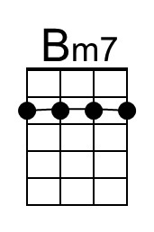
 |  |  |  |  |  |  |  | 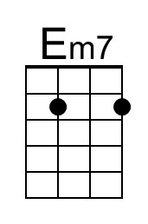 | 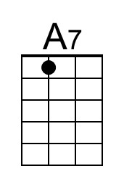
Bari | 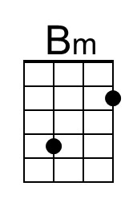 | 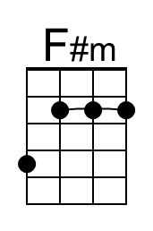 | 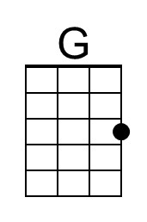 | 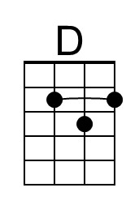 | 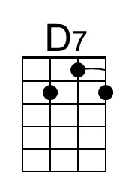 | 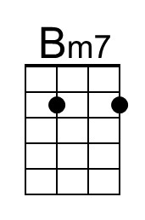 | 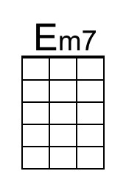 | 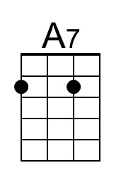

The Long And Winding Road (McCartney & Lennon, 1968) (Cm)
The Long And Winding Road by The Beatles (Cm)

Cm Gm Ab Eb Eb7 Ab  The long and winding road, that leads to your door,  Gm Cm7 Fm7 Bb7 Eb - Eb7  Will never disap-pear __ I've seen that road be-fore.  Ab Gm Cm Cm7 Fm7 Bb7 Eb  __ It always leads me here ___ Leads me to your door.  Cm Gm Ab Eb Eb7 Ab  The wild and windy night, that the rain washed a-way,  Gm Cm7 Fm7 Bb7 Eb - Eb7  Has left a pool of tears, ___ Crying for the day.  Ab Gm Cm Cm7 Fm7 Bb7 Eb  __ Why leave me standing here? ___ Let me know the way.  Bridge  Eb Ab Eb Fm7 Bb7  Many times I've been alone and many times I've cried  Eb Ab Eb Fm7 Bb7  Anyway you'll never know the many ways I've tried.  Cm Gm Ab Eb Eb7 Ab  And still they lead me back, to the long winding road,  Gm Cm7 Fm7 Bb7 Eb - Eb7  You left me standing here ___ a long, long time a-go.  Ab Gm Cm Cm7 Fm7 Bb7 Eb  __ Don't leave me waiting here, ___ lead me to your door.  Instrumental Bridge  Cm Gm Ab Eb Eb7 Ab  But still they lead me back, to the long winding road,  Gm Cm7 Fm7 Bb7 Eb - Eb7  You left me standing here ___ a long, long time a-go  Ab Gm Cm Cm7 Fm7 Bb7 Eb  __ Don't keep me waiting here, ___ lead me to your door.  Ab Eb  __ Yeah, yeah, yeah, yeah. |  |  |  |  |  |  |  | 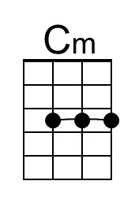 | 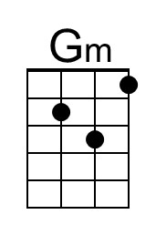
 |  |  |  |  |  |  |  | 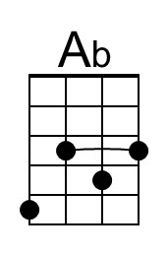 | 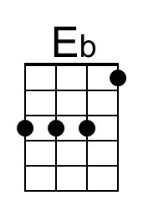
 |  |  |  |  |  |  |  | 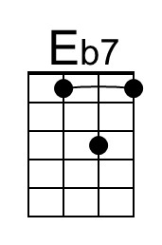 | 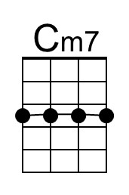
 |  |  |  |  |  |  |  | 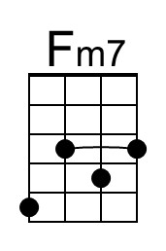 | 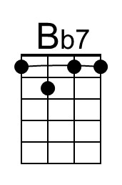
Bari | 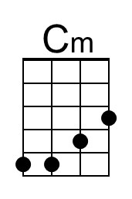 | 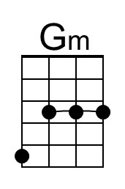 | 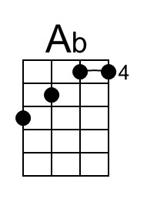 | 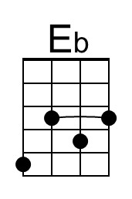 | 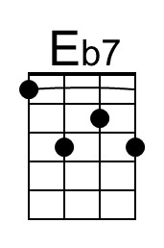 | 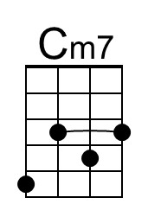 | 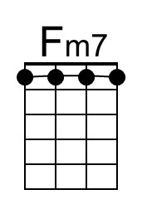 | 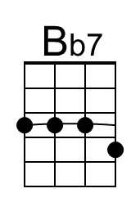

The Long And Winding Road (McCartney & Lennon, 1968) (Gm)
The Long And Winding Road by The Beatles (Cm)

Em Bm C G G7 C
The long and winding road, that leads to your door,
Bm Em7 Am7 D7 G - G7
Will never disap-pear __ I've seen that road be-fore.
C Bm Em Em7 Am7 D7 G
_ It always leads me here ___ Leads me to your door.

Em Bm C G G7 C
The wild and windy night, that the rain washed a-way,
Bm Em7 Am7 D7 G - G7
Has left a pool of tears, ___ Crying for the day.
C Bm Em Em7 Am7 D7 G
_ Why leave me standing here? ___ Let me know the way.

Bridge
G C G Am7 D7
Many times I've been alone and many times I've cried
G C G Am7 D7
Anyway you'll never know the many ways I've tried.

Em Bm C G G7 C
And still they lead me back, to the long winding road,
Bm Em7 Am7 D7 G - G7
You left me standing here ___ a long, long time a-go.
C Bm Em Em7 Am7 D7 G
_Don't leave me waiting here, ___ lead me to your door.

Instrumental Bridge

Em Bm C G G7 C
But still they lead me back, to the long winding road,
Bm Em7 Am7 D7 G - G7
You left me standing here ___ a long, long time a-go
C Bm Em Em7 Am7 D7 G
_Don't keep me waiting here, ___ lead me to your door.
C G
_Yeah, yeah, yeah, yeah.

Bari

