**The Longest Time (Billy Joel) GCEA (STANDARD)**

**F C F Bb C7 F**

Oh, oh, oh, oh, for the longest time

**C F Bb C7**

Oh, oh-oh, oh, for the longest -

**F C Bb F**

If you said goodbye to me tonight

**C G7 C7**

There would still be music left to write

**A7 Dm C7**

What else could I do?

**F F7**

I'm so inspired by you

**Bb Gm C7 F**

That hasn't happened for the longest time

**F C Bb F**

Once I thought my innocence was gone

**C G7 C7**

Now I know that happiness go es on

**A7 Dm**

That's where you found me



C

F



**C7 F F7**

When you put your arms around me

**Bb Gm C7 F**

I haven't been there for the longest time

**F C F Bb C7 F**

Oh, oh, oh, oh, for the longest time

**C F Bb C7**

Oh, oh-oh, oh, for the longest -

**F C Bb F**

I'm that voice you're hearing in the hall

**C G7 C7**

And the greatest miracle of all

**A7 Dm C7**

Is how I need you

**F F7**



Bb

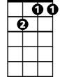

Gm7



G

E7

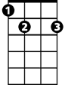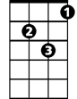

Gm

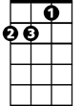

Dm

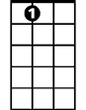

A7

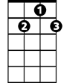

G7

And how you needed me too

**Bb Gm C7 F**

That hasn't happened for the longest time

**C Dm**

Maybe this won't last very long

**E7 Dm**

But you feel so right, and I could be wrong

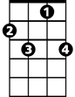

F7

**Am Dm**

Maybe I've been hoping too hard

**G G7**

But I've gone this far

**Gm7 C7**

And it's more than I hoped for

**F C Bb F**

Who knows how much further we'll go on

**C G7 C7**

Maybe I'll be sorry when you're gone

**A7 Dm**

I'll take my chances

**C7 F F7**

I forgot how nice romance is

**Bb Gm C7 F**

I haven't been there for the longest time

**C Dm**

I had second thoughts at the start

**E7 Dm**

I said to myself, hold on to your heart

**Am Dm**

Now I know the woman that you are

**G G7**

You're wonderful so far

**Gm7 C7**

And it's more than I hoped for

**F C Bb F**

I don't care what consequence it brings

**C G7 C7**

I have been a fool for lesser things

**A7 Dm C7**

I want you so bad

**F F7**

I think you ought to know that

**Bb Gm C7 F**

I intend to hold you for the longest time

**F C F Bb C7 F**

Oh, oh, oh, oh, for the longest time

**C F Bb C7**

Oh, oh-oh, oh, for the longest -

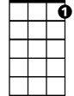

C7

**For the Longest Time (Billy Joel) DGBE (BARITONE)**

**F C F Bb C7 F**

Oh, oh, oh, oh, for the longest time

**C F Bb C7**

Oh, oh-oh, oh, for the longest -

**F C Bb F**

If you said goodbye to m e tonight

**C G7 C7**

There would still be music left to write

**A7 Dm**

What else could I do?

**C7 F F7**

I'm so inspired by you

**Bb Gm C7 F**

That hasn't happened for the longest time

**F C Bb F**

Once I thought my innocence was gone

**C G7 C7**

Now I know that happiness goes on

**A7 Dm**



F

That's where you found me

**C7 F F7**

When you put your arms around me

**Bb Gm C7 F**

I haven't been there for the longest time

**F C F Bb C7 F**

Oh, oh, oh, oh, for the longest time

C



**C F Bb C7**

Oh, oh-oh, oh, for the longest -

**F C Bb F**

I'm that voice you're hearing in the hall

**C G7 C7**

And the greatest miracle of all

**A7 Dm C7**

Is how I need you

**F F7**

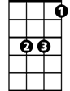

Bb

And how you needed me too

**Bb Gm C7 F**

That hasn't happened for the longest time

**C Dm**

Maybe this won't last very long

**E7 Dm**

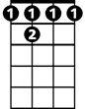

F 7

But you feel so right, and I could be wrong

**Am Dm**

Maybe I've been hoping too hard

**G G7**

But I've gone this far

**Gm7 C7**

And it's more than I hoped for

**F C Bb F**

Who knows how much further we'll go on

**C G7 C7**

Maybe I'll be sorry when you're gone

**A7 Dm**

I'll take my chances

**C7 F F7**

I forgot how nice romance is

**Bb Gm C7 F**

I haven't been there for the longest time

**C Dm**

I had second thoughts at the start

**E7 Dm**

I said to myself, hold on to your heart

**Am Dm**

Now I know the woman that you are

**G G7**

You're wonderful so far

**Gm7 C7**

And it's more than I hoped for

**F C Bb F**

I don't care what consequence it brings

**C G7 C7**

I have been a fool for lesser things

**A7 Dm C7**

I want you so bad

**F F7**

I think you ought to know that

**Bb Gm C7 F**

I intend to hold you for the longest time

**F C F Bb C7 F**

Oh, oh, oh, oh, for the longest time

**C F Bb C7**

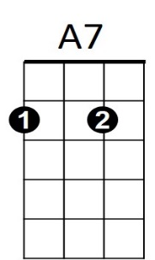Oh, oh-oh, oh, for the longest -



Dm



C7



G7

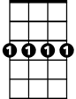

Gm7



E7



G

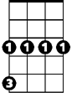

Gm