The Longest Time (Billy Joel) GCEA (STANDARD)
F C F Bb C7 F
Oh, oh, oh, oh, for the longest time
C F Bb C7
Oh, oh-oh, oh, for the longest -

F C Bb F
If you said goodbye to me tonight
C G7 C7
There would still be music left to write
A7 Dm C7
What else could I do?
F F7
I'm so inspired by you
Bb Gm C7 F
That hasn't happened for the longest time

F C Bb F
Once I thought my innocence was gone
C G7 C7
Now I know that happiness go es on
A7 Dm


That's where you found me
C
F
C7 F F7
When you put your arms around me
Bb Gm C7 F
I haven't been there for the longest time

F C F Bb C7 F
Oh, oh, oh, oh, for the longest time
C F Bb C7
Oh, oh-oh, oh, for the longest -

F C Bb F
I'm that voice you're hearing in the hall
C G7 C7
And the greatest miracle of all
A7 Dm C7
Is how I need you

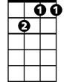

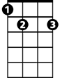
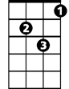
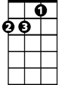
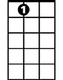
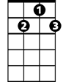
F F7
Bb
Gm7
G
E7
Gm
Dm
A7
G7
And how you needed me too
Bb Gm C7 F
That hasn't happened for the longest time

C Dm
Maybe this won't last very long
E7 Dm
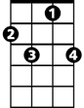
But you feel so right, and I could be wrong
F7
Am Dm
Maybe I've been hoping too hard
G G7
But I've gone this far
Gm7 C7
And it's more than I hoped for

F C Bb F
Who knows how much further we'll go on
C G7 C7
Maybe I'll be sorry when you're gone
A7 Dm
I'll take my chances
C7 F F7
I forgot how nice romance is
Bb Gm C7 F
I haven't been there for the longest time

C Dm
I had second thoughts at the start
E7 Dm
I said to myself, hold on to your heart
Am Dm
Now I know the woman that you are
G G7
You're wonderful so far
Gm7 C7
And it's more than I hoped for

F C Bb F
I don't care what consequence it brings
C G7 C7
I have been a fool for lesser things
A7 Dm C7
I want you so bad
F F7
I think you ought to know that
Bb Gm C7 F
I intend to hold you for the longest time

F C F Bb C7 F
Oh, oh, oh, oh, for the longest time
C F Bb C7
Oh, oh-oh, oh, for the longest -
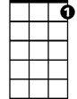
C7

For the Longest Time (Billy Joel) DGBE (BARITONE)
F C F Bb C7 F
Oh, oh, oh, oh, for the longest time
C F Bb C7
Oh, oh-oh, oh, for the longest -

F C Bb F
If you said goodbye to m e tonight
C G7 C7
There would still be music left to write
A7 Dm
What else could I do?
C7 F F7
I'm so inspired by you
Bb Gm C7 F
That hasn't happened for the longest time

F C Bb F
Once I thought my innocence was gone
C G7 C7
Now I know that happiness goes on
A7 Dm
F
That's where you found me
C7 F F7
When you put your arms around me
Bb Gm C7 F
I haven't been there for the longest time

F C F Bb C7 F
Oh, oh, oh, oh, for the longest time
C
C F Bb C7
Oh, oh-oh, oh, for the longest -
F C Bb F
I'm that voice you're hearing in the hall
C G7 C7
And the greatest miracle of all
A7 Dm C7
Is how I need you
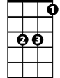
F F7
Bb
And how you needed me too
Bb Gm C7 F
That hasn't happened for the longest time

C Dm
Maybe this won't last very long
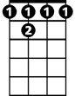
E7 Dm
F 7
But you feel so right, and I could be wrong
Am Dm
Maybe I've been hoping too hard
G G7
But I've gone this far
Gm7 C7
And it's more than I hoped for

F C Bb F
Who knows how much further we'll go on
C G7 C7
Maybe I'll be sorry when you're gone
A7 Dm
I'll take my chances
C7 F F7
I forgot how nice romance is
Bb Gm C7 F
I haven't been there for the longest time

C Dm
I had second thoughts at the start
E7 Dm
I said to myself, hold on to your heart
Am Dm
Now I know the woman that you are
G G7
You're wonderful so far
Gm7 C7
And it's more than I hoped for

F C Bb F
I don't care what consequence it brings
C G7 C7
I have been a fool for lesser things
A7 Dm C7
I want you so bad
F F7
I think you ought to know that
Bb Gm C7 F
I intend to hold you for the longest time

F C F Bb C7 F
Oh, oh, oh, oh, for the longest time
C F Bb C7
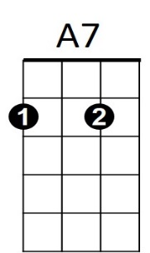
Oh, oh-oh, oh, for the longest -
Dm
C7
G7

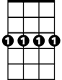
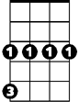
Gm7
E7
G
Gm

