**The Muppet Show Theme (Sam Pottle / Jim Henson)**



C

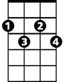

Ebdim

**C Ebdim G7**

It's time to play the music

**C Ebdim G7**

It's time to light the lights

**C F Fm Am Abaug G**

It's time to meet the Muppets on the Muppet Show tonight

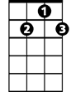

G7

F

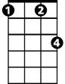

Fm

**C Ebdim G7**

It's time to put on make up

**C Ebdim G7**

It's time to dress up right

**C F Fm Am Abaug G**

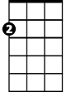

Am

It's time to raise the curtain on the Muppet Show tonight

**C Ebdim G7**

*It's time to play the music*

**C Ebdim G7**

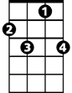

F7

*It's time to light the lights*

**C F Fm C F Fm**

It's time to get things started (Why don’t you get things started?)

**C**

on the most sensational,

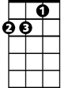

Dm

**Am F F7**

Inspirational celebrational muppetstational

**Dm F G7 C**

This is what we call the Muppet Show

**BARITONE**

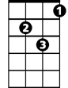

Dm

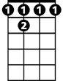

F 7



Am

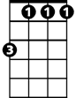

Fm



F

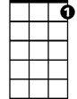

G7

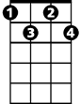

Ebdim

C

