**The Music of the Night (Andrew Lloyd Webber / Charles Hart / Richard Stilgoe)**

**(GCEA) Key F**

**F C F C**

Night time sharpens, heightens each sensation

**F C Bb C**

Darkness stirs and wakes imagination

**Bb F Bb F**

Silently the senses abandon their defenses

**Bb Eb Bb F / Gm Am**

**F C F C**

Slowly, gently night unfurls it's splendor

**F C Bb C**

Grasp it, sense it, tremulous and tender

**Bb F Bb F**

Turn your face away from the garish light of day

**Bb Eb Bb F**

Turn your thoughts away from cold, unfeeling light

**Bb C7 F**

And listen to the music of the night

**Eb**

Close your eyes and surrender

**Ab**

To your darkest dreams

**Db G G7**

Purge your thoughts of the life you knew before

**C C7 F**

Close your eyes, let your spirit start to soar

**Am E7 A7**

And you’ll live as you never lived before

**F C F C**

Softly, deftly, music shall caress you

**F C Bb C**

Hear it, feel it, secretly possess you

**Bb F Bb F**

Open up your mind, let your fantasies unwind

**Bb Eb Bb F**

In this darkness which you know you cannot fight

**Bb C7 F**

The darkness of the music of the night

**Eb Ab**

Let your mind start a journey to a strange new world

**Db G G7**

Leave all thoughts of the life you knew before

**C C7 F**

Let your soul take you where you long to be

**Am E7 A7**

Only then can you belong to me

**F C F C**

Floating, falling, sweet intoxication

**F C Bb C**

Touch me, trust me, savor each sensation

**Bb F Bb F**

Let the dream begin, let your darker side give in

**Bb Eb Bb F**

To the power of the music that I write

**Bb C7 F**

The power of the music of the night

**F C F C / F C Bb C / Bb F Bb F**

**Bb Eb Bb F**

You alone can make my song take flight

**Bb C7 Bb Gm F#m Bb**

Help me make the music of the night

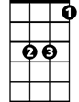

Eb



Bb



C

F

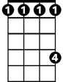

Db

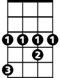

Ab

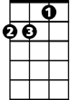

Am

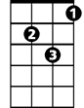

Gm

E7

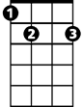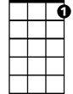

C7

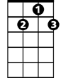

G7



G

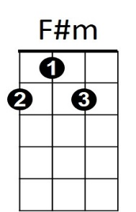

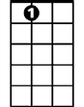

A7

**The Music of the Night (Andrew Lloyd Webber / Charles Hart / Richard Stilgoe)**

**BARITONE (DGBE) Key F**

**F C F C**

Night time sharpens, heightens each sensation

**F C Bb C**

Darkness stirs and wakes imagination

**Bb F Bb F**

Silently the senses abandon their defenses

**Bb Eb Bb F / Gm Am**

**F C F C**

Slowly, gently night unfurls it's splendor

**F C Bb C**

Grasp it, sense it, tremulous and tender

**Bb F Bb F**

Turn your face away from the garish light of day

**Bb Eb Bb F**

Turn your thoughts away from cold, unfeeling light

**Bb C7 F**

And listen to the music of the night

**BARITONE**

**Eb**

Close your eyes and surrender

**Ab**

To your darkest dreams

**Db G G7**

Purge y our thoughts of the life you knew before

**C C7 F**

Close your eyes, let your spirit start to soar

**Am E7 A7**

And you’ll live as you never lived before

**F C F C**

Softly, deftly, music shall caress you

**F C Bb C**

Hear it, feel it, secretly possess you

**Bb F Bb F**

Open up your mind, let your fantasies unwind

**Bb Eb Bb F**

In this darkness which you know you cannot fight

**Bb C7 F**

The darkness of the music of the night

**Eb Ab**

Let your mind start a journey to a strange new world

**Db G G7**

Leave all thoughts of the life you knew before

**C C7 F**

Let your soul take you where you long to be

**Am E7 A7**

Only then can you belong to me

**F C F C**

Floating, falling, sweet intoxication

**F C Bb C**

Touch me, trust me, savor each sensation

**Bb F Bb F**

Let the dream begin, let your darker side give in

**Bb Eb Bb F**

To the power of the music that I write

**Bb C7 F**

The power of the music of the night

**F C F C / F C Bb C / Bb F Bb F**

**Bb Eb Bb F**

You alone can make my song take flight

**Bb C7 Bb Gm F#m Bb**

Help me make the music of the night



Eb



Bb



F

C

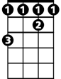

Db

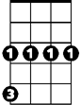

Gm



Ab



Am

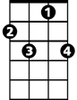

C7



G7



G



E7

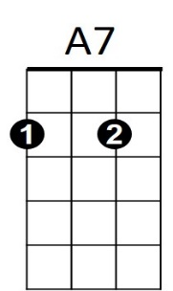

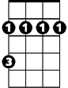

F#m