**The Music of the Night (Andrew Lloyd Webber / Charles Hart / Richard Stilgoe)**

**(GCEA)**

**C G C G**

Night time sharpens, heightens each sensation

**C G F G**

Darkness stirs and wakes imagination

**F C F C**

Silently the senses abandon their defenses

**F Bb F C Dm Em**

**C G C G**

Slowly, gently night unfurls it's splendor

**C G F G**

Grasp it, sense it, tremulous and tender

**F C F C**

Turn your face away from the garish light of day

**F Bb F C**

Turn your thoughts away from cold, unfeeling light

**F G7 C**

And listen to the music of the night

**Bb**

Close your eyes and surrender

**Eb**

To your darkest dreams

**Ab D D7**

Purge y our thoughts of the life you knew before

**G G7 C**

Close your eyes, let your spirit start to soar

**Em B E7**

And you’ll live as you never lived before

**C G C G**

Softly, deftly, music shall caress you

**C G F G**

Hear it, feel it, secretly possess you

**F C F C**

Open up your mind, let your fantasies unwind

**F Bb F C**

In this darkness which you know you cannot fight

**F G7 C**

The darkness of the music of the night

**Bb Eb**

Let your mind start a journey to a strange new world

**Ab D D7**

Leave all thoughts of the life you knew before

**G G7 C**

Let your soul take you where you long to be

**Em B E7**

Only then can you belong to me

**C G C G**

Floating, falling, sweet intoxication

**C G F G**

Touch me, trust me, savor each sensation

**F C F C**

Let the dream begin, let your darker side give in

**F Bb F C**

To the power of the music that I write

**F G7 C**

The power of the music of the night

**C G C G / C G F G7 / F C F C**

**F Bb F C**

You alone can make my song take flight

**F G7 F Dm Dbm B C**

Help me make the music of the night

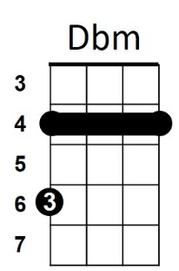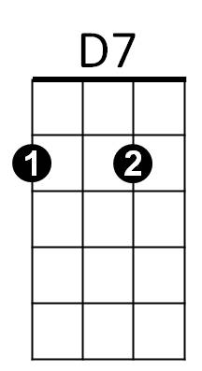

E7

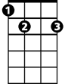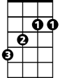

B

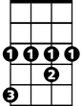

Ab

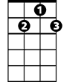

G7

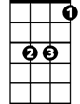

Eb



Bb

F



Em

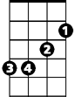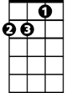

Dm

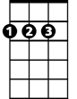

D



C



G

**The Music of the Night (Andrew Lloyd Webber / Charles Hart / Richard Stilgoe)**

**BARITONE (DGBE)**

**C G C G**

Night time sharpens, heightens each sensation

**C G F G**

Darkness stirs and wakes imagination

**F C F C**

Silently the senses abandon their defenses

**F Bb F C Dm Em**

**C G C G**

Slowly, gently night unfurls it's splendor

**C G F G**

Grasp it, sense it, tremulous and tender

**F C F C**

Turn your face away from the garish light of day

**F Bb F C**

Turn your thoughts away from cold, unfeeling light

**F G7 C**

**BARITONE**

And listen to the music of the night

**Bb**

Close your eyes and surrender

**Eb**

To your darkest dreams

**Ab D D7**

Purge your thoughts of the life you knew before

**G G7 C**

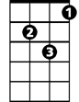

Dm

Close your eyes, let your spirit start to soar

**Em B E7**

And you’ll live as you never lived before

**C G C G**

Softly, deftly, music shall caress you

**C G F G**

Hear it, feel it, secretly possess you

**F C F C**

Open up your mind, let your fantasies unwind

**F Bb F C**

In this darkness which you know you cannot fight

**F G7 C**

The darkness of the music of the night

**Bb Eb**

Let your mind start a journey to a strange new world

**Ab D D7**

Leave all thoughts of the life you knew before

**G G7 C**

Let your soul take you where you long to be

**Em B E7**

Only then can you belong to me

**C G C G**

Floating, falling, sweet intoxication

**C G F G**

Touch me, trust me, savor each sensation

**F C F C**

Let the dream begin, let your darker side give in

**F Bb F C**

To the power of the music that I write

**F G7 C**

The power of the music of the night

**C G C G / C G F G7 / F C F C**

**F Bb F C**

You alone can make my song take flight

**F G7 F Dm Dbm B C**

Help me make the music of the night



F

B

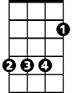

G



Bb

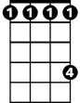

Ab



Eb

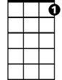

G7

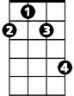

Dbm

C



D

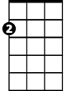

Em



D7