The Night They Drove Old Dixie Down (Robbie Robertson) (Am)
The Night They Drove Old Dixie Down by Joan Baez (Capo 1)

Intro (4 Measures): Em  Am C F Am  Virgil Caine is my name and I drove on the Danville Train  C Am F Am  'Til so much cavalry came and tore up the tracks a-gain  F C Am F  In the winter of '65, we were hungry, just barely alive  Am F C Am D D7  I took the train to Richmond myself, it was a time I re-member oh so well.  Chorus  C F C Am  The night they drove old Dixie down, and all the bells were ringin'.  C F C Am  The night they drove old Dixie down, and all the people were singin'  C Am D F - Am  They went na na-na na-na-na naa, na-na na-na naa, na na-na-na-na.  Am C F Am  Back with my wife in Tennessee, when one day she said to me,  C Am F Am  "Virgil, quick come see, there goes the Robert E. Lee!"  F C Am F  Now I don't mind choppin' wood, and I don't care if the money's no good.  Am F  You take what you need and you leave the rest,  C Am D D7  But they should never have taken the very best. Chorus  Am C F Am  Like my father be-fore me I'm a working man  C Am F Am  And like my brother be-fore me I took a rebel stand  F C Am F  He was just eighteen, proud and brave, but a Yankee laid him in his grave  Am F  I swear by the blood be-low my feet,  C Am D D7  You can't raise a Caine back up when he's in de-feat. Chorus |  |  |  |  |  |  | 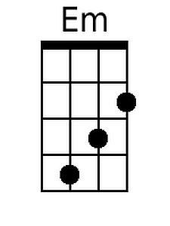
 |  |  |  |  |  |  | 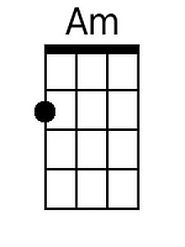
 |  |  |  |  |  |  | 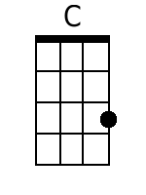
 |  |  |  |  |  |  | 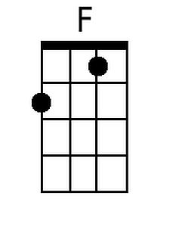
 |  |  |  |  |  |  | 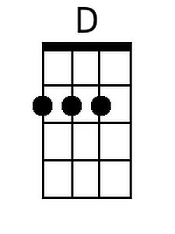
 |  |  |  |  |  |  | 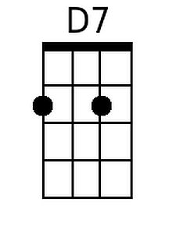
Baritone | 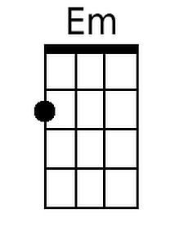 | 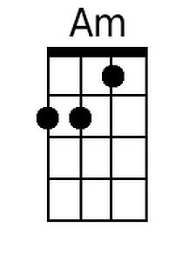 | 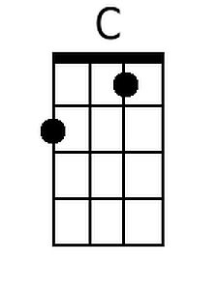 | 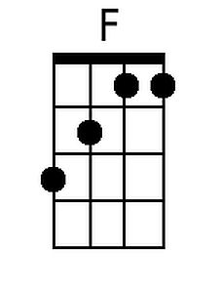 | 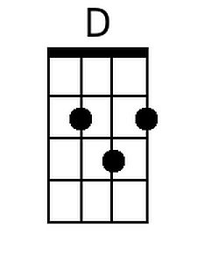 | 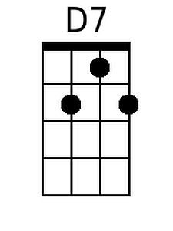

The Night They Drove Old Dixie Down (Robbie Robertson) (Em)
The Night They Drove Old Dixie Down by Joan Baez

Intro (4 Measures): Bm  Em G C Em  Virgil Caine is my name and I drove on the Danville Train  G Em C Em  'Til so much cavalry came and tore up the tracks a-gain  C G Em C  In the winter of '65, we were hungry, just barely alive  Em C G Em A A7  I took the train to Richmond myself, it was a time I re-member oh so well.  Chorus  G C G Em  The night they drove old Dixie down, and all the bells were ringin'.  G C G Em  The night they drove old Dixie down, and all the people were singin'  G Em A C - Em  They went na na-na na-na-na naa, na-na na-na naa, na na-na-na-na.  Em G C Em  Back with my wife in Tennessee, when one day she said to me,  G Em C Em  "Virgil, quick come see, there goes the Robert E. Lee!"  C G Em C  Now I don't mind choppin' wood, and I don't care if the money's no good.  Em C  You take what you need and you leave the rest,  G Em A A7  But they should never have taken the very best. Chorus  Em G C Em  Like my father be-fore me I'm a working man  G Em C Em  And like my brother be-fore me I took a rebel stand  C G Em C  He was just eighteen, proud and brave, but a Yankee laid him in his grave  Em C  I swear by the blood be-low my feet,  G Em A A7  You can't raise a Caine back up when he's in de-feat. Chorus |  |  |  |  |  |  | 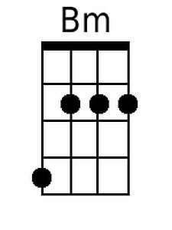
 |  |  |  |  |  |  | 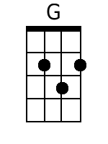
 |  |  |  |  |  |  | 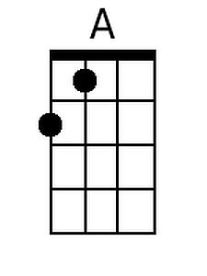
 |  |  |  |  |  |  | 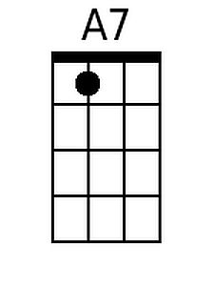
Baritone | 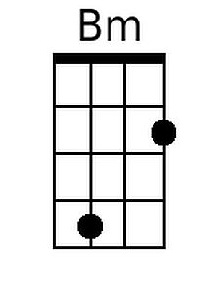 |  | 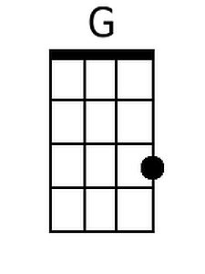 |  | 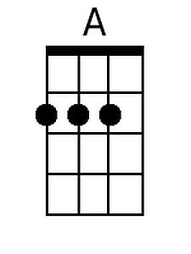 | 