The Only Living Boy In New York (Paul Simon)
Key C - Simon & Garfunkel

Intro (2 measures): C | C |  1st Chorus  C F | F |  Tom, get your plane right on time.  C F | F |  I know your part'll go fine.  C | F Am7 | Dm7 F |  Fly down to Mexi - co o o o o o o  G F | F |  Da-n-do-da-n-do-da-n-do-da and here I am  C F | F | C | F . C Dm7 |  The only living boy in New York  C  I get the news I need  F  on the weather re-port, aahh  C  I can gather all the news I need  F | F |  on the weather re-port  C F C Dm F6 G7  Hey, I've got nothing to do to-day but smile  F | F  Da-n-do-da-n-do-da-n-do-da and here I am  C F | F | Am | Am |  The only living boy in New York  Bridge  Dm G7  Half of the time we're gone,  C  but we don't know where  F | F |  And we don't know where. |  |  |  |  | Instrumental Verse:  C F | F |  Tom, get your plane right on time  C F | F |  I know your part'll go fine  C | F Am7 | Dm7 F |  Fly down to Mexi- cooooooo  G7  Da-n-do-da-n-do-da-n-do-da and  F | F |  here . . I . . am.  Bridge  2nd Chorus  C F | F |  Tom, get your plane right on time  C F | F |  I know that you've been eager to fly now  C | F C | Dm F |  Hey, let your honesty shine, shine, shine now,  G Fmaj7 F6 F  Do-n-da-da-n-da-da-n-do like it shines on me  C F | F |  The only living boy in New York.  C F | F | Am | Am |  The only living boy in New York.  Instrumental Bridge  Instrumental Verse (2x)  Outro on C (2 measures).
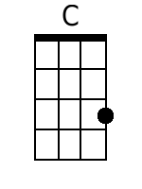 | 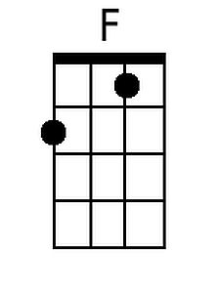 | 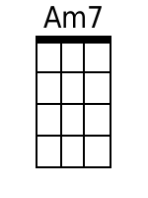 | 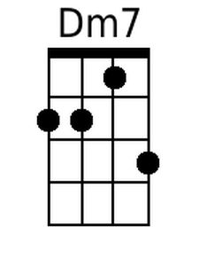 | 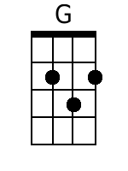 |  | 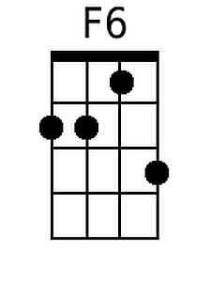 | 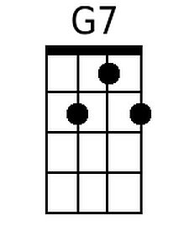 | 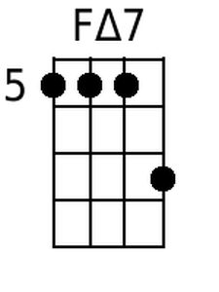
Baritone
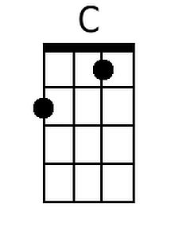 | 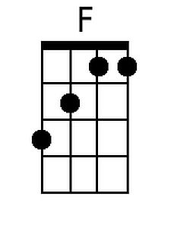 | 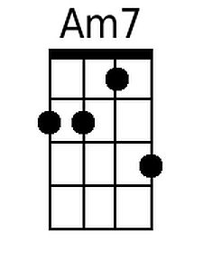 | 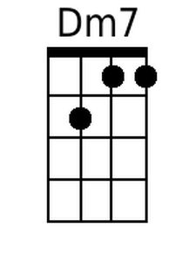 | 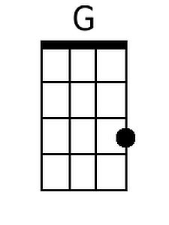 |  | 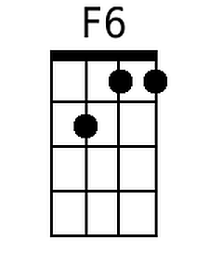 | 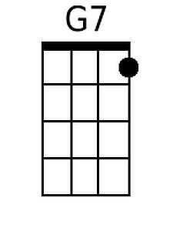 | 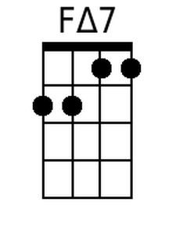

The Only Living Boy In New York (Paul Simon)
Key G - Simon & Garfunkel

Intro (2 measures): G | G |  1st Chorus  G C | C |  Tom, get your plane right on time.  G C | C |  I know your part'll go fine.  G | C Em7 | Am7 C |  Fly down to Mexi - co o o o o o o  D C | C |  Da-n-do-da-n-do-da-n-do-da and here I am  G C | C | G | C . G Am7 |  The only living boy in New York  G  I get the news I need  C  on the weather re-port, aahh  G  I can gather all the news I need  C | C |  on the weather re-port  G C G Am C6 D7  Hey, I've got nothing to do to-day but smile  C | C  Da-n-do-da-n-do-da-n-do-da and here I am  G C | C | Em | Em |  The only living boy in New York  Bridge  Am D7  Half of the time we're gone,  G  but we don't know where  C | C |  And we don't know where. |  |  |  |  | Instrumental Verse:  G C | C |  Tom, get your plane right on time  G C | C |  I know your part'll go fine  G | C Em7 | Am7 C |  Fly down to Mexi- cooooooo  D7  Da-n-do-da-n-do-da-n-do-da and  C | C |  here . . I . . am.  Bridge  2nd Chorus  G C | C |  Tom, get your plane right on time  G C | C |  I know that you've been eager to fly now  G | C G | Am C |  Hey, let your honesty shine, shine, shine now,  D Cmaj7 C6 C  Do-n-da-da-n-da-da-n-do like it shines on me  G C | C |  The only living boy in New York.  G C | C | Em | Em |  The only living boy in New York.  Instrumental Bridge  Instrumental Verse (2x)  Outro on G (2 measures).
 |  | 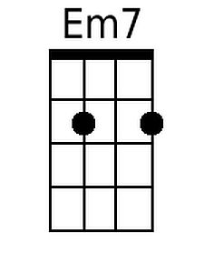 |  | 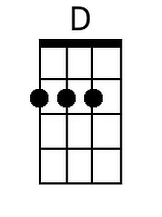 |  | 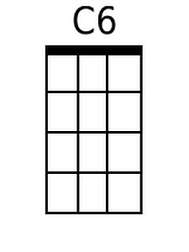 | 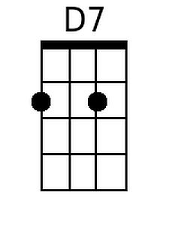 | 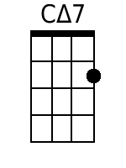
Baritone
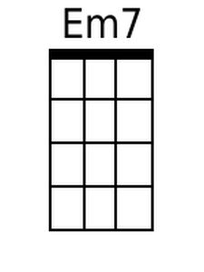 |  |  |  | 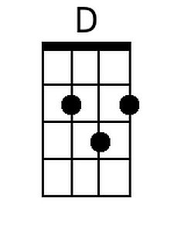 |  | 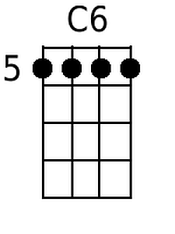 | 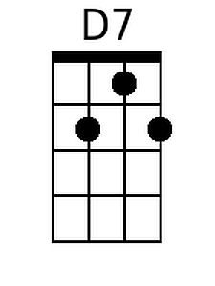 | 