**The Rainbow Connection (Paul Williams / Kenneth Ascher) Key C**

**Intro: C Csus4 4x**

**C Am**

Why are there so many

**Dm G7**

Songs about rainbows?

**Cmaj7 Am Dm G7**

And what's on the other side

**C Am Dm G7**

Rainbows are visions but only illusions

**Cmaj7 Am Dm G7**

And rainbows have nothing to hide

**F**

So we've been told and some choose to believe it

**Em7 Gmaj7 Em7**

I know they're wrong, wait and see

**F G7 Em7 A7**

Some day we'll find it, the rainbow connection

**Dm G7 C**

The lovers, the dreamers, and me

**C Csus4 C Csus4**

**C Am**

Who said that every wish

**Dm G7**

Would be heard and answered

**Cmaj7 Am Dm G7**

When wished on the morning star

**C Am Dm G7**

Somebody thought of that and someone believed it

**Cmaj7 Am Dm G7**

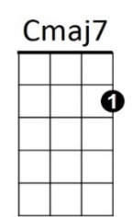And look what it's done so far

**F**

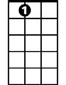

**A7**

**Em7**

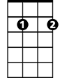

**F**

What's so amazing that keeps us stargazing?

**Em7 Gmaj7 Em7**

And what do we think we might see

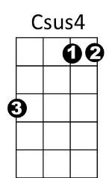**F G7 Em7 A7**

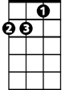

Am

C

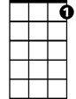

G7

Some day we'll find it, the rainbow connection

**BARITONE**

**Dm G7 C**

The lovers, the dreamers, and me

**Em7 Am Cmaj7**

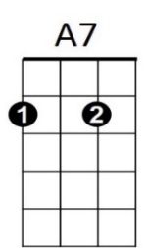All of us under its spell,

**F C Dm G7**

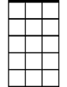

Em7



F

We know that it's probably ma - gic

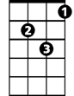

Dm

**C Am**

Have you been half asleep?

**Dm G7**

And have you heard voices?

**Cmaj7 Am Dm G7**

I've heard them calling my name

**C Am**

Is this the sweet sound

**Dm G7**

That called the young sailors?

**Cmaj7 Am Dm G7**

The voice might be one and the same

**F**

I've heard it too many times to ignore it

**Em7 Gmaj7 Em7**

It's something that I'm supposed to be

**F G7 Em7 A7**

Some day we'll find it, the rainbow connection

**Dm G7 C**

The lovers, the dreamers, and me

**Em7 Am Cmaj7**

La da da di da da dum

**F G7 C**

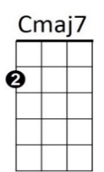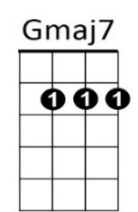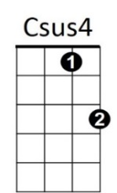La duh da da dum di da doo

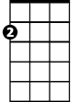

**Am**



**C**



**Dm**

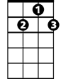

**G7**

**The Rainbow Connection (Paul Williams / Kenneth Ascher) Key F**

**Intro: F Fsus4 4x**

**F Dm**

Why are there so many

**Gm C7**

Songs about rainbows?

**Fmaj7 Dm Gm C7**

And what's on the other side

**F Dm Gm C7**

Rainbows are visions but only illusions

**Fmaj7 Dm Gm C7**

And rainbows have nothing to hide

**Bb**

So we've been told and some choose to believe it

**Am7 Cmaj7 Am7**

I know they're wrong, wait and see

**Bb C7 Am7 D7**

Some day we'll find it, the rainbow connection

**Gm C7 F**

The lovers, the dreamers, and me

**F Fsus4 F Fsus4**

**F Dm**

Who said that every wish

**Gm C7**

Would be heard and answered

**Fmaj7 Dm Gm C7**

When wished on the morning star

**F Dm Gm C7**

Somebody thought of that and someone believed it

**Fmaj7 Dm Gm C7**

And look what it's done so far

**Bb**

What's so amazing that keeps us stargazing?

**Am7 Cmaj7 Am7**

And what do we think we might see

**Bb C7 Am7 D7**

**BARITONE**

Some day we'll find it, the rainbow connection



F

**Gm C7 F**

The lovers, the dreamers, and me

**Am7 Dm Fmaj7**

All of us under its spell,

**Bb F Gm C7**

We know that it's probably ma - gic

**F Dm**

Have you been half asleep?

**Gm C7**

And have you heard voices?

**Fmaj7 Dm Gm C7**

I've heard them calling my name

**F Dm**

Is this the sweet sound

**Gm C7**

That called the young sailors?

**Fmaj7 Dm Gm C7**

The voice might be one and the same

**Bb**

I've heard it too many times to ignore it

**Am7 Cmaj7 Am7**

It's something that I'm supposed to be

**Bb C7 Am7 D7**

Some day we'll find it, the rainbow connection

**Gm C7 F**

The lovers, the dreamers, and me

**Am7 Dm Fmaj7**

La da da di da da dum

**Bb C7 F**

La duh da da dum di da doo



**Dm**



C7



Gm

**F**



**Em7**



Bb



Am7

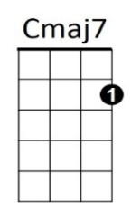



Dm

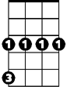

Gm

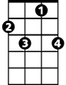

C7



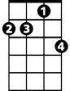

Am7

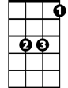

Bb



Em7

**The Rainbow Connection (Paul Williams / Kenneth Ascher) Key G**

**Intro: G Gsus4 4x**

**G Em**

Why are there so many

**Am D7**

Songs about rainbows?

**Gmaj7 Em Am D7**

And what's on the other side

**G Em Am D7**

Rainbows are visions but only illusions

**Gmaj7 Em Am D7**

And rainbows have nothing to hide

**C**

So we've been told and some choose to believe it

**Bm7 Dmaj7 Bm7**

I know they're wrong, wait and see

**C D7 Bm7 E7**

Some day we'll find it, the rainbow connection

**Am D7 G**

The lovers, the dreamers, and me

**G Gsus4 G Gsus4**

**G Em**

Who said that every wish

**Am D7**

Would be heard and answered

**Gmaj7 Em Am D7**

When wished on the morning star

**G Em Am D7**

Somebody thought of that and someone believed it

**Gmaj7 Em Am D7**

And look what it's done so far

**C**

What's so amazing that keeps us stargazing?

**Bm7 Dmaj7 Bm7**

And what do we think we might see

**C D7 Bm7 E7**

**BARITONE**

Some day we'll find it, the rainbow connection

**Am D7 G**

The lovers, the dreamers, and me

**Bm7 Em Gmaj7**

All of us under its spell,

**C G Am D7**

We know that it's probably ma - gic

**G Em**

Have you been half asleep?

**Am D7**

And have you heard voices?

**Gmaj7 Em Am D7**

I've heard them calling my name

**G Em**

Is this the sweet sound

**Am D7**

That called the young sailors?

**Gmaj7 Em Am D7**

The voice might be one and the same

**C**

I've heard it too many times to ignore it

**Bm7 Dmaj7 Bm7**

It's something that I'm supposed to be

**C D7 Bm7 E7**

Some day we'll find it, the rainbow connection

**Am D7 G**

The lovers, the dreamers, and me

**Bm7 Em Gmaj7**

La da da di da da dum

**C D7 G**

La duh da da dum di da doo



**Am**

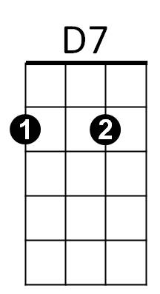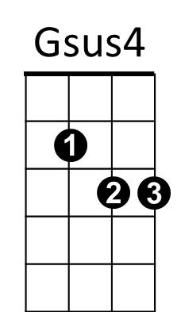

Em

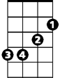

G

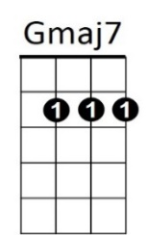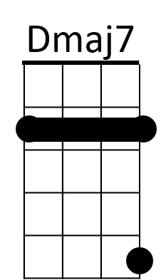

E7

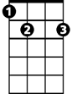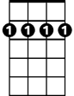

Bm7



**C**



**Em**



D7



Am



G



**E7**

**Bm7**



**C**

