**The Sadder but Wiser Girl (Meredith Wilson)**

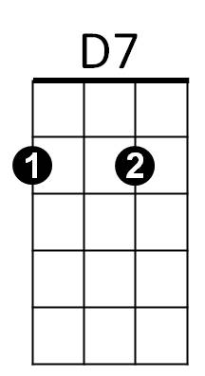**(Spoken)**No wide-eyed, eager, wholesome Innocent Sunday school teacher for me



G

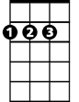

D

That kinda girl spins webs no spider ever -

**D/ G/**

Listen boy, a girl who trades on all that purity

**D/ G/**

Merely wants to trade my independence for her security

**D D7 G G7**

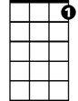

C7

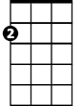

Am

E7

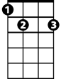

The only affirmative she will file, refers to marching down the aisle

**C D7**

No golden, glorious, gleaming pristine goddess, no sir

**E7 Am C7**

For no Diana do I play faun, I can tell you that right now

**F D7 C A7**

I snarl, I hiss, how can ignorance be compared to bliss?

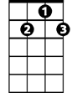

G7



C

F

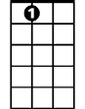

A7

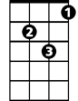

Gm

**F D7 C A7**

I spark, I fizz for the lady who knows what time it is

**F D7 C A7**

I cheer, I rave for the virtue I'm too late to save

**D7 G7 C C Gm C Gm**

The sadder but wiser girl for me

**C D7**

No bright-eyed, blushing, breathless baby-doll baby, no sir

**Am G C**

That kinda child ties knots no sailor ever knew

**E7 Am E7 Am**

I prefer to take a chance on a more adult romance

**D**

**BARITONE**

No dewy young miss who keeps resisting



E7



D7



D



G

**G**

All the time she keeps insisting

**C D7**

No wide-eyed, wholesome, innocent female, no sir

**E7 Am C7**

Why, she's the fisherman, I'm the fish, you see? Plop!



F

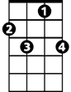

C7

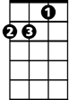

Am

**F D7 C A7**

I flinch, I shy when the lass with the delicate air goes by

**F D7 C A7**

I smile, I grin when the gal with a touch of sin walks in

**F D7 C A7**

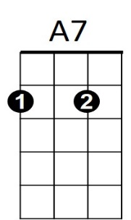I hope, I pray for Hester to win just one more “A”

C



**D7 G7 C A7**

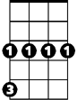

Gm



G7

The sadder but wiser girl's the girl for me

**D7 G7 C**

The sad-der but wiser girl for meeeee