The Sidewalks of New York (Chas. B. Lawlor and James W. Blake, 1894)
Key of C in ¾ Time

Intro: | C | G7 | C | C7 |  C G7 C C7 F C C7  Down in front of Casey's . . . old brown wooden stoop  F C A7 D7 G G7  On a summer's evening, we formed a merry group;  C G7 C C7 F C C7  Boys and girls to-gether . . . we would sing and waltz  F C A7 D7 G7 C  While the "ginnie" played the organ on the sidewalks of New York.  Chorus  C G7 C7 F C C7  East Side, West Side, all around the town.  F C A7 D7 G G7  The tots sang "ring-around-rosie," "London Bridge is falling down"  C G7 C C7 F C C7  Boys and girls to-gether . . . me and Mamie O'Rourke,  F C A7 D7 G7 C  Tripped the light fan-tastic on the sidewalks of New York.  C G7 C C7 F C C7  That's where Johnny Casey . . . and little Jimmy Crowe  F C A7 D7 G G7  With Jakey Krause, the baker . . . who always had the dough.  C G7 C C7 F C C7  Pretty Nellie Shannon . . . with a dude as light as cork,  F C A7 D7 G7 C  First picked up the waltz-step on the sidewalks of New York. Chorus  C G7 C C7 F C C7  Things have changed since those times . . . some are up in "G"  F C A7 D7 G G7  Others they are wand'rers but they all feel just like me.  C G7 C C7 F C C7  They'd part with all they've got . . . could they but once more walk,  F C A7 D7 G7 C  With their best girl and have a twirl on the sidewalks of New York. Chorus  Outro (Retard):  F C A7 D7 G7 C C7  Tripped the light fan-tastic on the sidewalks of New York. |  |  |  |  |  |  |  | 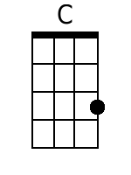
 |  |  |  |  |  |  |  | 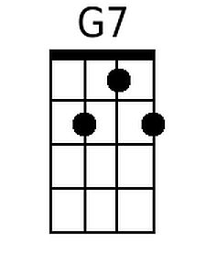
 |  |  |  |  |  |  |  | 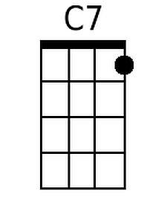
 |  |  |  |  |  |  |  | 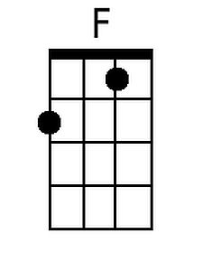
 |  |  |  |  |  |  |  | 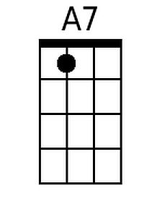
 |  |  |  |  |  |  |  | 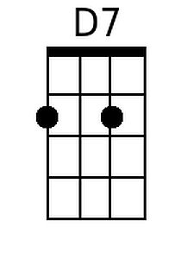
 |  |  |  |  |  |  |  | 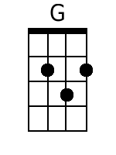
Baritone
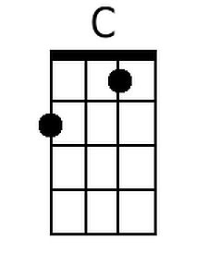 | 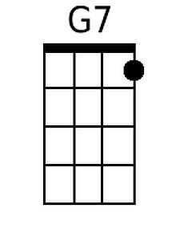 | 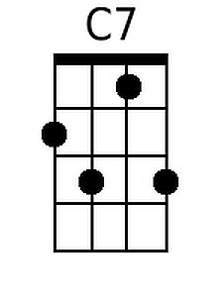 | 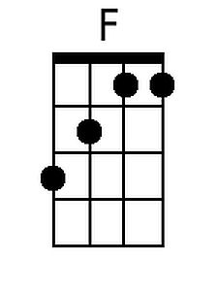 | 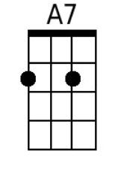 | 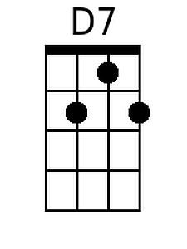 | 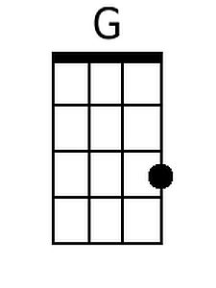

The Sidewalks of New York (Chas. B. Lawlor and James W. Blake, 1894)
Key of G in ¾ Time

Intro: G D7 G G7

G D7 G G7 C G G7
Down in front of Casey's . . . old brown wooden stoop
C G E7 A7 D D7
On a summer's evening, we formed a merry group;
G D7 G G7 C G G7
Boys and girls to-gether . . . we would sing and waltz
C G E7 A7 D7 G
While the "ginnie" played the organ on the sidewalks of New York.

Chorus
G D7 G7 C G G7
East Side, West Side, all around the town.
C G E7 A7 D D7
The tots sang "ring-around-rosie," "London Bridge is falling down"
G D7 G G7 C G G7
Boys and girls to-gether . . . me and Mamie O'Rourke,
C G E7 A7 D7 G
Tripped the light fan-tastic on the sidewalks of New York.

G D7 G G7 C G G7
That's where Johnny Casey . . . and little Jimmy Crowe
C G E7 A7 D D7
With Jakey Krause, the baker . . . who always had the dough.
G D7 G G7 C G G7
Pretty Nellie Shannon . . . with a dude as light as cork,
C G E7 A7 D7 G
First picked up the waltz-step on the sidewalks of New York. Chorus

G D7 G G7 C G G7
Things have changed since those times . . . some are up in "G"
C G E7 A7 D D7
Others they are wand'rers but they all feel just like me.
G D7 G G7 C G G7
They'd part with all they've got . . . could they but once more walk,
C G E7 A7 D7 G G7
With their best girl and have a twirl on the sidewalks of New York. Chorus

Outro (Retard):
C G E7 A7 D7 G
Tripped the light fan-tastic on the sidewalks of New York.
 |  |  |  |  |  |  |  | 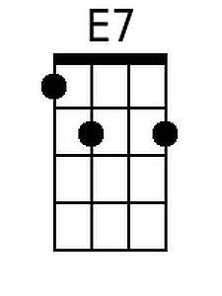
 |  |  |  |  |  |  |  | 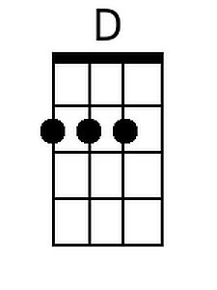
Baritone
 |  |  |  | 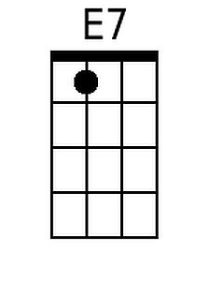 |  | 