The Sidewalks of New York (Chas. B. Lawlor and James W. Blake, 1894) (C)
Source: “The Sidewalks of New York” (Pioneer Music Pub. Co., 1894, 1914) - In ¾ Time

Intro: | C | G7 | C | Ebº7 | C | G7 | C |

C G7 C  1. Down in front of Casey's  F C  Old brown wooden stoop  F C  On a summer's evening  D7 G7  We formed a merry group  C G7 C  Boys and girls to-gether  F C  We would sing and waltz  C7 F Ebº7 C  While the "Ginnie" played the organ  G7b5 A7 D7 G7 C  On the sidewalks of New York  Chorus:  C G7 C - C7  East side, west side,  F G7 C  All around the town  C7 F C  The tots sang "ring a rosie"  F C D7 G7  "Lon-don Bridge is falling down"  C G7 C - C7  Boys and girls to-gether  F C  Me and Mamie O'Rorke  F C  Tripped the light fan-tastic  G7b5 A7 D7 G7 C  On the sidewalks of New York |  |  |  |  | C G7 C  2. That's where Johnny Casey  F C  And little Jimmy Crowe  F C  With Jakey Krause the baker  D7 G7  Who always had the dough  C G7 C  Pretty Nellie Shannon  F C - C7  With a dude as light as cork  F Ebº7 C  First picked up the waltz step  G7b5 A7 D7 G7 C  On the sidewalks of New York. Chorus  C G7 C  3. Things have changed since those times  F C  Some are up in "G"  F C  Others, they are wand'rers,  D7 G7  But they all feel just like me  C G7 C  They'd part with all they've got  F C  Could they but once more walk  C7 F Ebº7 C  With their best girl and have a  G7b5 A7 D7 G7 C  Twirl on the sidewalks of New York. Chorus |  |  |  |  |  |  | 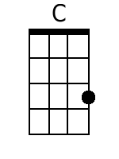 | 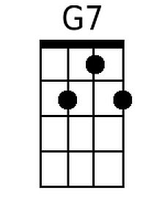
 |  |  |  |  |  |  |  |  |  |  |  | 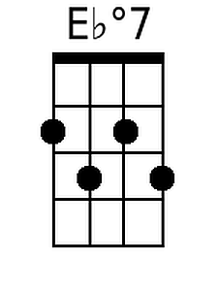 |  | 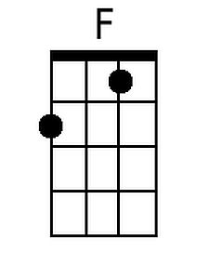
 |  |  |  |  |  |  |  |  |  |  |  | 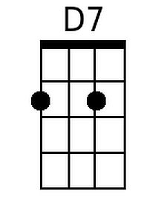 |  | 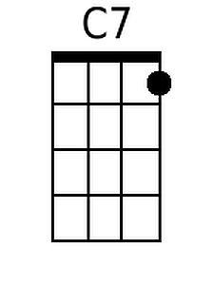
 |  |  |  |  |  |  |  |  |  |  |  | 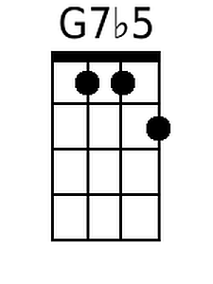 |  | 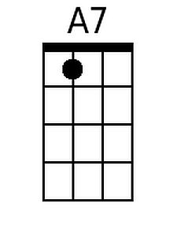
Baritone
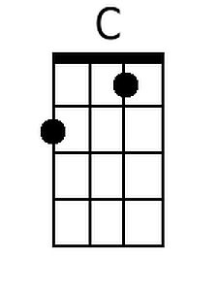 | 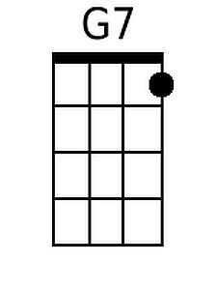 |  | 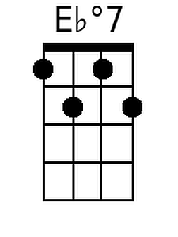 | 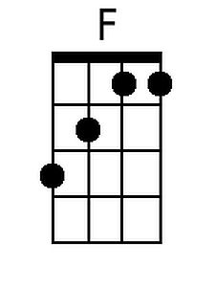 |  |  | 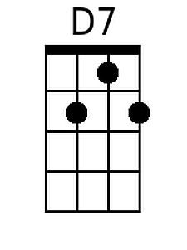 | 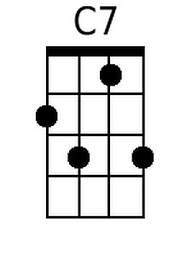 | 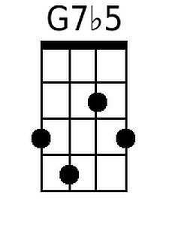 |  | 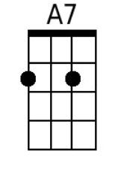

The Sidewalks of New York (Chas. B. Lawlor and James W. Blake, 1894) (G)
Source: “The Sidewalks of New York” (Pioneer Music Pub. Co., 1894, 1914) - In ¾ Time

Intro: | G | D7 | G | A#º7 | G | D7 | G |

G D7 G  1. Down in front of Casey's  C G  Old brown wooden stoop  C G  On a summer's evening  A7 D7  We formed a merry group  G D7 G  Boys and girls to-gether  C G  We would sing and waltz  G7 C Bbº7 G  While the "Ginnie" played the organ  D7b5 E7 A7 D7 G  On the sidewalks of New York  Chorus:  G D7 G - G7  East side, west side,  C D7 G  All around the town  G7 C G  The tots sang "ring a rosie"  C G A7 D7  "Lon-don Bridge is falling down"  G D7 G - G7  Boys and girls to-gether  C G  Me and Mamie O’Rorke  C G  Tripped the light fan-tastic  D7b5 E7 A7 D7 G  On the sidewalks of New York |  |  |  |  |  | G D7 G  2. That's where Johnny Casey  C G  And little Jimmy Crowe  C G  With Jakey Krause the baker  A7 D7  Who always had the dough  G D7 G  Pretty Nellie Shannon  C G - G7  With a dude as light as cork  C Bbº7 G  First picked up the waltz step  D7b5 E7 A7 D7 G  On the sidewalks of New York. Chorus  G D7 G  3. Things have changed since those times  C G  Some are up in "G"  C G  Others, they are wand’rers,  A7 D7  But they all feel just like me  G D7 G  They’d part with all they've got  C G  Could they but once more walk  G7 C Bbº7 G  With their best girl and have a  D7b5 E7 A7 D7 G  Twirl on the sidewalks of New York. Chorus |  |  |  |  |  |  | 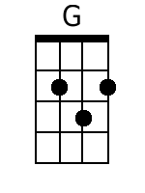
 |  |  |  |  |  |  |  |  |  |  |  |  | 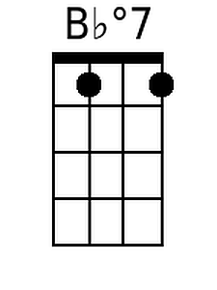
 |  |  |  |  |  |  |  |  |  |  |  |  | 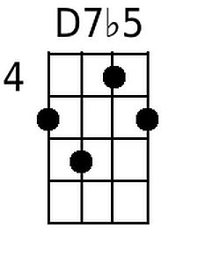 |  | 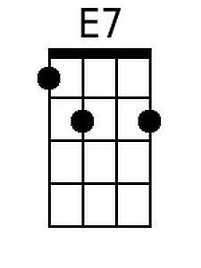
Baritone
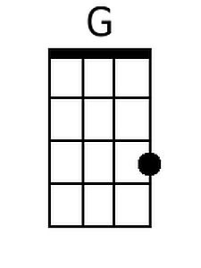 |  |  | 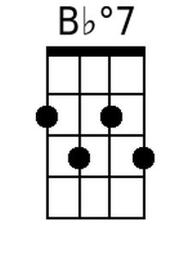 |  |  |  |  |  |  | 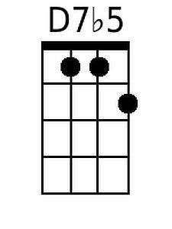 |  | 