
The Song That Never Ends (Norman Martin, 1988) (C)
The Song That Never Ends by Sheri Lewis and Her Puppets

Intro C G7  C G  1. This is the song that doesn't end.  G7 C  Yes, it goes on and on my friend.  C7 E7 A7  Some people started singing it not knowing what it was,  D7 G  And they'll continue singing it for-ever just because  Repeat Verse 1 (Indefinitely, or {2x} and then Verse 2)  D A  2. This is the song that doesn't end.  A7 D  Yes, it goes on and on my friend.  D7 F#7 B7  Some people started singing it not knowing what it was,  E7 A  And they'll continue singing it for-ever just because  Repeat Verse 2 (Indefinitely) |  |  |  |  |  |  | 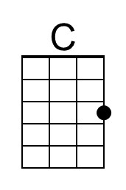 | 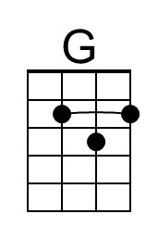
 |  |  |  |  |  |  | 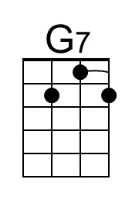 | 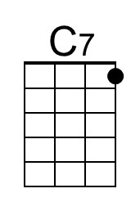
 |  |  |  |  |  |  | 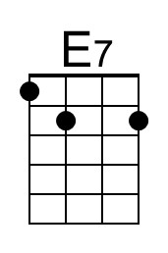 | 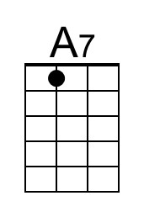
 |  |  |  |  |  |  | 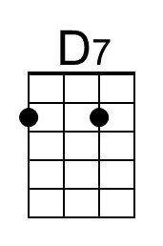 | 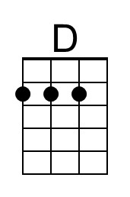
 |  |  |  |  |  |  | 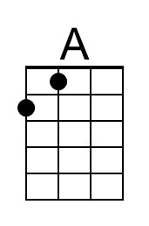 | 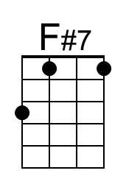
Bari | 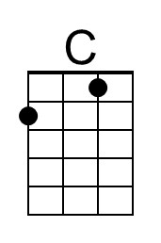 | 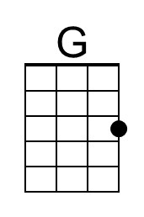 | 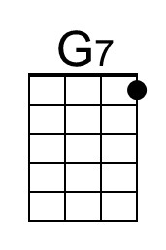 | 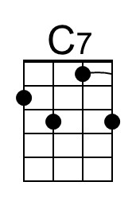 | 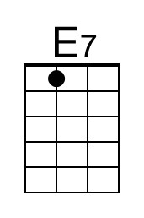 | 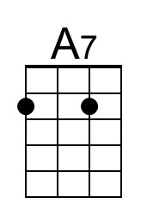 | 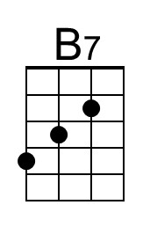
 | 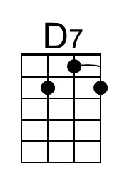 | 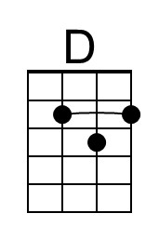 | 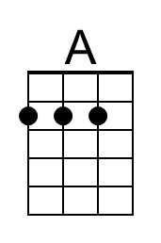 | 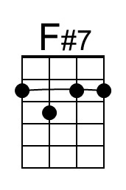 | 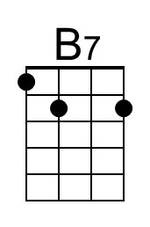

The Song That Never Ends (Norman Martin, 1988) (F)
The Song That Never Ends by Sheri Lewis and Her Puppets

Intro F C7  F C  1. This is the song that doesn't end.  C7 F  Yes, it goes on and on my friend.  F7 A7 D7  Some people started singing it not knowing what it was,  G7 C  And they'll continue singing it for-ever just because  Repeat Verse 1 (Indefinitely, or {2x} and then Verse 2)  G D  2. This is the song that doesn't end.  D7 G  Yes, it goes on and on my friend.  G7 B7 E7  Some people started singing it not knowing what it was,  A7 D  And they'll continue singing it for-ever just because  Repeat Verse 2 (Indefinitely) |  |  |  |  |  |  | 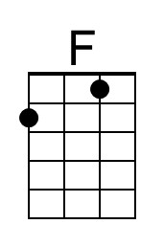
 |  |  |  |  |  |  |  | 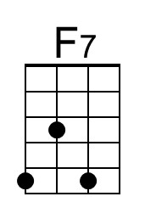
Bari | 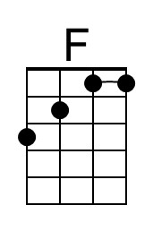 |  |  | 