The Sound of Music (Richard Rogers and Oscar Hammerstein II, 1959) (C)

C B  The hills are alive with the sound of music  Am F Dm7  With songs they have sung for a thousand years  C B  The hills fill my heart with the sound of music  C F G7 C  My heart wants to sing every song it hears.  F G#dim C  My heart wants to beat like the wings of the birds that rise  F G C  From the lake to the trees (to the trees)  F E7 C  My heart wants to sigh like a chime that flies  D7 G7  From a church on a breeze  F G#dim C F G7 C  To laugh like a brook when it trips and falls over stones on its way  (on its way)  Am Em Am7 D7 G G7  To sing through the night like a lark who is learning to pray  C B  I go to the hills when my heart is lonely  C F Dm7  I know I will hear what I've heard before  C Em F Dm7  My heart will be blessed with the sound of music  Em - G G7 C  And I'll si ---ing------ once------ more |  |  |  |  |  | 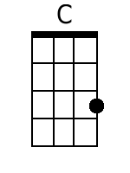 | 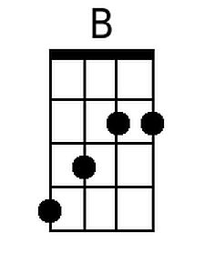
 |  |  |  |  |  | 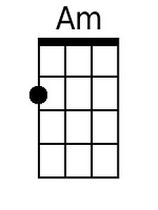 | 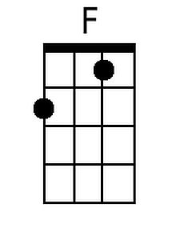
 |  |  |  |  |  | 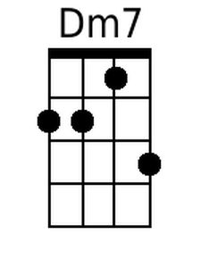 | 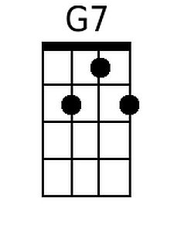
 |  |  |  |  |  | 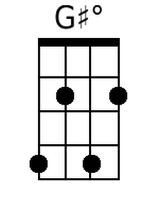 | 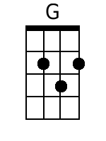
 |  |  |  |  |  | 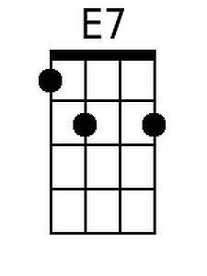 | 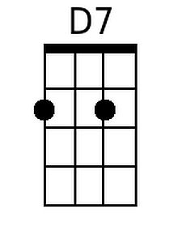
 |  |  |  |  |  | 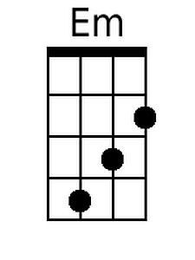 | 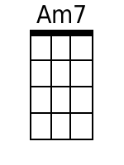
Baritone
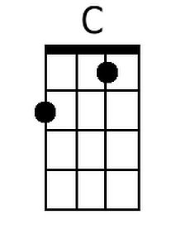 | 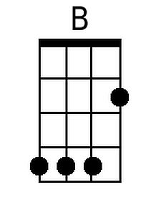 | 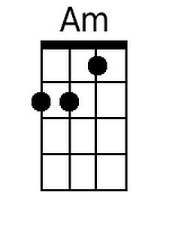 | 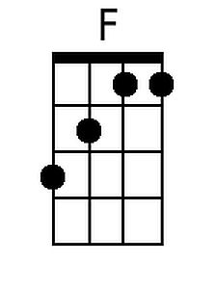 | 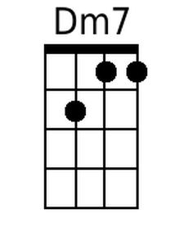 | 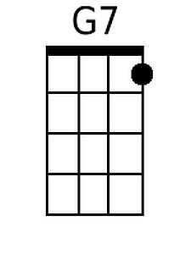
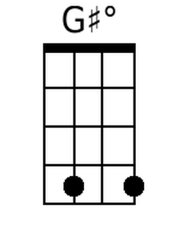 | 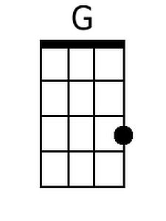 | 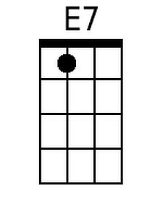 | 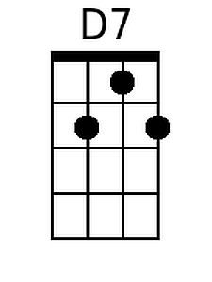 | 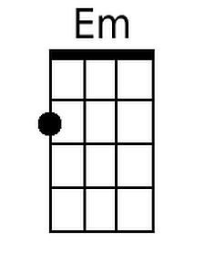 | 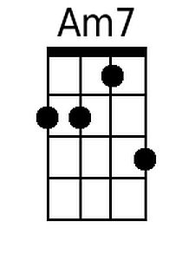

The Sound of Music (Richard Rogers and Oscar Hammerstein II, 1959) (F)

F E  The hills are alive with the sound of music  Dm Bb Gm7  With songs they have sung for a thousand years  F E  The hills fill my heart with the sound of music  F Bb C7 F  My heart wants to sing every song it hears.  Bb C#dim F  My heart wants to beat like the wings of the birds that rise  Bb C F  From the lake to the trees (to the trees)  Bb A7 F  My heart wants to sigh like a chime that flies  G7 C7  From a church on a breeze  Bb C#dim F Bb C7 F  To laugh like a brook when it trips and falls over stones on its way (on its way)  Dm Am Dm7 G7 C C7  To sing through the night like a lark who is learning to pray  F E  I go to the hills when my heart is lonely  F Bb Gm7  I know I will hear what I've heard before  F Am Bb Gm7  My heart will be blessed with the sound of music  Am - C C7 F  And I'll si ---ing------ once------ more |  |  |  |  |  |  | 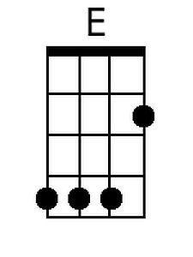
 |  |  |  |  |  | 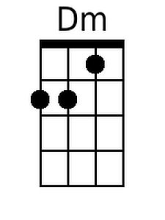 | 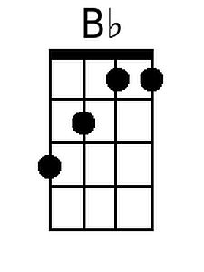
 |  |  |  |  |  | 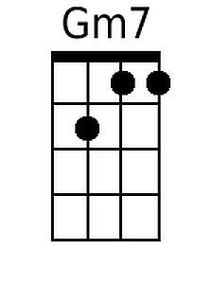 | 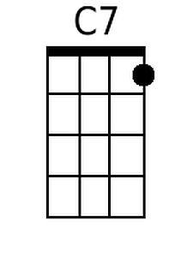
 |  |  |  |  |  | 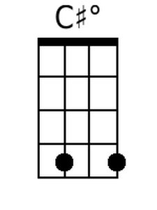
 |  |  |  |  |  | 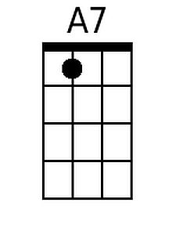
Baritone
 | 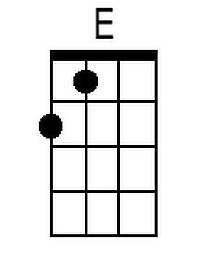 | 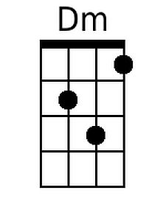 | 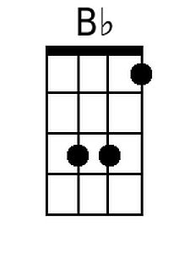 | 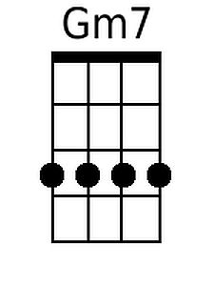 | 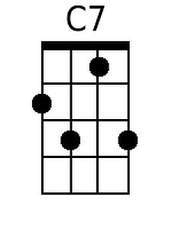
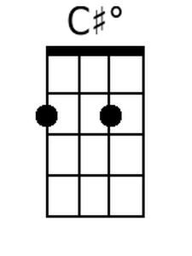 |  | 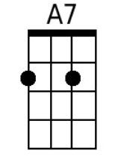

The Sound of Music (Richard Rogers and Oscar Hammerstein II, 1959) (G)

G F#  The hills are alive with the sound of music  Em C Am7  With songs they have sung for a thousand years  G F#  The hills fill my heart with the sound of music  G C D7 G  My heart wants to sing every song it hears.  C D#dim G  My heart wants to beat like the wings of the birds that rise  C D G  From the lake to the trees (to the trees)  C B7 G  My heart wants to sigh like a chime that flies  A7 D7  From a church on a breeze  C D#dim G C D7 G  To laugh like a brook when it trips and falls over stones on its way  (on its way)  Em Bm Em7 A7 D D7  To sing through the night like a lark who is learning to pray  G F#  I go to the hills when my heart is lonely  G C Am7  I know I will hear what I've heard before  G Bm C Am7  My heart will be blessed with the sound of music  Bm - D D7 G  And I'll si ---ing------ once------ more |  |  |  |  |  |  | 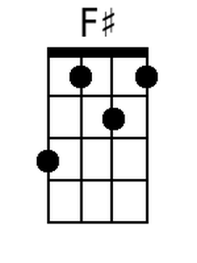
 |  |  |  |  |  | 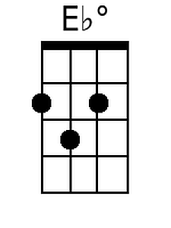 | 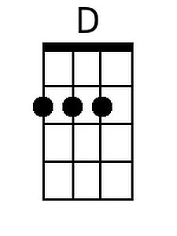
 |  |  |  |  |  | 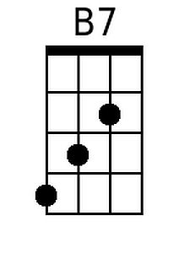
 |  |  |  |  |  | 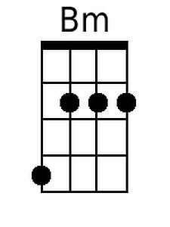 | 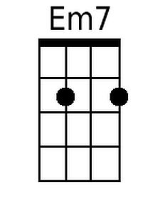
Baritone
 | 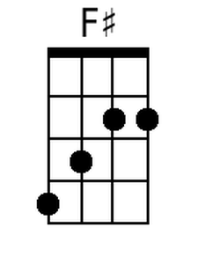
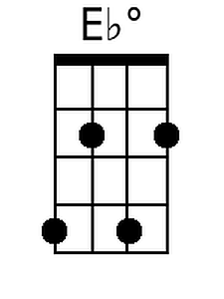 | 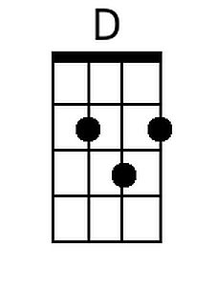 | 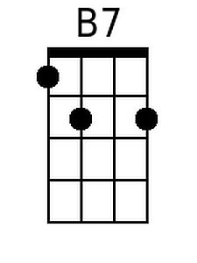 |  | 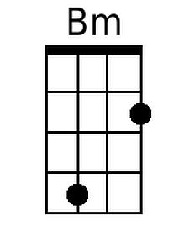 | 