The Sound of Music (Richard Rogers and Oscar Hammerstein II, 1959) (F)

F E  The hills are alive with the sound of music  Dm Bb Bº7  With songs they have sung for a thousand years  F E  The hills fill my heart with the sound of music  F Bb C7 F  My heart wants to sing every song it hears.  Bb C#º7 F  My heart wants to beat like the wings of the birds that rise  Bb C F  From the lake to the trees (to the trees)  Bb A7 F  My heart wants to sigh like a chime that flies  G7 C7  From a church on a breeze  Bb C#º7 F Bb C7 F  To laugh like a brook when it trips and falls over stones on its way (on its way)  Dm Am Dm7 G7 C C7  To sing through the night like a lark who is learning to pray  F E  I go to the hills when my heart is lonely  Dm Bb Bº7  I know I will hear what I've heard be-fore  F Am Bb Gm7  My heart will be blessed with the sound of music  Am - C C7 F  And I'll si ---ing------ once------ more |  |  |  |  |  | 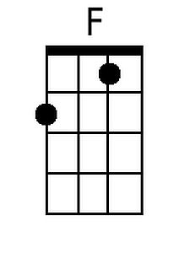 | 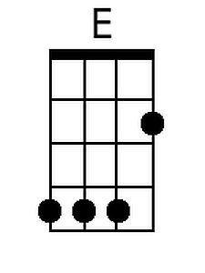
 |  |  |  |  |  | 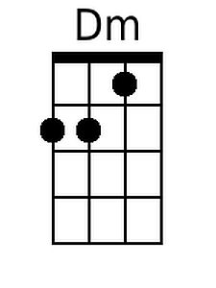 | 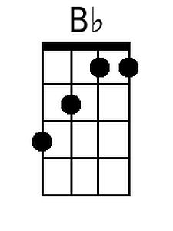
 |  |  |  |  |  | 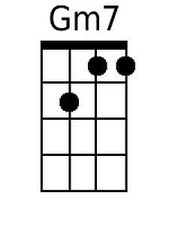 | 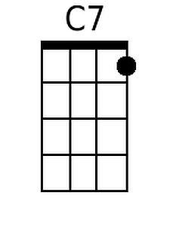
 |  |  |  |  |  | 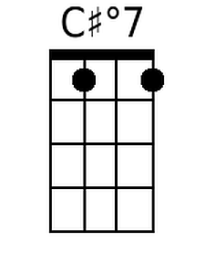 | 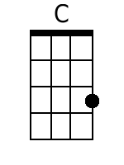
 |  |  |  |  |  | 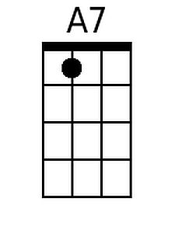 | 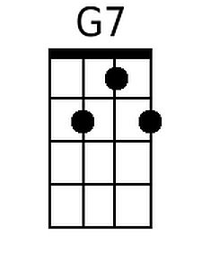
 |  |  |  |  |  | 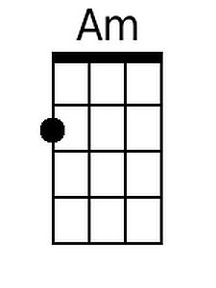 | 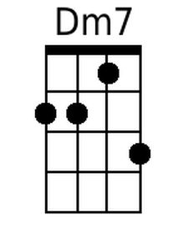
 |  |  |  |  |  |  | 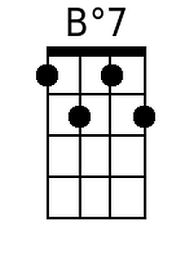
Baritone
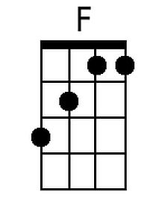 | 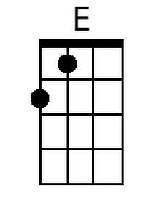 | 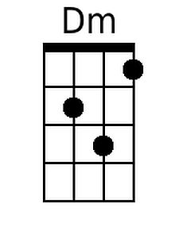 | 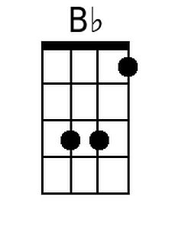 | 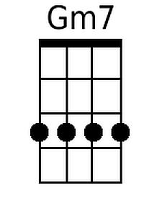 | 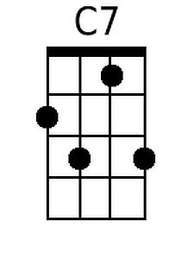 | 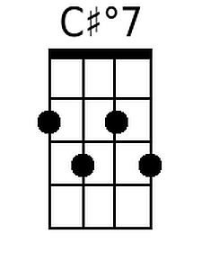
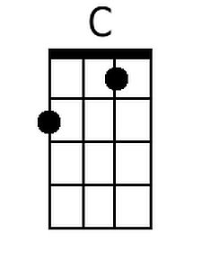 | 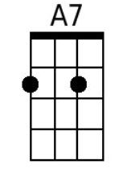 | 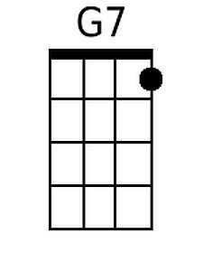 | 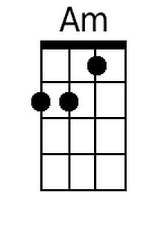 | 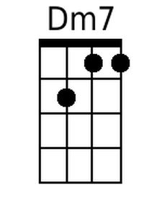 | 