The Spanish Lady (Traditional) – Version 1 – Key C

C Am  As I came down through Dublin City  Dm G7  At the hour of twelve at night  C Am  Who should I spy but a Spanish lady  Dm G7  Washing her feet by the candlelight  C Am  First she washed them, then she dried them  C G  Over a fire of amber coal  C Am  In all me life I ne'er did see  Dm G7  A maid so sweet about the soul  Chorus  C Am  Whack for the toora loora laddie  Dm G7  Whack for the toora loora lay  C Am  Whack for the toora loora laddie  Dm G7  Whack for the toora loora lay  As I came back through Dublin City  At the hour of half past eight  Who should I spy but the Spanish lady  Brushing her hair in the broad daylight  First she brushed it, then she tossed it  On her lap was a silver comb  In all me life I ne'er did see  A maid so fair since I did roam (Chorus)  As I returned to Dublin City  As the sun began to set  Who should I spy but a Spanish lady  Catching a moth, in a golden net  First she saw me, then she fled me  Lifted her petticoats o'er her knee  In all me life I ne'er did see  A maid so fair as the Spanish lady  (Chorus) | I stopped to look but the Watchman passed  Says he, “Young fella, now the night is late”  Along with ye now or I will wrestle ya  Straight way through the Bridewell Gate  I threw a kiss to the Spanish lady  Hot as a fire of angry coal  In all me life I ne'er did see  A maid so sweet about the soul  (Chorus)  As I went out through Dublin City  As the hour of dawn was ‘oer  Who should I see but the Spanish lady  I was lonely and footsore  First she coaxed me, then she chid me  Then she laughed at my sad plight  In all me time I ne’er did see  A maid so sweet as on that night  (Chorus)  I've wandered north and I have wandered south  Through Stoney Barter and Patrick's close  Up and around, by the Gloucester Diamond  And back by Napper Tandys' house  Auld age has laid her hands on me  Cold as a fire of ashy coals  But there is the love of me Spanish lady  Neat and sweet about the soul  (Chorus) 2x
 | 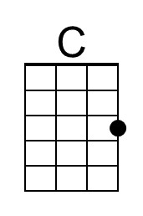 | 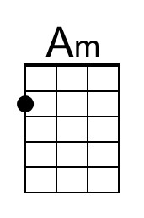 | 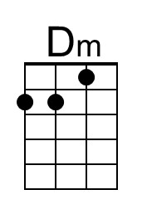 | 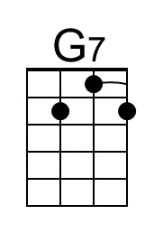 | 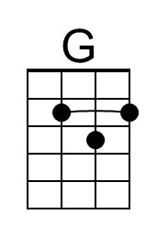
 | 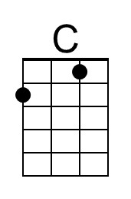 | 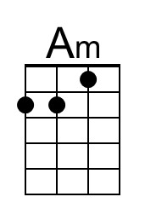 | 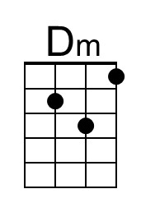 | 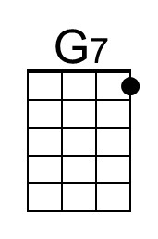 | 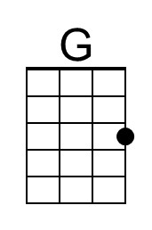

The Spanish Lady (Traditional) – Version 1 – Key G

G Em  As I came down through Dublin City  Am D7  At the hour of twelve at night  G Em  Who should I spy but a Spanish lady  Am D7  Washing her feet by the candlelight  G Em  First she washed them, then she dried them  G D  Over a fire of amber coal  G Em  In all me life I ne'er did see  Am D7  A maid so sweet about the soul  Chorus  G Em  Whack for the toora loora laddie  Am D7  Whack for the toora loora lay  G Em  Whack for the toora loora laddie  Am D7  Whack for the toora loora lay  As I came back through Dublin City  At the hour of half past eight  Who should I spy but the Spanish lady  Brushing her hair in the broad daylight  First she brushed it, then she tossed it  On her lap was a silver comb  In all me life I ne'er did see  A maid so fair since I did roam (Chorus)  As I returned to Dublin City  As the sun began to set  Who should I spy but a Spanish lady  Catching a moth, in a golden net  First she saw me, then she fled me  Lifted her petticoats o'er her knee  In all me life I ne'er did see  A maid so fair as the Spanish lady  (Chorus) | I stopped to look but the Watchman passed  Says he, "Young fella, now the night is late"  Along with ye now or I will wrestle ya  Straight way through the Bridewell Gate  I threw a kiss to the Spanish lady  Hot as a fire of angry coal  In all me life I ne'er did see  A maid so sweet about the soul  (Chorus)  As I went out through Dublin City  As the hour of dawn was 'oer  Who should I see but the Spanish lady  I was lonely and footsore  First she coaxed me, then she chid me  Then she laughed at my sad plight  In all me time I ne'er did see  A maid so sweet as on that night  (Chorus)  I've wandered north and I have wandered south  Through Stoney Barter and Patrick's close  Up and around, by the Gloucester Diamond  And back by Napper Tandys' house  Auld age has laid her hands on me  Cold as a fire of ashy coals  But there is the love of me Spanish lady  Neat and sweet about the soul  (Chorus) 2x
 |  | 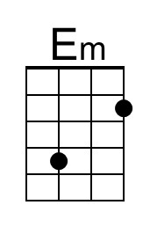 |  | 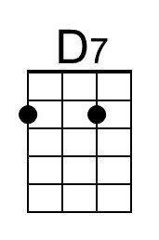 | 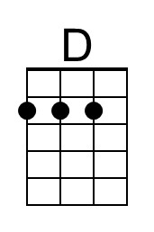
 |  | 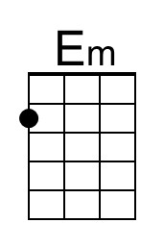 |  | 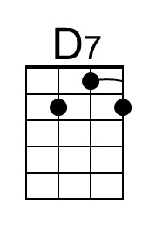 | 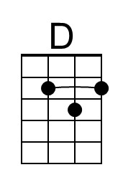

The Spanish Lady (Traditional) – Version 2 – Key C

C Am  As I came down thru Dublin city  Dm G7  At the hour of twelve at night  C Am  Who should I see but a Spanish Lady,  Dm G7  Washing her feet by candlelight  C Am  First she washed them, then she dried them  C G  Over a fire of amber coals  C Am  In all my life I ne'er did see  Dm G7  A maid so sweet about the soul  Chorus:  C Am  Whack for the toora loora laddy  Dm G7  Whack for the toora loora lay  C Am  Whack for the toora loora laddy  Dm G7  Whack for the toora loora lay  C Am  As I came back thru Dublin city  Dm G7  At the hour of half past eight  C Am  Who should I see but the Spanish lady  Dm G7  Brushing her hair outside the gate  C Am  First she tossed it, then she combed it,  C G  On her lap was a silver comb  C Am  In all my life I ne'er did see  Dm G7  A maid so fair since I did roam  (Chorus) | C Am  I stopped to look but the Watchman passed  Dm G7  He said “Young fellah, now the night is late  C Am  Along with ye home or I will wrestle you  Dm G7  Straight back through the Bridewell gate”  C Am  I threw a kiss to the Spanish lady  C G  Hot as a fire of angry coal  C Am  In all my life I ne'er did see  Dm G7  A maid so sweet about the soul  C Am  As I came back thru Dublin city  Dm G7  As the sun began to set  C Am  Who should I see but the Spanish lady  Dm G7  Catching a moth in a golden net  C Am  When she saw me, then she fled me  C G  Lifting her petticoat over her knee  C Am  In all my life I ne'er did see  Dm G7  A maid so shy as the Spanish Lady  (Chorus)  C Am  I've wandered north and south through  Dm G7  Stoneybatter and Patrick's Close  C Am  Up and around by the Gloucester Diamond  Dm G7  And back by Napper Tandy's house  C Am  Old age has laid her hand on me  C G  Cold as a fire of ashy coals  C Am  In all my life I ne'er did see  Dm G7  A maid so sweet as the Spanish Lady

The Spanish Lady (Traditional) – Version 2 – Key G

G Em  As I came down thru Dublin city  Am D7  At the hour of twelve at night  G Em  Who should I see but a Spanish Lady,  Am D7  Washing her feet by candlelight  G Em  First she washed them, then she dried them  G D  Over a fire of amber coals  G Em  In all my life I ne'er did see  Am D7  A maid so sweet about the soul  Chorus  G Em  Whack for the toora loora laddy  Am D7  Whack for the toora loora lay  G Em  Whack for the toora loora laddy  Am D7  Whack for the toora loora lay  G Em  As I came back thru Dublin city  Am D7  At the hour of half past eight  G Em  Who should I see but the Spanish lady  Am D7  Brushing her hair outside the gate  G Em  First she tossed it, then she combed it,  G D  On her lap was a silver comb  G Em  In all my life I ne'er did see  Am D7  A maid so fair since I did roam  (Chorus) | G Em  I stopped to look but the Watchman passed  Am D7  He said "Young fellah, now the night is late  G Em  Along with ye home or I will wrestle you  Am D7  Straight back through the Bridewell gate"  G Em  I threw a kiss to the Spanish lady  G D  Hot as a fire of angry coal  G Em  In all my life I ne'er did see  Am D7  A maid so sweet about the soul  G Em  As I came back thru Dublin city  Am D7  As the sun began to set  G Em  Who should I see but the Spanish lady  Am D7  Catching a moth in a golden net  G Em  When she saw me, then she fled me  G D  Lifting her petticoat over her knee  G Em  In all my life I ne'er did see  Am D7  A maid so shy as the Spanish Lady  (Chorus)  G Em  I've wandered north and south through  Am D7  Stoneybatter and Patrick's Close  G Em  Up and around by the Gloucester Diamond  Am D7  And back by Napper Tandy's house  G Em  Old age has laid her hand on me  G D  Cold as a fire of ashy coals  G Em  In all my life I ne'er did see  Am D7  A maid so sweet as the Spanish Lady

The Spanish Lady (Traditional) – Version 3 – Key C

C Am  As I came down thru Dublin city  Dm G7  At the hour of twelve at night  C Am  Who should I see but a Spanish Lady,  Dm G7  Washing her feet by candlelight  C Am  First she washed them, then she dried them  C G  Over a fire of amber coals  C Am  In all my life I ne'er did see  Dm G7  A maid so sweet about the soul  Chorus  C Am  Whack for the toora loora laddy  Dm G7  Whack for the toora loora lay  C Am  Whack for the toora loora laddy  Dm G7  Whack for the toora loora lay  C Am  As I came back thru Dublin city  Dm G7  At the hour of half past eight  C Am  Who should I see but the Spanish lady  Dm G7  Brushing her hair in broad daylight  C Am  First she tossed it, then she combed it,  C G  On her lap was a silver comb  C Am  In all my life I ne'er did see  Dm G7  A maid so fair since I did roam  (Chorus) | C Am  As I came back thru Dublin city  Dm G7  As the sun began to set  C Am  Who should I see but the Spanish lady  Dm G7  Catching a moth in a golden net  C Am  When she saw me, then she fled me  C G  Lifting her petticoat over her knee  C Am  In all my life I ne'er did see  Dm G7  A maid so shy as the Spanish Lady  (Chorus)  C Am  I've wandered north and south through  Dm G7  Stoneybatter and Patrick's Close  C Am  Up and around by the Gloucester Diamond  Dm G7  And back by Napper Tandy's house  C Am  Old age has laid her hand on me  C G  Cold as a fire of ashy coals  C Am  In all my life I ne'er did see  Dm G7  A maid so sweet as the Spanish Lady

The Spanish Lady (Traditional) – Version 3 – Key G

G Em  As I came down thru Dublin city  Am D7  At the hour of twelve at night  G Em  Who should I see but a Spanish Lady,  Am D7  Washing her feet by candlelight  G Em  First she washed them, then she dried them  G D  Over a fire of amber coals  G Em  In all my life I ne'er did see  Am D7  A maid so sweet about the soul  Chorus  G Em  Whack for the toora loora laddy  Am D7  Whack for the toora loora lay  G Em  Whack for the toora loora laddy  Am D7  Whack for the toora loora lay  G Em  As I came back thru Dublin city  Am D7  At the hour of half past eight  G Em  Who should I see but the Spanish lady  Am D7  Brushing her hair in broad daylight  G Em  First she tossed it, then she combed it,  G D  On her lap was a silver comb  G Em  In all my life I ne'er did see  Am D7  A maid so fair since I did roam  (Chorus) | G Em  As I came back thru Dublin city  Am D7  As the sun began to set  G Em  Who should I see but the Spanish lady  Am D7  Catching a moth in a golden net  G Em  When she saw me, then she fled me  G D  Lifting her petticoat over her knee  G Em  In all my life I ne'er did see  Am D7  A maid so shy as the Spanish Lady  (Chorus)  G Em  I've wandered north and south through  Am D7  Stoneybatter and Patrick's Close  G Em  Up and around by the Gloucester Diamond  Am D7  And back by Napper Tandy's house  G Em  Old age has laid her hand on me  G D  Cold as a fire of ashy coals  G Em  In all my life I ne'er did see  Am D7  A maid so sweet as the Spanish Lady

