The Surrey With the Fringe on Top (Rodgers & Hammerstein, 1943)
Version 1 (C)

C G C G  Chicks and ducks and geese better scurry,  C G C G  When I take ya out in the surrey  C G C G D G  When I take ya out in the surrey with the fringe on top.  C G C G  Watch that fringe and see how it flutters  C G C G  When I drive them high steppin' strutters  C G C G D7 G7  Nosey pokes 'll peek thru their shutters and their eyes 'll pop!  C7 F D  The wheels are yellow, the upholstery's brown  C F  The dashboard's genuine leather  D7 G  With isinglass curtains y' can roll right down  D7 G7 C7  In case there's a change in the wea-ther  C C G  Two bright sidelights winkin' and blinkin', ain't no finer rig I'm a thinkin'  C G C F Dm  You can keep your rig if you're thinkin' that I'd care t' swap  G Dm G C  For that shiny little surrey with the fringe on the top. |  |  |  |  |  |  | 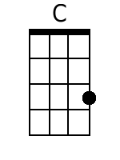 | 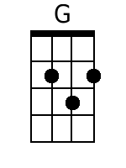
 |  |  |  |  |  |  | 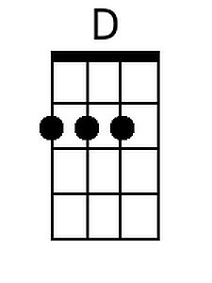 | 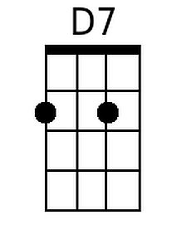
 |  |  |  |  |  |  | 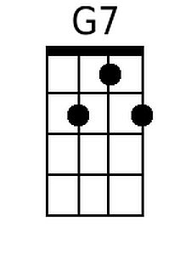 | 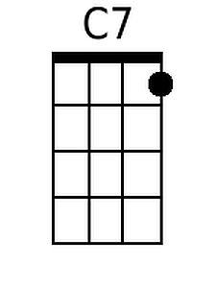
 |  |  |  |  |  |  | 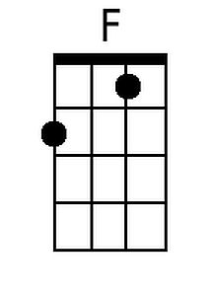 | 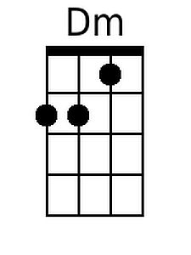
 |  |  |  |  |  |  | 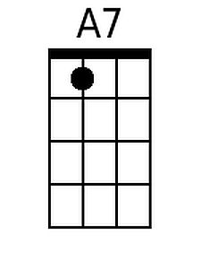 | 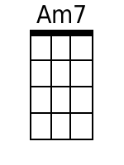
 |  |  |  |  |  |  | 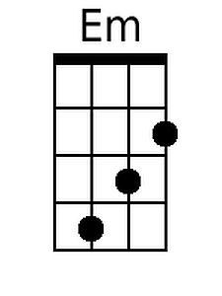 | 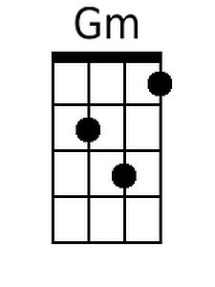
Baritone
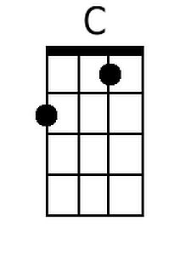 | 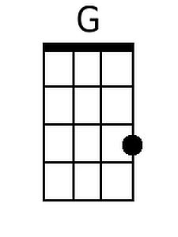 | 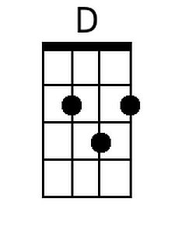 | 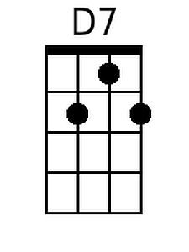 | 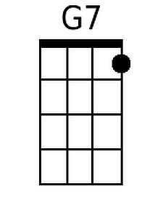 | 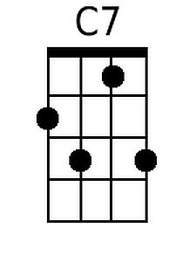
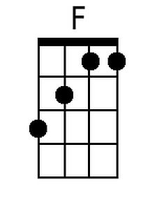 | 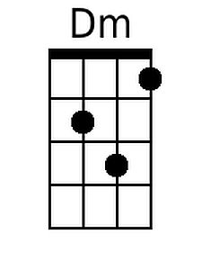 | 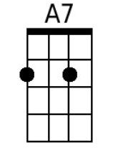 | 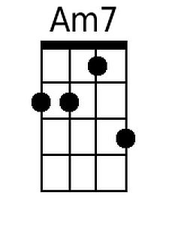 | 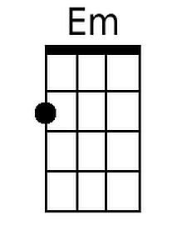 | 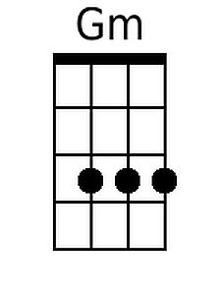

The Surrey With the Fringe on Top – Version 1 – Page 2 (C)

C
All the world 'll fly in a flurry when I take you out in the surrey
C A7 D G
When I take you out in the surrey with the fringe on the top.

C G C G C G C G
When we hit that road hell for leather. Cats and dogs'll dance in the heather.
C G C G A7 D G7
Birds and frogs'll sing all to-gether and the toads will hop

C F D C F
The wind 'll whistle as we rattle a-long, the cows 'll moo in the clover.
D7 G D7 G7
The river will ripple out a whispered song, and whisper it over and over.

First 3 lines: softly
C
Don't you wisht it'd go on forever? Don't you wisht it'd go on forever?
C G C G F D
Don't you wisht it'd go on forever, (louder) And it'd never stop?
G G7 G C F C
In that shiny little surrey with the fringe on the top

Softly and slower until the end
C G C G C G C G
I can see the stars gettin' blurry, when we ride back home in the surrey
C G C G D G7
Riding slowly home in the surrey with the fringe on top

C G C G C G C G
I can feel the day gettin' older, feel a sleepy head near my shoulder
C G C G F G7
Noddin', droopin' close to my shoulder, ‘til it falls ker-plop

C7 F D C F
The sun is swimmin' on the rim of a hill, the moon is takin' a header
D7 G Am7 D7 G7
And just as I'm thinkin' all the earth is still, a lark wakes up in the meader.

C G C G C G C G
Hush you bird, my baby's a sleepin'. Maybe got a dream worth a keepin'
C G C G F Em D
Whoa you team, and just keep a creepin', at a slow clip – clop.
C Gm Dm G7 C
Don't you hurry with the surrey, with the fringe on the top.

The Surrey With the Fringe on Top (Rodgers & Hammerstein, 1943)
Version 1 (G)

G D G D
Chicks and ducks and geese better scurry
G D G D
When I take ya out in the surrey
G D G D A D
When I take ya out in the surrey with the fringe on top.

G D G D
Watch that fringe and see how it flutters
G D G D
When I drive them high steppin' strutters
G D G D A7 D7
Nosey pokes 'll peek thru their shutters and their eyes 'll pop!

G7 C A
The wheels are yellow, the upholstery's brown
G C
The dashboard's genuine leather
A7 D
With isinglass curtains y' can roll right down
A7 D7 G7
In case there's a change in the wea-ther

G G D
Two bright sidelights winkin' and blinkin', ain't no finer rig I'm a thinkin'
G D G C Am
You can keep your rig if you're thinkin' that I'd care t' swap
D Am D G
For that shiny little surrey with the fringe on the top.

 |  |  |  |  |  |  | 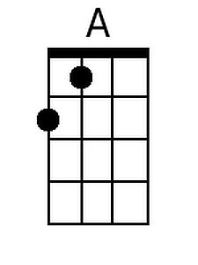
 |  |  |  |  |  |  |  | 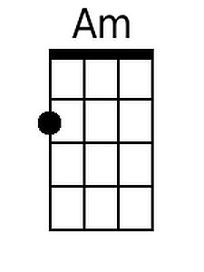
 |  |  |  |  |  |  | 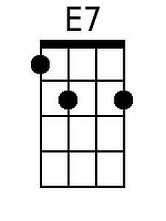 | 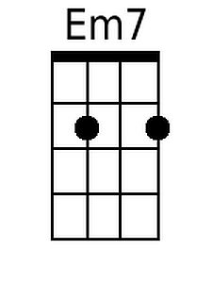
 |  |  |  |  |  |  | 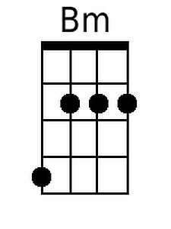
Baritone
 |  | 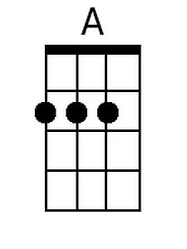
 | 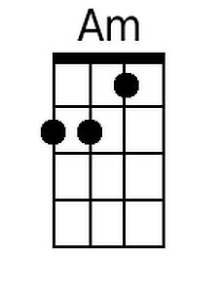 | 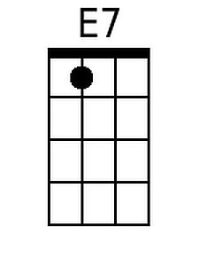 | 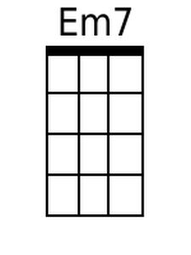 | 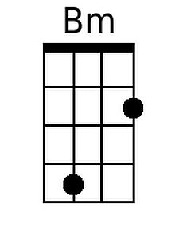

The Surrey With the Fringe on Top – Version 1 – Page 2 (G)
G
All the world 'll fly in a flurry, when I take you out in the surrey,
G E7 A D
When I take you out in the surrey with the fringe on the top

G D G D G D G D
When we hit that road hell for leather. Cats and dogs 'll dance in the heather.
G D G D E7 A D7
Birds and frogs 'll sing all to-gether and the toads will hop

G C A G C
The wind 'll whistle as we rattle a-long, the cows 'll moo in the clover.
A7 D A7 D7
The river will ripple out a whispered song, and whisper it over and over.

First 3 lines: softly
G
Don't you wisht it'd go on forever? Don't you wisht it'd go on forever?
G D G D C A
Don't you wisht it'd go on forever, (louder) And it'd never stop?
D D7 D G C G
In that shiny little surrey with the fringe on the top

Softly and slower until the end
G D G D G D G D
I can see the stars gettin' blurry, when we ride back home in the surrey
G D G D A D7
Riding slowly home in the surrey with the fringe on top

G D G D G D G D
I can feel the day gettin' older, feel a sleepy head near my shoulder
G D G D C D7
Noddin', droopin' close to my shoulder, 'til it falls ker-plop

G7 C A G C
The sun is swimmin' on the rim of a hill, the moon is takin' a header
A7 D Em7 A7 D7
And just as I'm thinkin' all the earth is still, a lark wakes up in the meader.

G D G D G D G D
Hush you bird, my baby's a sleepin'. Maybe got a dream worth a keepin'
G D G D C Bm A
Whoa you team, and just keep a creepin', at a slow clip - clop.
G Dm Am D7 G
Don't you hurry with the surrey, with the fringe on the top.

