The Surrey With the Fringe on Top (Rodgers & Hammerstein, 1943)
Version 3 (G)

Introduction: G (4x)  Prelude (Optional)  G E  When I take you out to-night with me.  E C#  Honey, here's the way it's gonna be.  C# Bb Eb - F  You will set behind a team of snow-white hor - ses,  G  In the slickest gig ya ever see!  G  1. Chicks and ducks and geese better scurry, when I take ya out in the surrey  G Em (A7) D7  When I take ya out in the surrey with the fringe on top.  G  Watch that fringe and see how it flutters. when I drive them high steppin' strutters  G Em (A7) Am - D7  Nosey pokes 'll peek thru their shutters and their eyes will pop!  Dm G7 C  The wheels are yellow, the up-holstery's brown,  Dm G7 C  The dashboard's genuine leather  Em A7 D  With isinglass curtains y' can roll right down,  Em A7 Am D7  In case there's a change in the wea – ther.  G  Two bright sidelights winkin' and blinkin', ain't no finer rig I'm a thinkin'  G C E7 Am  You can keep your rig if you're thinkin' that I'd care to swap  G Am D7 G | F D7 |  For that shiny little surrey with the fringe on the top. |  |  |  |  |  |  |  | 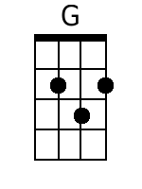 |  | 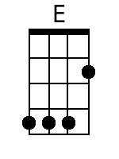
 |  |  |  |  |  |  |  | 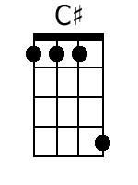 |  | 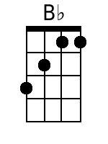
 |  |  |  |  |  |  |  | 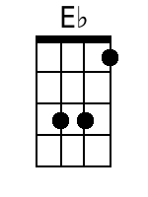 |  | 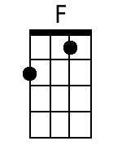
 |  |  |  |  |  |  |  | 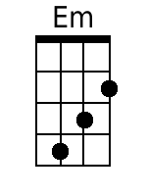 |  | 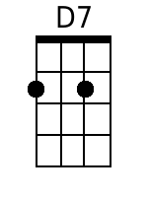
 |  |  |  |  |  |  |  | 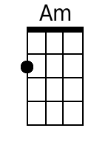 |  | 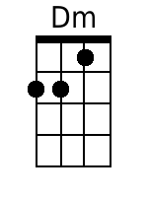
 |  |  |  |  |  |  |  | 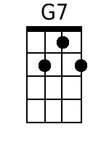 |  | 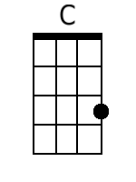
 |  |  |  |  |  |  |  | 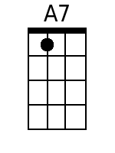 |  | 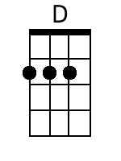
 |  |  |  |  |  |  |  | 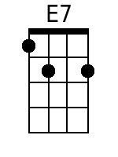
Baritone
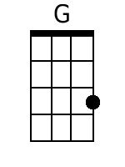 | 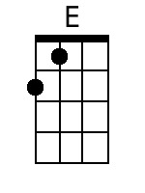 | 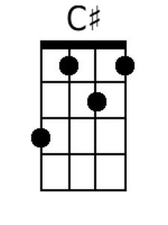 | 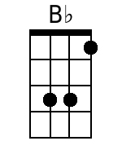 | 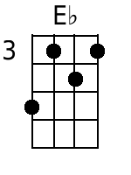 | 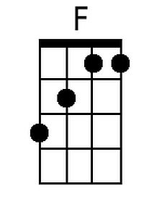 | 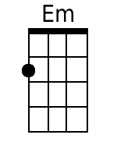 | 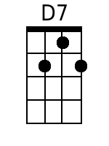
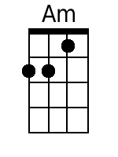 | 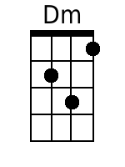 | 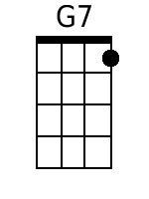 | 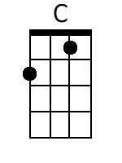 | 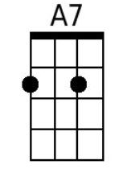 | 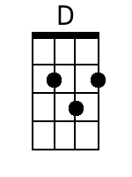 | 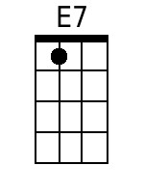

The Surrey With The Fringe On Top (G) – Page 2
Interlude (Optional)
G E
Would you say the fringe was made of silk?
E C#
Wouldn't have no other kind but silk!
C# Bb Eb - F
Has it really got a team of snow-white hor-ses?
G
One's like snow, the other's more like milk.

G
2. All the world 'll fly in a flurry when I take you out in the surrey
G Em (A7) D7
When I take you out in the surrey with the fringe on the top.
G
When we hit that road hell-for-leather. Cats and dogs'll dance in the heather.
G Em (A7) Am - D7
Birds and frogs'll sing all together and the toads will hop
Dm G7 C Dm G7 C
The wind 'll whistle as we rattle along, the cows 'll moo in the clover.
Em A7 D Em A7 Am D7
The river will ripple out a whispered song, and whisper it over and over.
First 1 ½ lines softly and slower
G
Don't you wisht it'd go on forever? Don't you wisht it'd go on for-ever?
G C E7 Am
Don't you wisht it'd go on forever, (louder) And it'd ne - ver stop?
G Am D7 G | F D7 |
In that shiny little surrey with the fringe on the top

Softly and slower until the end
G
3. I can see the stars gettin' blurry, when we ride back home in the surrey
G Em (A7) D7
Riding slowly home in the surrey with the fringe on top.
G
I can feel the day gettin' older, feel a sleepy head near my shoulder
G Em (A7) D7
Noddin', droopin' close to my shoulder, ‘til it falls ker - plop
Dm G7 C Dm G7 C
The sun is swimmin' on the rim of a hill, the moon is takin' a header
Em A7 D Em A7 Am D7
And just as I'm thinkin' all the earth is still, a lark wakes up in the mea - der.
G
Hush, you bird, my baby's a sleepin'. Maybe got a dream worth a keepin'
G C E7 Am
Whoa, you team, and just keep a creepin', at a slow clip – clop.
G Am D7 G C G (Hold)
Don't you hurry with the surrey, with the fringe on the top.

