**The Thing (Charles Grean)**

**G**



G

While I was walkin' down the beach

**C G**

One bright and sunny day,

I saw a great big wooden box

**Am D7**

A-floatin' in the bay

**G**



C

I pulled it in and opened it up

**C G**

And much to my surprise

**(2x) N.C.**

Oh, I discovered a... (# - # - #)

**C D7 G**

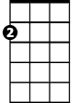

Am

Right before my eyes

**G**

I picked it up and ran to town

**C G**

As happy as a king –

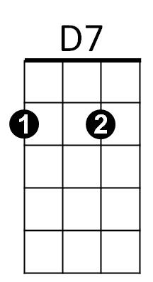I took it to a guy I knew

**Am D7**

Who'd buy most anything

**G**

But this is what he hollered at me

**C G**

As I walked in his shop

**(2x) N.C.**

"Oh, get out of here with that {#, #, #}

**C D7 G**

Before I call a cop"

**G**

I turned around and got right out

**C G**

A-runnin' for my life -

And then I took it home with me

**Am D7**

To give it to my wife

**G**

But this is what she hollered at me

**C G**

As I walked in the door

**(2x) N.C.**

"Oh, get out of here with that {#, #, #}

**C D7 G**

And don't come back no more"

**G**

I wandered all around the town

**C G**

Until I chanced to meet

A hobo who was lookin' for

**Am D7**

A handout on the street

**G**

He said he'd take most any old thing

**C G**

He was a desperate man

**(2x) N.C.**

But when I showed him the {#, #, #}

**C D7 G**

He turned around and ran

**G**

I wandered on for many years

**C G**

A victim of my fate - Until one day I came upon

**Am D7**

**BARITONE**

St Peter at the gate



G

**G**

And when I tried to take it inside

**C G**

He told me where to go

**(2x) N.C.**

Get out of here with that {#, #, #}

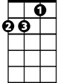

Am

C



**C D7 G**

And take it down below

**G**

The moral of this story is

**C G**

If you're out on the beach

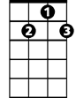

D7

And you should see a great big box

**Am D7**

And it's within your reach

**G**

Don't ever stop and open it up

**C G**

That's my advice to you

**N.C.**

'Cause, you'll never get rid of the {#, #, #}

**C D7 G**

No matter what you do

**N.C.**

Oh, you'll never get rid of the {#, #, #}

**C D7 G**

No matter what you do