**The Things We Do For Love (Eric Stewart / G. Gouldman)**

**INTRO: G C / Em C / G C Gm7 (last 4 lines of Reprise)**

**Am F**

Too many broken hearts have fallen in the river

**C Em Dm**

Too many lonely souls have drifted out to sea

**F E7**

You lay your bets and then you pay the price

**Dm C**

The things we do for love

**F C**

The things we do for love

**Am F**

Communication is the problem to the answer

**C Em Dm**

You've got her number and your hand is on the phone

**F E7**

The weather's turned and all the lines are down

**Dm C**

The things we do for love



G

Em

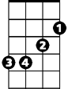

C

**F C (break)**

The things we do for love

**Reprise:**

**C**

Like walking in the rain and the snow

When there's nowh ere to go when you're

**Dm C G7**

Feeling like a part of you is dying

**Am G F**

And you're looking for the answer in her eyes

**G E7**

You think you're gonna break up

**Am Fm**

Then she says she wants to make up

**G C**

Ooh you make me love you

**BARITONE**

**Em C**



G

Ooh you've got a way

**G C**

Ooh you had me crawling

**Gm7**

On the floor (oooh oooh ...)

**Instrumental Verse (break)**

**(Reprise)**

**Am F**

A compromise would surely help the situation

**C Em Dm**

Agree to disagree but disagree before

**F E7**

When after all it's just a compromise

**Dm C**

Of the things we do for love

**F C**

The things we do for love

**Dm C**

The things we do for love

**F C**

The things we do for love

**Dm C**

The things we do for love

**F C**

The things we do for love

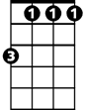

Fm

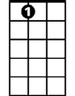

E7



F

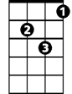

Dm

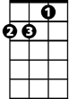

Am

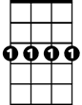

Gm7

C

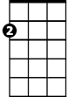

Em

F



E7

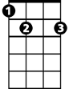

Dm

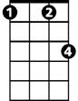

Fm



Am

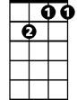

Gm7