The Unicorn (Shel Silverstein, 1962)
The Unicorn by The Irish Rovers (1968) – Key of C

Intro (last line of chorus) C Dm G C

C Dm  A long time ago when the earth was green,  G C  There were more kinds of animals than you've ever seen.  C Dm  They'd run around free while the earth was being born,  C Dm G C  But the loveliest of them all was the un - i - corn.  There was . . .  C Dm  Green alligators and long-necked geese.  G C  Some humpty back camels and some chimpanzees.  C Dm  Some cats and rats and elephants but sure as you're  C Dm G C born,  The loveliest of all was the un - i - corn.  C Dm  Now God seen some sinnin' and it gave him pain  G C  And he says “Stand back - I'm gonna make it rain!”  C Dm  He says “Hey brother Noah, I'll tell you what to do,  C Dm G C  Build me a float - ing zoo . . .and take some of them”  C Dm  Green alligators and long-necked geese.  G C  Some humpty back camels and some chimpanzees.  C Dm  Some cats and rats and elephants but sure as you're  C Dm G C born,  Don’t you forget my un - i - corns.  C Dm  Old Noah was there to answer the call  G C  He finished up making the ark just as the rain started  C Dm fallin’.  He marched in the animals two by two  C Dm G C  And he called out as they went through . . .  “Hey Lord I’ve got your”  C Dm  Green alligators and long-necked geese.  G C  Some humpty back camels and some chimpanzees.  C Dm  Some cats and rats and elephants, but Lord I’m so forlorn  C Dm G C  I just can't see no un - i - corns." | C Dm  Then Noah looked out through the driving rain,  G C  Them unicorns were hiding, playing silly games,  C Dm  Kicking and spashing while the rain was pouring  C Dm G C  Oh them silly un - i - corns. There was …  C Dm  Green alligators and long-necked geese.  G C  Some humpty back camels and some chimpanzees.  C Dm  Noah cried “Close the door cause the rain is pourin’  C Dm G C  And we just can’t wait for those un - i - corns.”  C Dm  The ark started moving, it drifted with the tide,  G C  Them unicorns looked up from the rock and they cried,  C Dm  And the waters came down and sort of floated them away,  [Spoken]  And that's why you've never seen a unicorn  to this very day . . . You’ll see”  C Dm  Green alligators and long-necked geese.  G C  Some humpty back camels and some chimpanzees.  C Dm  Some cats and rats and elephants, but sure as you're  C Dm G C born  You're never gonna see no un - i - corns."
 | 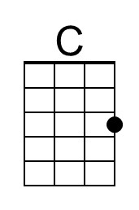 | 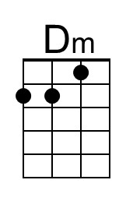 | 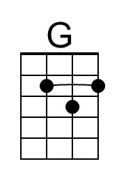
 | Bari | 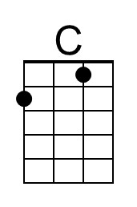 | 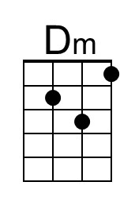 | 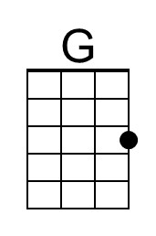

The Unicorn (Shel Silverstein, 1962)
The Unicorn by The Irish Rovers (1968) – Key of G

Intro (last line of chorus) G Am D G

G Am  A long time ago when the earth was green,  D G  There were more kinds of animals than you've ever seen.  G Am  They'd run around free while the earth was being born,  G Am D G  But the loveliest of them all was the un - i - corn.  There was . . .  G Am  Green alligators and long-necked geese.  D G  Some humpty back camels and some chimpanzees.  G Am  Some cats and rats and elephants but sure as you're  G Am D G born,  The loveliest of all was the un - i - corn.  G Am  Now God seen some sinnin' and it gave him pain  D G  And he says "Stand back - I'm gonna make it rain!"  G Am  He says "Hey brother Noah, I'll tell you what to do,  G Am D G  Build me a float - ing zoo . . .and take some of them"  G Am  Green alligators and long-necked geese.  D G  Some humpty back camels and some chimpanzees.  G Am  Some cats and rats and elephants but sure as you're  G Am D G born,  Don't you forget my un - i - corns.  G Am  Old Noah was there to answer the call  D G  He finished up making the ark just as the rain started  G Am fallin'.  He marched in the animals two by two  G Am D G  And he called out as they went through . . .  "Hey Lord I've got your"  G Am  Green alligators and long-necked geese.  D G  Some humpty back camels and some chimpanzees.  G Am  Some cats and rats and elephants, but Lord I'm so forlorn  G Am D G  I just can't see no un - i - corns." | G Am  Then Noah looked out through the driving rain,  D G  Them unicorns were hiding, playing silly games,  G Am  Kicking and spashing while the rain was pouring  G Am D G  Oh them silly un - i - corns. There was  G Am  Green alligators and long-necked geese.  D G  Some humpty back camels and some chimpanzees.  G Am  Noah cried "Close the door cause the rain is pourin'  G Am D G  And we just can't wait for those un - i - corns."  G Am  The ark started moving, it drifted with the tide,  D G  Them unicorns looked up from the rock and they cried,  G Am  And the waters came down and sort of floated them away,  [Spoken]  And that's why you've never seen a unicorn  to this very day . . . You'll see"  G Am  Green alligators and long-necked geese.  D G  Some humpty back camels and some chimpanzees.  G Am  Some cats and rats and elephants, but sure as you're  G Am D G born  You're never gonna see no un - i - corns."
 |  | 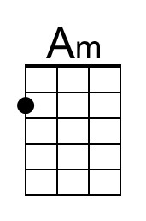 | 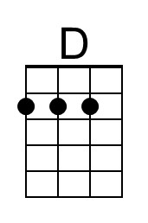
 | Bari |  | 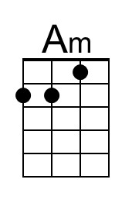 | 