The Way You Look Tonight (Jerome Kern & Dorothy Fields, 1936) (A)
The Way You Look Tonight by Fred Astaire (D) from the 1936 movie "Swing Time"
The Way You Look Tonight by Frank Sinatra (Eb) (1964; 2008 Remaster)

Intro A F#m | Bm E7 |  A F#m Bm E7 C#m F#7  Some day, when I'm awfully low, when the world is cold  Bm E7 A F#m  I will feel a glow just thinking of you,  Bm E7 A F#m | Bm  And the way you look to-night.  E7 A F#m Bm E7  Yes you're love – ly, with your smile so warm,  C#m F#7  And your cheeks so soft  Bm E7 A F#m  There is nothing for me but to love you,  Bm E7 A F#m | Dm G7 |  And the way you look to-night.  Bridge  C Dm G7  With each word your tenderness grows,  C Em7 - Dm G7  Tearing my fear a-part  C Dm G7  And that laugh that wrinkles your nose,  C Bm - E7  It touches my foolish heart.  A F#m Bm E7 C#m F#7  Love - ly, Never, ever change. Keep that breathless charm  Bm E7 A F#m  Won't you please arrange it? 'Cause I love you  Bm E7 A F#m | Bm E7  Just the way you look to-night.  Bm E7 A  Just the way you look to-night. |  |  |  |  |  |  |  | 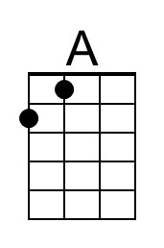 | 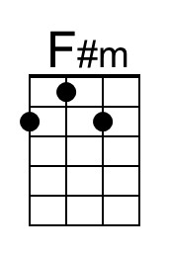
 |  |  |  |  |  |  |  | 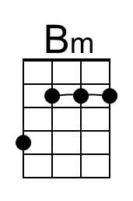 | 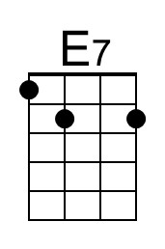
 |  |  |  |  |  |  |  | 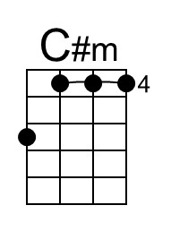 | 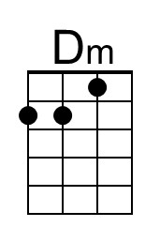
 |  |  |  |  |  |  |  | 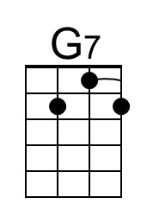 | 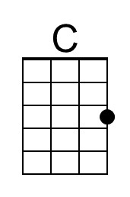
 |  |  |  |  |  |  |  | 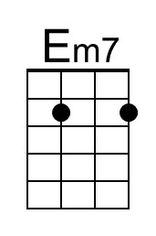
Bari | 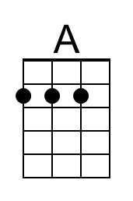 | 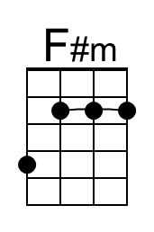 | 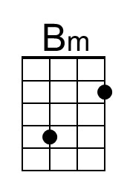 | 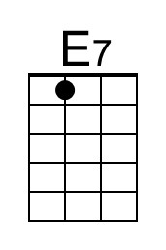 | 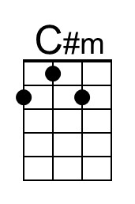 | 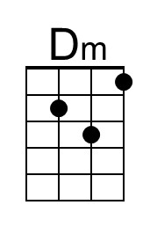 | 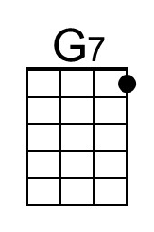 | 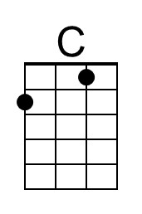 | 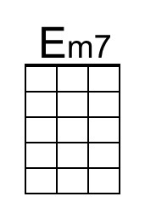

The Way You Look Tonight (Jerome Kern & Dorothy Fields, 1936) (C)
The Way You Look Tonight by Fred Astaire (D) from the 1936 movie "Swing Time"
The Way You Look Tonight by Frank Sinatra (Eb) (1964; 2008 Remaster)

Intro C Am | Dm G7 |  C Am Dm G7 C A7  Some day, when I'm awfully low, when the world is cold  Dm G7 C Am  I will feel a glow just thinking of you,  Dm G7 C Am | Dm  And the way you look to-night.  G7 C Am Dm G7  Yes you're love – ly, with your smile so warm,  C A7  And your cheeks so soft  Dm G7 C Am  There is nothing for me but to love you,  Dm G7 C Am | Fm Bb7 |  And the way you look to-night.  Bridge  Eb Fm Bb7  With each word your tenderness grows,  Eb Gm7 - Fm Bb7  Tearing my fear a-part  Eb Fm Bb7  And that laugh that wrinkles your nose,  Eb Dm - G7  It touches my foolish heart.  C Am Dm G7 C A7  Love - ly, Never, ever change. Keep that breathless charm  Dm G7 C Am  Won't you please arrange it? 'Cause I love you  Dm G7 C Am | Dm G7  Just the way you look to-night.  Dm G7 C  Just the way you look to-night. |  |  |  |  |  |  |  |  | 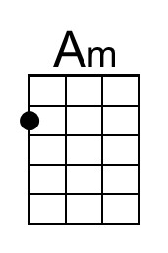
 |  |  |  |  |  |  |  | 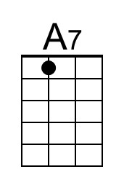 | 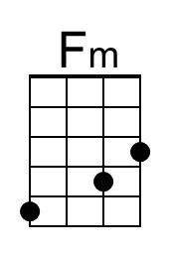
 |  |  |  |  |  |  |  | 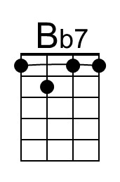 | 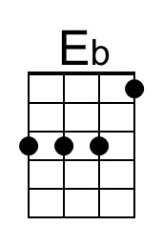
 |  |  |  |  |  |  |  | 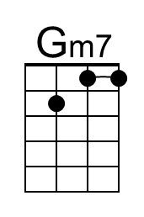
Bari |  | 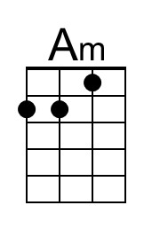 |  |  | 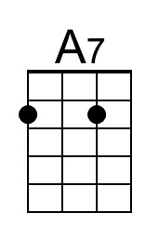 | 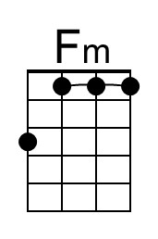 | 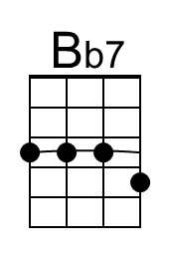 | 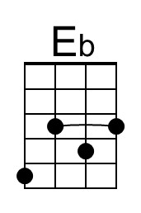 | 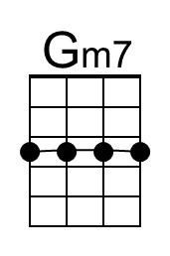

The Way You Look Tonight (Jerome Kern & Dorothy Fields, 1936) (D)
The Way You Look Tonight by Fred Astaire (D) from the 1936 movie "Swing Time"
The Way You Look Tonight by Frank Sinatra (Eb) (1964; 2008 Remaster)

Intro D Bm | Em A7 |  D Bm Em A7 F#m B7  Some day, when I'm awfully low, when the world is cold  Em A7 D Bm  I will feel a glow just thinking of you,  Em A7 D Bm | Em  And the way you look to-night.  A7 D Bm Em A7  Yes you're love – ly, with your smile so warm,  F#m B7  And your cheeks so soft  Em A7 D Bm  There is nothing for me but to love you,  Em A7 D Bm | Gm C7 |  And the way you look to-night.  Bridge  F Gm C7  With each word your tenderness grows,  F Am7 - Gm C7  Tearing my fear a-part  F Gm C7  And that laugh that wrinkles your nose,  F Em - A7  It touches my foolish heart.  D Bm Em A7 F#m B7  Love - ly, Never, ever change. Keep that breathless charm  Em A7 D Bm  Won't you please arrange it? 'Cause I love you  Em A7 D Bm | Em A7  Just the way you look to-night.  Em A7 D  Just the way you look to-night. |  |  |  |  |  |  |  | 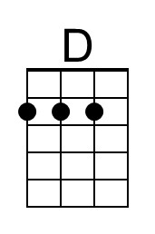
 |  |  |  |  |  |  |  | 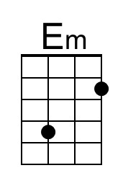
 |  |  |  |  |  |  |  | 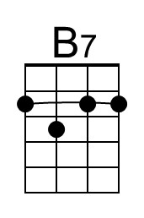 | 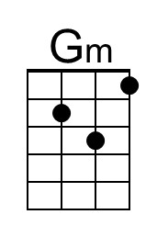
 |  |  |  |  |  |  |  | 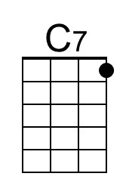 | 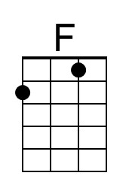
 |  |  |  |  |  |  |  | 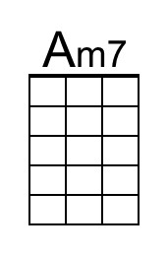
Bari | 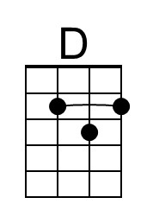 |  | 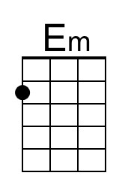 |  | 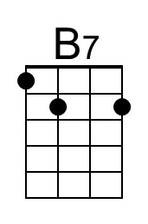 | 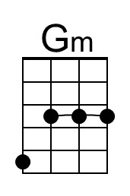 | 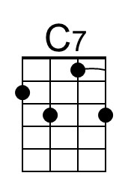 | 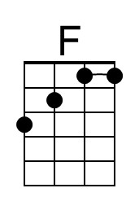 | 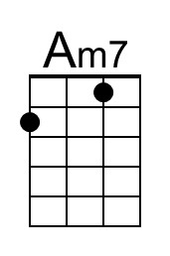
The Way You Look Tonight (Jerome Kern & Dorothy Fields, 1936) (G)
The Way You Look Tonight by Fred Astaire (D) from the 1936 movie "Swing Time"
The Way You Look Tonight by Frank Sinatra (Eb) (1964; 2008 Remaster)

Intro G Em | Am D7 |  G Em Am D7 Bm E7  Some day, when I'm awfully low, when the world is cold  Am D7 G Em  I will feel a glow just thinking of you,  Am D7 G Em | Am  And the way you look to-night.  D7 G Em Am D7  Yes you're love – ly, with your smile so warm,  Bm E7  And your cheeks so soft  Am D7 G Em  There is nothing for me but to love you,  Am D7 G Em | Cm F7 |  And the way you look to-night.  Bridge  Bb Cm F7  With each word your tenderness grows,  Bb Dm7 - Cm F7  Tearing my fear a-part  Bb Cm F7  And that laugh that wrinkles your nose,  Bb Am - D7  It touches my foolish heart.  G Em Am D7 Bm E7  Love - ly, Never, ever change. Keep that breathless charm  Am D7 G Em  Won't you please arrange it? 'Cause I love you  Am D7 G Em | Am D7  Just the way you look to-night.  Am D7 G  Just the way you look to-night. |  |  |  |  |  |  |  | 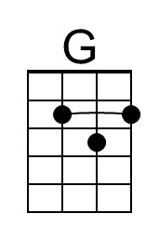
 |  |  |  |  |  |  |  |  | 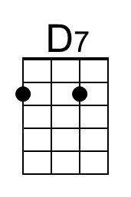
 |  |  |  |  |  |  |  |  | 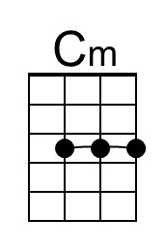
 |  |  |  |  |  |  |  | 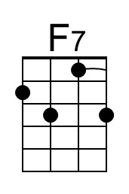 | 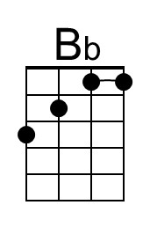
 |  |  |  |  |  |  |  | 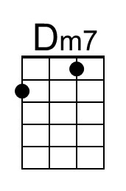
Bari | 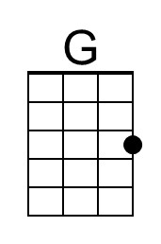 |  |  | 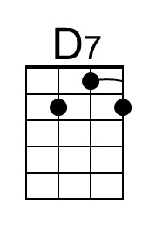 |  | 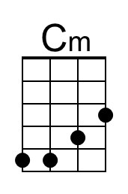 | 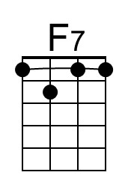 | 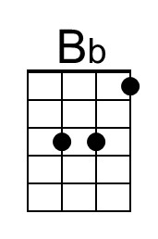 | 