**The Wayward Wind (Herbert Newman / Stanley R. Lebowsky) Key C**

**Intro: C**

F



C

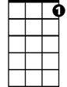

C7

**Chorus:**

**C C7 F Fm**

The wayward wind is a restless wind

**C G7**

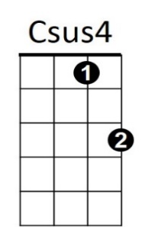A restless wind that yearns to wander

**C C7 F Fm**

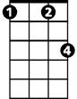

Fm

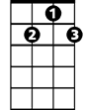

G7

And he was born - the next of kin

**C G7 F C**

The next of kin to the wayward wind

**C Csus4 C**

In a lonely shack by a railroad track

He spent his younger days

**Csus4 C**

And I guess the sound of the outward-bound

**G7 C**

Made him a slave to his wand'rin ways

**BARITONE**

**(Chorus)**



F

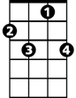

C7

C



**C Csus4 C**

Oh I met him there in a border town

He vowed we'd never part

**Csus4 C**



G7

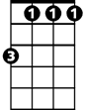

Fm

Though he tried his best to settle down

**G7 C**

I'm now alone with a broken heart

**(Chorus)**

**C G7 F C**

The next of kin to the wayward wind

**The Wayward Wind (Herbert Newman / Stanley R. Lebowsky) Key G**

**Intro: G**

**Chorus:**



G7



C



G

**G G7 C Cm**

The wayward wind is a restless wind

**G D7**

A restless wind that yearns to wander

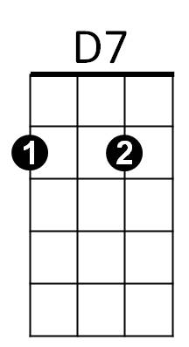 **G G7 C Cm**

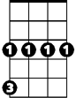

Cm

And he was born - the next of kin

**G D7 C G**

The next of kin to the wayward wind

**G Gsus4 G**

In a lonely shack by a railroad track

He spent his younger days

**Gsus4 G**

And I guess the sound of the outward-bound

**D7 G**

Made him a slave to his wand'rin ways

**(Chorus)**

**G Gsus4 G**

**BARITONE**

Oh I met him there in a border town



G7



G



Cm

C



He vowed we'd never part

**Gsus4 G**

Though he tried his best to settle down

**D7 G**

I'm now alone with a broken heart



D7

**(Chorus)**

**G D7 C G**

The next of kin to the wayward wind