The Wearing Of The Green (Dion Boucicault, 1864; anonymous ballad, 1841) (C)

Intro (last line of verse) F C G C

C G
O Paddy dear, and did ye hear the news that's goin' round?
F C G C
The shamrock is for-bid by law to grow on Irish ground!
C G
Saint Patrick's Day no more we'll keep, his color can't be seen,
F C G C
For there's a bloody law ag'in the wearin' of the green."

C G
I met with Napper Tandy, and he took me by the hand,
F C G C
And he said, "How's poor old Ireland, and how does she stand?"
C G
"She's the most distressful country that ever you have seen,
F C G C
For they're hanging men and women there, for the wearin' of the green."

C G
"Then since the color we must wear is England's cruel red,
F C G C
Sure Ireland's sons will ne'er forget, the blood that they have shed,
C G
Sure take the Shamrock from your hat, and cast it on the sod,
F C G C
But 'twill take root and flourish, still tho' under foot 'tis trod,

C G
When law can stop the blades of grass from growing as they grow,
F C G C
And when the leaves in summer-time their verdure dare not shun.
C G
Then I will change the color I wear in my corbeen,
F C G C
But till that day, please God, I'll stick to the wearin' o' the green.

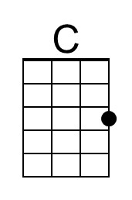 | 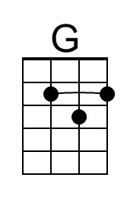 | 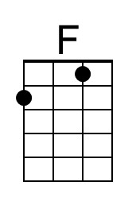 |  | Bari | 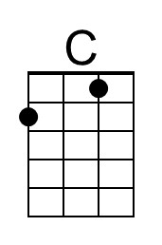 | 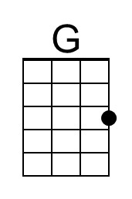 | 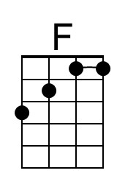

The Wearing Of The Green (Dion Boucicault, 1864; anonymous ballad, 1841) (G)

Intro (last line of verse) C G D G

G D
O Paddy dear, and did ye hear the news that's goin' round?
C G D G
The shamrock is for-bid by law to grow on Irish ground!
G D
Saint Patrick's Day no more we'll keep, his color can't be seen,
C G D G
For there's a bloody law ag'in the wearin' of the green."

G D
I met with Napper Tandy, and he took me by the hand,
C G D G
And he said, "How's poor old Ireland, and how does she stand?"
G D
"She's the most distressful country that ever you have seen,
C G D G
For they're hanging men and women there, for the wearin' of the green."

G D
"Then since the color we must wear is England's cruel red,
C G D G
Sure Ireland's sons will ne'er forget, the blood that they have shed,
G D
Sure take the Shamrock from your hat, and cast it on the sod,
C G D G
But 'twill take root and flourish, still tho' under foot 'tis trod,

G D
When law can stop the blades of grass from growing as they grow,
C G D G
And when the leaves in summer-time their verdure dare not shun.
G D
Then I will change the color I wear in my corbeen,
C G D G
But till that day, please God, I'll stick to the wearin' o' the green.

 | 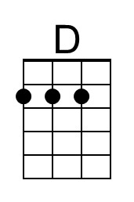 |  |  | Bari |  | 