The Wexford Carol
C80 C
(Irish Traditional Carol) – The Wexford Carol by Alison Krauss

C Am G  Good people all, this Christmas time,  C Eb Bb  Consider well and bear in mind  C Am G  What our good God for us has done,  C F C  In sending His belovèd Son.  Eb  With Mary holy we should pray  C Eb Bb  To God with love this Christmas Day.  C Am G  In Bethlehem upon the morn  C F C  There was a blest Messiah born.  C Am G  The night before that happy tide,  C Eb Bb  The noble virgin and her guide  C Am G  Were long time seeking up and down  C F C  To find a lodging in the town.  Eb  But mark how all things came to pass:  C Eb Bb  From every door re pelled, alas!  C Am G  As long foretold, their refuge all  C F C  Was but a humble oxen stall.  C Am G  Near Bethlehem did shepherds keep  C Eb Bb  Their flocks of lambs and feeding sheep,  C Am G  To whom God’s angels did appear,  C F C  Which put the shepherds in great fear.  Eb  “Prepare and go”, the angels said,  C Eb Bb  “To Bethlehem, be not afraid !  C Am G  For there you’ll find, this happy morn,  C F C  A princely Babe, sweet Jesus born.” | C Am G  With thankful heart and joyful mind,  C Eb Bb  The shepherds went the babe to find.  C Am G  And as God’s angel has foretold,  C F C  They did our Savior Christ behold.  Eb  Within a manger he was laid,  C Eb Bb  And by his side the virgin maid,  C Am G  Attending to the Lord of Life,  C F C  Who came on earth to end all strife.  C Am G  Good people all, this Christmas time,  C Eb Bb  Consider well and bear in mind  C Am G  What our good God for us has done,  C F C  In sending His belovèd Son.  Eb  With Mary holy we should pray  C Eb Bb  To God with love this Christmas Day.  C Am G  In Bethlehem upon the morn  C F C  There was a blest Messiah born.
 | 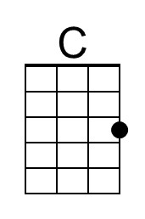 | 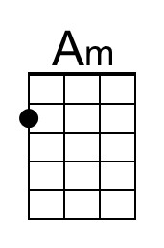 | 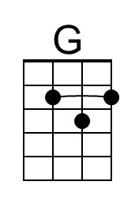 | 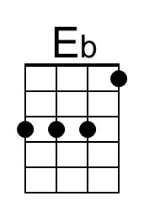 | 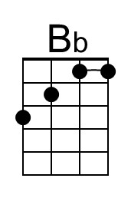 | 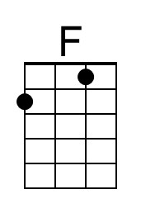
 | Bari
 | 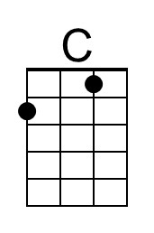 | 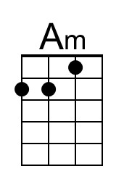 | 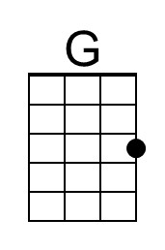 | 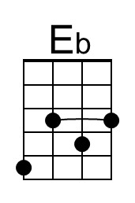 | 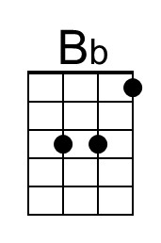 | 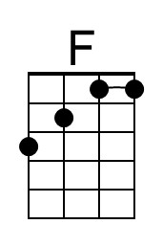


The Wexford Carol
C80 G
(Irish Traditional Carol) – The Wexford Carol by Alison Krauss

G Em D  Good people all, this Christmas time,  G Bb F  Consider well and bear in mind  G Em D  What our good God for us has done,  G C G  In sending His belovèd Son.  Bb  With Mary holy we should pray  G Bb F  To God with love this Christmas Day.  G Em D  In Bethlehem upon the morn  G C G  There was a blest Messiah born.  G Em D  The night before that happy tide,  G Bb F  The noble virgin and her guide  G Em D  Were long time seeking up and down  G C G  To find a lodging in the town.  Bb  But mark how all things came to pass:  G Bb F  From every door re pelled, alas!  G Em D  As long foretold, their refuge all  G C G  Was but a humble oxen stall.  G Em D  Near Bethlehem did shepherds keep  G Bb F  Their flocks of lambs and feeding sheep,  G Em D  To whom God’s angels did appear,  G C G  Which put the shepherds in great fear.  Bb  “Prepare and go”, the angels said,  G Bb F  “To Bethlehem, be not afraid !  G Em D  For there you’ll find, this happy morn,  G C G  A princely Babe, sweet Jesus born.” | G Em D  With thankful heart and joyful mind,  G Bb F  The shepherds went the babe to find.  G Em D  And as God’s angel has foretold,  G C G  They did our Savior Christ behold.  Bb  Within a manger he was laid,  G Bb F  And by his side the virgin maid,  G Em D  Attending to the Lord of Life,  G C G  Who came on earth to end all strife.  G Em D  Good people all, this Christmas time,  G Bb F  Consider well and bear in mind  G Em D  What our good God for us has done,  G C G  In sending His belovèd Son.  Bb  With Mary holy we should pray  G Bb F  To God with love this Christmas Day.  G Em D  In Bethlehem upon the morn  G C G  There was a blest Messiah born.
 |  | 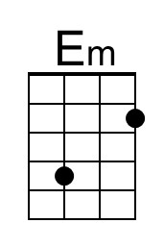 | 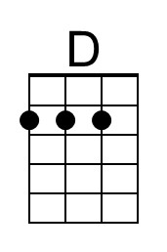
 | Bari
 |  | 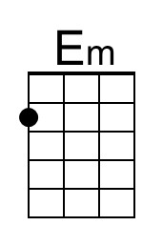 | 