The Whistling Gypsy (Leo Maguire, ca. 1952, Arr. By G. Millar & W. McDowell)
The Whistling Gypsy by The Irish Rovers – Key of C
Intro: Last 3 lines of verse
C G C G7  The gypsy rover came over the hill,  C F C G  And down through the valley so shad-y;  C G  He whistled and he sang,  Em Am  Till the green woods rang,  C F C F C G7  And he won the heart of a la - a - dy.  Chorus  C G C G7  Ah di doo ah di doo dah day,  C F C G  Ah di doo ah de day-dee.  C G  He whistled and he sang,  Em Am  Till the green woods rang,  C F C F C G7  And he won the heart of a la - a - dy.  C G C G7  She left her father's castle gate;  C F C G  She left her own fond lo - ver,  C G Em Am  She left her servants and her es - tate,  C F C F C G7  To follow the gypsy ro - o - er. Chorus |  |  |  |  | C G C G7  Her father saddled up his fastest steed,  C F C G  And he roamed the valleys all o - ver,  C G Em Am  He sought his daughter at great speed,  C F C F C G7  And the whistling gypsy ro - o - er. Chorus  C G C G7  He came at last to a mansion fine,  C F C G  Down by the River Cla - de,  C G Em Am  And there was music, and there was wine,  C F C F C G7  For the gypsy and his la - a - dy. Chorus  C G C G7  Well he's no gypsy my father she said,  C F C G  But lord of these lands all o - ver,  C G Em Am  And I will stay till me dying day,  C F C F C G7  With my whistling gypsy ro - o - er.  Chorus (2x) End on C
 |  | 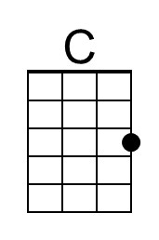 | 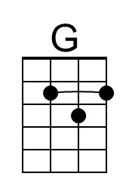 | 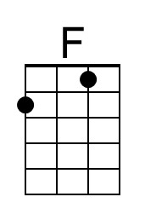 |  | 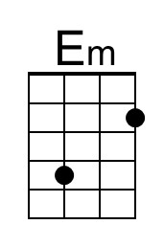 | 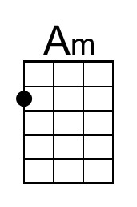 | 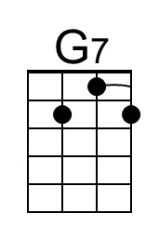
 | Bari | 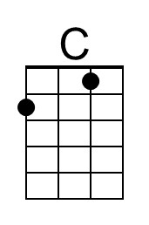 | 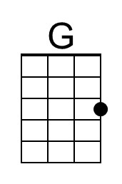 | 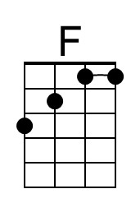 |  | 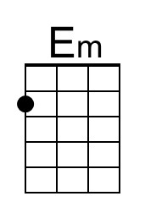 | 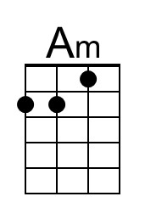 | 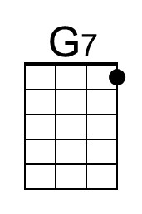

The Whistling Gypsy (Leo Maguire, ca. 1952, Arr. By G. Millar & W. McDowell)
The Whistling Gypsy by The Irish Rovers – Key of D
Intro: Last 3 lines of verse
D A D A7  The gypsy rover came over the hill,  D G D A  And down through the valley so shad-y;  D A  He whistled and he sang,  F#m Bm  Till the green woods rang,  D G D G D A7  And he won the heart of a la - a - dy.  Chorus  D A D A7  Ah di doo ah di doo dah day,  D G D A  Ah di doo ah de day-dee.  D A  He whistled and he sang,  F#m Bm  Till the green woods rang,  D G D G D A7  And he won the heart of a la - a - dy.  D A D A7  She left her father's castle gate;  D G D A  She left her own fond lo - ver,  D A F#m Bm  She left her servants and her es - tate,  D G D G D A7  To follow the gypsy ro - o - er. Chorus |  |  |  | D A D A7  Her father saddled up his fastest steed,  D G D A  And he roamed the valleys all o - ver,  D A F#m Bm  He sought his daughter at great speed,  D G D G D A7  And the whistling gypsy ro - o - er. Chorus  D A D A7  He came at last to a mansion fine,  D G D A  Down by the River Cla - de,  D A F#m Bm  And there was music, and there was wine,  D G D G D A7  For the gypsy and his la - a - dy. Chorus  D A D A7  Well he's no gypsy my father she said,  D G D A  But lord of these lands all o - ver,  D A F#m Bm  And I will stay till me dying day,  D G D G D A7  With my whistling gypsy ro - o - er.  Chorus (2x) End on D

The Whistling Gypsy (Leo Maguire, ca. 1952, Arr. By G. Millar & W. McDowell)
The Whistling Gypsy by The Irish Rovers – Key of F
Intro: Last 3 lines of verse
F C F C7  The gypsy rover came over the hill,  F Bb F C  And down through the valley so shad-y;  F C  He whistled and he sang,  Am Dm  Till the green woods rang,  F Bb F Bb F C7  And he won the heart of a la - a - dy.  Chorus  F C F C7  Ah di doo ah di doo dah day,  F Bb F C  Ah di doo ah de day-dee.  F C  He whistled and he sang,  Am Dm  Till the green woods rang,  F Bb F Bb F C7  And he won the heart of a la - a - dy.  F C F C7  She left her father's castle gate;  F Bb F C  She left her own fond lo - ver,  F C Am Dm  She left her servants and her es - tate,  F Bb F Bb F C7  To follow the gypsy ro - o - er. Chorus |  |  |  | F C F C7  Her father saddled up his fastest steed,  F Bb F C  And he roamed the valleys all o - ver,  F C Am Dm  He sought his daughter at great speed,  F Bb F Bb F C7  And the whistling gypsy ro - o - er. Chorus  F C F C7  He came at last to a mansion fine,  F Bb F C  Down by the River Cla - de,  F C Am Dm  And there was music, and there was wine,  F Bb F Bb F C7  For the gypsy and his la - a - dy. Chorus  F C F C7  Well he's no gypsy my father she said,  F Bb F C  But lord of these lands all o - ver,  F C Am Dm  And I will stay till me dying day,  F Bb F Bb F C7  With my whistling gypsy ro - o - er.  Chorus (2x) End on F
The Whistling Gypsy (Leo Maguire, ca. 1952, Arr. By G. Millar & W. McDowell)
The Whistling Gypsy by The Irish Rovers – Key of G
Intro: Last 3 lines of verse
G D G D  The gypsy rover came over the hill,  G C G D7  And down through the valley so shad-y;  G D  He whistled and he sang,  Bm Em  Till the green woods rang,  G C G C G D7  And he won the heart of a la – a – dy.  Chorus  G D G D7  Ah di doo ah di doo dah day,  G C G D  Ah di doo ah de day-dee.  G D  He whistled and he sang,  Bm Em  Till the green woods rang,  G C G C G D7  And he won the heart of a la – a – dy.  G D G D7  She left her father's castle gate;  G C G D  She left her own fond lo – ver,  G D Bm Em  She left her servants and her es - tate,  G C G C G D7  To follow the gypsy ro – o – er. Chorus |  |  |  |  | G D G D7  Her father saddled up his fastest steed,  G C G D  And he roamed the valleys all o - ver,  G D Bm Em  He sought his daughter at great speed,  G C G C G D7  And the whistling gypsy ro – o – er. Chorus  G D G D7  He came at last to a mansion fine,  G C G D  Down by the River Cla – de,  G D Bm Em  And there was music, and there was wine,  G C G C G D7  For the gypsy and his la – a – dy. Chorus  G D G D7  Well he's no gypsy my father she said,  G C G D  But lord of these lands all o – ver,  G D Bm Em  And I will stay till me dying day,  G C G C G D7  With my whistling gypsy ro – o – er.  Chorus (2x) End on G
 |  |  | 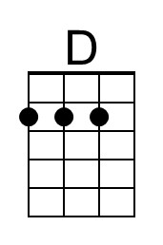 |  |  | 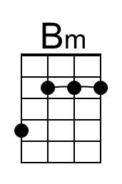 |  | 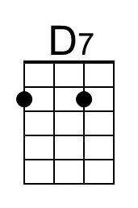
 | Bari |  | 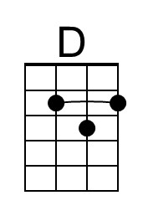 |  |  | 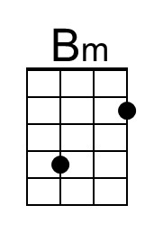 |  | 