The Witch Queen Of New Orleans (Lolly and Pat Vegas) (Am)
The Witch Queen Of New Orleans by Redbone (1971) (Gm)
Tabs are available at Ultimate Guitar, The Witch Queen Of New Orleans

This song about Marie Laveau paints her in an evil light, but the original famous Voodoo priestess was reported to be beautiful, benign and charitable. Although after her death, her daughter, with the same name, cultivated more of a sinister persona.

Intro (4x) | Am Am Am7 Am | ^ = Emphasize the beat  Chorus  Am Am7 Am D7 Am  (Marie, Marie La- 'Voo - doo' -veau) She'll put a spell on you,  Am Am7 Am D7 Am  (Marie, Marie La- 'Voo - doo' -veau) She'll put a spell on you,  Am Am7 Am  (Marie, Marie La- 'Voo - doo' -veau)  Am7 Dm7 E7#9 Am - Am7 Am  She's the Witch Queen (Ahhh!) ...of New Or-leans,  ^ ^ ^ ^ ^  Am Am7 Am  __ Of New Orleans.  Am Am7 Am Am Am7 Am Am Am7 Am Am - Am7 Am  I'm gonna tell you a story, __ __ strange as it now seems,  Am Am7 Am Am - Am7 Am  Of Zombie voo - doo gris - gris,  Am Am7 D7 - D7sus4 D7 D7  And the Witch Queen of New Or - leans, ^ ^ ^  Am Am7 Am Am - Am7 Am  She lived in a wor - ld of magic,  Am Am7 Am Am - Am7 Am  Pos - sessed by the Dev - il's skew,  Am Am7 Am Am Am7 - Am  From a shack, near the swamp - land, made of mud - pile brick,  Am Am7 D7 Am - Am7 Am  Ma – rie stirred her witch's brew. Chorus  Am Am7 Am Am Am7 Am Am Am7 Am Am - Am7 Am  Dime or a nick - el, any - one could buy __ voodoo of an - y kind,  Am Am7 Am Am Am7 - Am  She had potions and lo - tions, herbs and tanna leaves,  Am Am7 D7 - D7sus4 D7 D7  Guaranteed to blow your mind, ^ ^ ^  Am Am7 Am Am Am7 - Am  Early one morn - ing, into murky swamp dew,  Am Am7 Am Am - Am7 Am  Vanished Marie with hate in her eye,  Am Am7 Am Am Am7 - Am  Though she'll never re - turn, all the Cajuns knew,  Am Am7 D7 Am - Am7 Am  A Witch Queen never dies. Chorus | 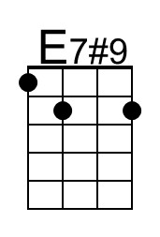
 | 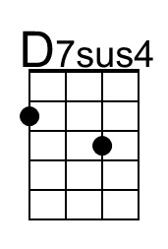
 | Bari
 | 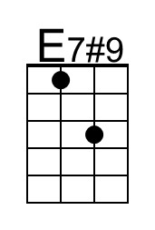
 | 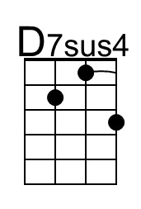

The Witch Queen Of New Orleans (Lolly and Pat Vegas) (Em)
The Witch Queen Of New Orleans by Redbone (1971) (Gm)
Tabs are available at Ultimate Guitar, The Witch Queen Of New Orleans

This song about Marie Laveau paints her in an evil light, but the original famous Voodoo priestess was reported to be beautiful, benign and charitable. Although after her death, her daughter, with the same name, cultivated more of a sinister persona.

Intro (4x) | Em Em Em7 Em | ^ = Emphasise the beat  Chorus  Em Em7 Em A7 Em  (Marie, Marie La- 'Voo - doo' -veau) She'll put a spell on you,  Em Em7 Em A7 Em  (Marie, Marie La- 'Voo - doo' -veau) She'll put a spell on you,  Em Em7 Em  (Marie, Marie La- 'Voo - doo' -veau)  Em7 Am7 B7#9 Em - Em7 Em  She's the Witch Queen (Ahhh!) ...of New Or-leans,  ^ ^ ^ ^ ^  Em Em7 Em  __ Of New Orleans.  Em Em7 Em Em Em7 Em Em Em7 Em Em - Em7 Em  I'm gonna tell you a story, __ __ strange as it now seems,  Em Em7 Em Em - Em7 Em  Of Zombie voo - doo gris - gris,  Em Em7 A7 - A7sus4 A7 A7  And the Witch Queen of New Or - leans, ^ ^ ^  Em Em7 Em Em - Em7 Em  She lived in a wor - ld of magic,  Em Em7 Em Em - Em7 Em  Pos - sessed by the Dev - il's skew,  Em Em7 Em Em Em7 - Em  From a shack, near the swamp - land, made of mud - pile brick,  Em Em7 A7 Em - Em7 Em  Ma – rie stirred her witch's brew. Chorus  Em Em7 Em Em Em7 Em Em Em7 Em Em - Em7 Em  Dime or a nick - el, any - one could buy __ voodoo of an - y kind,  Em Em7 Em Em Em7 - Em  She had potions and lo - tions, herbs and tanna leaves,  Em Em7 A7 - A7sus4 A7 A7  Guaranteed to blow your mind, ^ ^ ^  Em Em7 Em Em Em7 - Em  Early one morn - ing, into murky swamp dew,  Em Em7 Em Em - Em7 Em  Vanished Marie with hate in her eye,  Em Em7 Em Em Em7 - Em  Though she'll never re - turn, all the Cajuns knew,  Em Em7 A7 Em - Em7 Em  A Witch Queen never dies. Chorus | 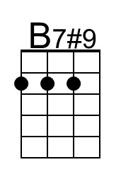
 | 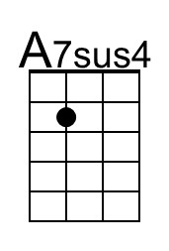
 | Bari
 | 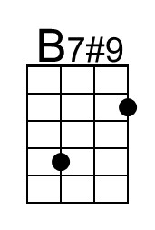
 | 