There’s A Kind Of Hush (Les Reed & Geoff Stephens, 1966) (D)
There’s A Kind Of Hush by the New Vaudeville Band (1966) (C#)
Herman's Hermits (1967) (C @ 129) – Carpenters (1976) (D @ 126)
Arrangement by William Heney (2023)

A7 D F#7 Bm D7  __ There's a kind of hush __ all over the world to-night.  G A D  All over the world you can hear the sound of lovers in love,  A  You know what I mean.  D F#7 Bm D7  Just the two of us ___ and nobody else in sight.  G A D | D7  There's nobody else and I'm feeling good just holding you tight.  Bridge  G G6 Gmaj7 G6 D  So listen very carefully. Closer now and you will see what I mean.  | D7  It isn't a dream.  G G6 G#7 G6  The only sound that you will hear is when I whisper in your ear  A NC | A  I love you, forever and ever.  NC D F#7 Bm D7  There's a kind of hush ___ all over the world to-night.  G A D  All over the world people just like us are falling in love.  D F#7 Bm  La-la-la-la-la-la-la La-la-la-la-la-la-la-la  D7 G A D | D7  La-la-la-la-la-la-la-la-la-la La-la-la-la-la.  Repeat Bridge  Outro  D F#7 Bm D7  There's a kind of hush ___ all over the world to-night.  G A D | G  All over the world people just like us are falling in love.  G A7 D | G | A7 D  ||: Yeah, they're fallin' in love. Yeah, they're fallin' in love. :||  2nd Time: Rallentando | 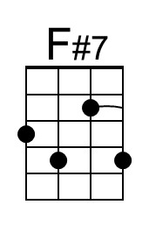
 | 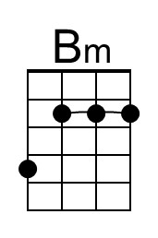
 | Bari
 | 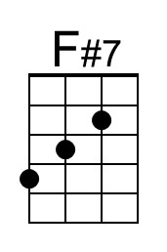
 | 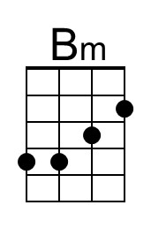

Gradually decrease speed

