
(There’s No Place Like) Home for the Holidays
C38 C
(Robert Allen & Al Stillman, 1954)
(There’s No Place Like) Home for the Holidays by Perry Como (1954) (C @ 78 BPM)
(There’s No Place Like) Home for the Holidays by Perry Como (1959) (F @ 146 BPM)

Intro C↓ ↓ | G7 Dm | G7 | C | G7 [Basis is last llne of 1st verse]  C F C  Oh there's no place like home for the holidays.  A7 D7 G7  Cause no matter how far away you roam,  C F C  When you pine for the sunshine of a friendly gaze,  G7 Dm G7 C – F | C7  For the holi-days you can't beat home, sweet home.  Bridge  F C  I met a man who lives in Tennessee and he was headin' for  G7 C – C7  Pennsylvania and some home-made pumpkin pie.  F Dm F C  From Pennsylvania, folks are travelling down to Dixie's sunny shores  G D7 G G7  From Atlantic to Pacific, gee, the traffic is terrific.  C F C  Oh there's no place like home for the holidays.  A7 D7 – G7  Cause no matter how far away you roam,  C F C  If you want to be happy in a million ways  _______________________________________________________________  │ G7 Dm G7 C – F | C7  │ 1. __ For the holi-days you can't beat home, sweet home. Repeat From Bridge  _______________________________________________________________  │ G7 Dm G7 C  │ 2. __ For the holi-days you can't beat home, sweet home. (Ritard)  │ G7 Dm G7 C – G7 | C  │ . __ For the holi-days you can't beat home, sweet home. |  |  |  |  |  |  |  | 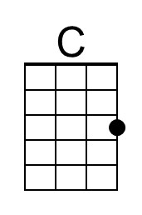
 |  |  |  |  |  |  |  | 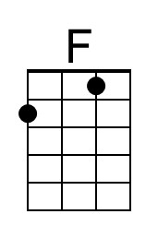
 |  |  |  |  |  |  |  | 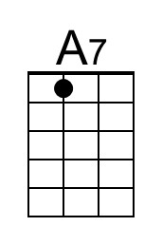
 |  |  |  |  |  |  |  | 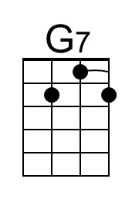
 |  |  |  |  |  |  |  | 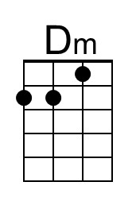
 |  |  |  |  |  |  |  | 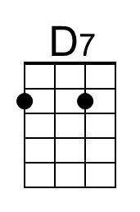
 |  |  |  |  |  |  |  | 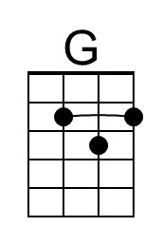
Baritone | 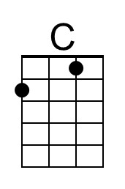 | 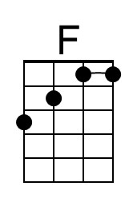 | 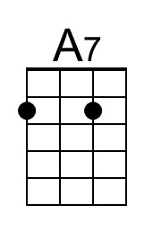 | 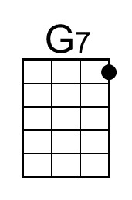 | 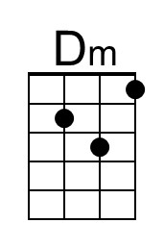 | 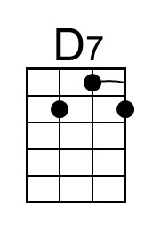 | 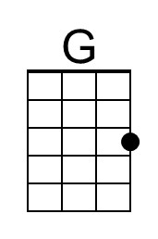

(There’s No Place Like) Home for the Holidays
C38 G
(Robert Allen & Al Stillman, 1954)
(There’s No Place Like) Home for the Holidays by Perry Como (1954) (C @ 78 BPM)
(There’s No Place Like) Home for the Holidays by Perry Como (1959) (F @ 146 BPM)

Intro G↓ ↓ | D7 Am | D7 | G | D7 [Basis is last llne of 1st verse]

G C G
Oh there's no place like home for the holidays.
E7 A7 D7
Cause no matter how far away you roam,
G C G
When you pine for the sunshine of a friendly gaze,
D7 Am D7 G – C | G7
For the holi-days you can't beat home, sweet home.

Bridge
C G
I met a man who lives in Tennessee and he was headin' for
D7 G – G7
Pennsylvania and some home-made pumpkin pie.
C Am C G
From Pennsylvania, folks are travelling down to Dixie's sunny shores
D A7 D D7
From Atlantic to Pacific, gee, the traffic is terrific.

G C G
Oh there's no place like home for the holidays.
E7 A7 – D7
Cause no matter how far away you roam,
G C G
If you want to be happy in a million ways
_______________________________________________________________
│ D7 Am D7 G – C | G7
│ 1. __ For the holi-days you can't beat home, sweet home. Repeat From Bridge
_______________________________________________________________
│ D7 Am D7 G
│ 2. __ For the holi-days you can't beat home, sweet home. (Ritard)
│ D7 Am D7 G – D7 | G
│ . __ For the holi-days you can't beat home, sweet home.

 |  |  |  |  |  |  |  | 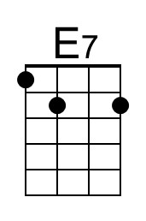
 |  |  |  |  |  |  |  | 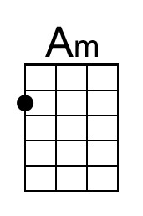
 |  |  |  |  |  |  |  | 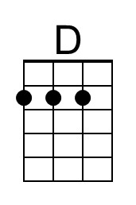
Baritone |  |  | 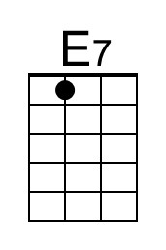 |  | 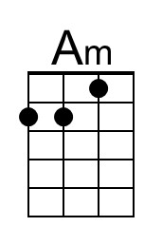 |  | 