There's No One As Irish As Barack O'Bama (D)
Written by Hardy Drew And The Nancy Boys / The Corrigan Brothers.

D G D  O'Leary, O'Reilly, O'Hare and O'Hara  A D  There's no one as Irish as Barack O'Bama  D A D  You don't believe me, I hear you say  A  But Barack's as Irish, as was JFK  D G D  His granddaddy's daddy came from Money-gall  A D  A small Irish village, well known to you all  Chorus  D G D  Toor a loo, toor a loo, toor a loo, toor a lama  A D  There's no one as Irish as Barack O'Bama.  D A D  He's as Irish as bacon and cabbage and stew  A  He's Hawaiian, he's Kenyan, American too  D G D  He's in the white house, he took his chance  A D  Now let's see Barack do River-dance. Chorus  D A D  From Kerry and cork to old Done-gal  A  Let's hear it for Barack from old Moneygall  D G D  From the lakes of Killarney to old Conne-mara  A D  There's no one as Irish as Barack O'Bama. Chorus |  |  |  | D G D  From the old blarney stone to the great hill of Tara  A D  There's no one as Irish as Barack O'Bama.  D A D  Two thousand and eight the white house is green,  A  they're cheering in Mayo and in Skibereen.  D G D  The Irish in Kenya, and in Yoka-hama,  A D  Are cheering for President Barack O'Bama. Chorus  D A D  The Hockey Moms gone, and so is McCain  A  They're cheering in Texas and Borrisokane,  D G D  In Moneygall town, the greatest of drama,  A D  For our famous president Barack O'Bama. Chorus  D A D  The great Stephen Neill, a great man of God,  A  He proved that Barack was from the Auld Sod  D G D  They came by bus and they came by car,  A D  To celebrate Barack in Ollie Hayes's Bar.  D G D  O'Leary, O'Reilly, O'Hare and O'Hara  A D  There's no one as Irish as Barack O'Bama
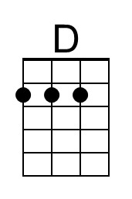 | 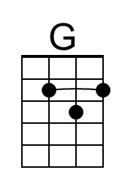 | 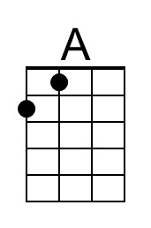 |  | Bari | 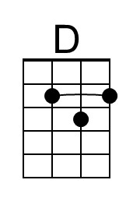 | 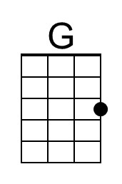 | 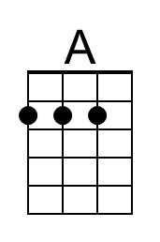

There's No One As Irish As Barack O'Bama (G)
Written by Hardy Drew And The Nancy Boys / The Corrigan Brothers.

G C G  O'Leary, O'Reilly, O'Hare and O'Hara  D G  There's no one as Irish as Barack O'Bama  G D G  You don't believe me, I hear you say  D  But Barack's as Irish, as was JFK  G C G  His granddaddy's daddy came from Money-gall  D G  A small Irish village, well known to you all  Chorus  G C G  Toor a loo, toor a loo, toor a loo, toor a lama  D G  There's no one as Irish as Barack O'Bama.  G D G  He's as Irish as bacon and cabbage and stew  D  He's Hawaiian, he's Kenyan, American too  G C G  He's in the white house, he took his chance  D G  Now let's see Barack do River-dance. Chorus  G D G  From Kerry and cork to old Done-gal  D  Let's hear it for Barack from old Moneygall  G C G  From the lakes of Killarney to old Conne-mara  D G  There's no one as Irish as Barack O'Bama. Chorus |  |  |  | G C G  From the old blarney stone to the great hill of Tara  D G  There's no one as Irish as Barack O'Bama.  G D G  Two thousand and eight the white house is green,  D  they're cheering in Mayo and in Skibereen.  G C G  The Irish in Kenya, and in Yoka-hama,  D G  Are cheering for President Barack O'Bama. Chorus  G D G  The Hockey Moms gone, and so is McCain  D  They're cheering in Texas and Borrisokane,  G C G  In Moneygall town, the greatest of drama,  D G  For our famous president Barack O'Bama. Chorus  G D G  The great Stephen Neill, a great man of God,  D  He proved that Barack was from the Auld Sod  G C G  They came by bus and they came by car,  D G  To celebrate Barack in Ollie Hayes's Bar.  G C G  O'Leary, O'Reilly, O'Hare and O'Hara  D G  There's no one as Irish as Barack O'Bama
 | 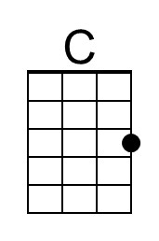 |  |  | Bari |  | 