**There’s No Place Like Home for the Holidays**

C38

**C F C**

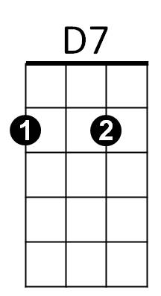Oh there's no place like home for the holidays.

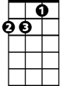

Dm



G

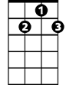

G7

F

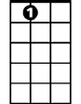

A7



C

**A7 D7 G7**

Cause no matter how far away you roam,

**C F C**

When you pine for the sunshine of a friendly gaze,

**G7 Dm G7 C F C**

For the holi-days you can't beat home, sweet home.

**Bridge**

**F C**

I met a man who lives in Tennessee and he was headin' for

**G7 C C7**

Pennsylvania and some home-made pumpkin pie.

**F Dm F C**

From Pennsylvania, folks are travelling down to Dixie's sunny shores

**G D7 G G7**

From Atlantic to Pacific, gee, the traffic is terrific.

**C F C**

Oh there's no place like home for the holidays.

**A7 D7 G7**

Cause no matter how far away you roam,

**C F C**

If you want to be happy in a million ways

**G7 Dm G7 C F C**

For the holi-days you can't beat home, sweet home.

**BARITONE**

**Repeat From Bridge**

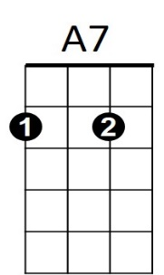**Outro (*Retard*)**

C



F

**G7 Dm G7 C F C**

For the holi-days you can't beat home, sweet home.

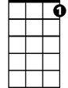

G7

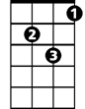

Dm



D7



G